Soft X-Ray Detection by Polymer Composites

Kulvinder Singh, Department of Physics, Deen Dayal Upadhyaya College, University of Delhi, India

Abstract
For material analysis, soft X-rays have their plenty of applications including X-ray diffraction (XRD), X-ray microscopy and spectroscopy etc. X-ray detector is an important component of the instruments. Choice of detector material is based on photoelectric conversion, mobility-life time product, stability, etc. Property like mechanical flexibility is now looked upon. For example, in dental radiography, if detector plate is flexible, it will be of great convenience. Similarly, for oscillation XRD plate there is requirement of cylindrical plate. In this connection, various polymer composite materials are being investigated. Polymer like Poly methyl methacrylate [PMMA or (C₅O₂H₈)_{n}] shows high resistance to X-Rays degradation. PMMA is used as matrix material and blended with various materials like mercuric iodide, lead iodide, potassium dichromate, bismuth iodide, lead oxide etc[1-5]. Solution casting technique was used to obtain composite material. Also, ion implantation of Argon, silver and Gold done on this material. Samples were mounted in vacuum chamber (pressure less than 10⁻⁶ torr). Argon ions (single positive charge state) were bombarded on the sample. Accelerating voltage was kept 80KV and current was kept 5μA. Beam area was kept 1X1cm².
Samples were then subjected to X-ray switching studies using X-rays at 35KV from copper target X-ray tube (Philips Holland). Continuous X-rays were obtained and beam was chopped at regular interval. It is done by using a switching rotor device using a stepper motor. Blocking of X-rays was done with thick semicircular lead ring. Rotation speed was controlled by a microprocessor P89C51RD2. Photocurrent was recorded by Keithley 6485 picometer.(Fig1)

Further using 2D implant from Axcelis.com (Monte Carlo program), depth profiling of Argon implant was carried out. Mobility-life time product is an important parameter of a detector material. This parameter is obtained by using modified Hecht equation. Soft X-ray detection studies conducted on Argon implanted PMMA and composites reveled that these are promising materials. PMMA sheets can be casted in any shape. It is most advantageous characteristic of this material.
Image
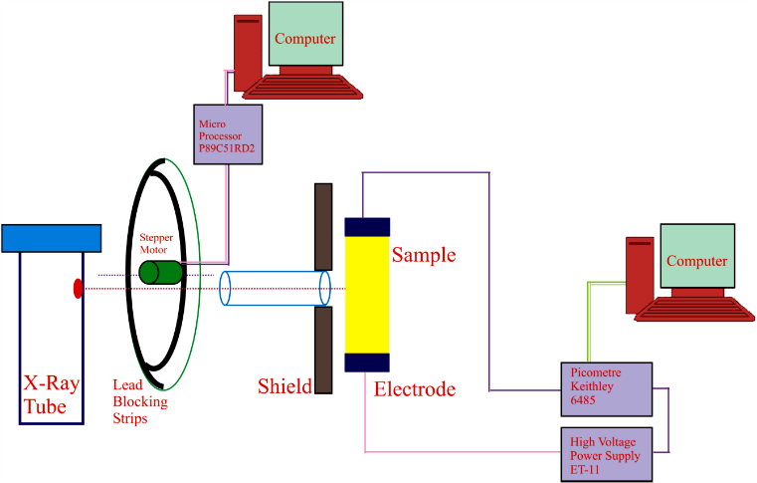
Figure1: Set-up for X-ray switching studies
Recent Publications:
[1] Kulvinder Singh and Suman Singh, Electrical conduction in PMMA-MX₂ composite Materials under X-rays Illumination, International Journal of Scientific research Vol. 5 issue, 2016 Page 141-142, 2
[2] Meena Kumari, Abhijit Nayak and Kulvinder Singh, X-Ray Switching Studies On Cadmium Iodide Polymer Composites, International Research Journal Of Natural and Applied Sciences, Vol 3, Issue9, Sepetember 2016, Page 107-112, IF 3.827 ISSN: (2349-4077).
[3] Kulvinder Singh, X-Ray Switching Studies on Mercury-Poly-Methyl-Methacrylate Composites, IJAR Oct-2016 Page 161-163, Vol6, Issue-10.
[4] Gaurav Suryan And Kulvinder Singh, BISMUTHOXIDE AS A GREEN ALTERNATIVE OF MERCURIC IODIDE FOR SOLID STATE X-RAY DETECTOR MATERIAL, Indian J.Sci.Res. 13 (1): 88-91, 2017
[5] Gaurav Suryan And Kulvinder Singh, X RAY SWITCHING STUDIES OF BISMUTH (III) OXIDE AND ITS COMPOSITES, Indian J.Sci.Res. 16 (1): 93-97, 2017.


Dr. Kulvinder Singh is an Associate Professor working in Department of Physics, Deen Dayal Upadhyaya College, University of Delhi. He established his own Lab on the material science. His areas of interest are X-Ray detector materials, Solar cells, Optical fiber technology and crystal growth. He is guiding many Ph.D. Students. Author of nearly 17 International Research Papers.
Email: kulvinder@ddu.du.ac.in

Notes/Comments:

