Effect Mechanism of Electron Beam on Oxygen and Carbon in Silicon during Melting
H M Noor ul Huda Khan Asghar
Department of Physics, Balochistan University of Information Technology, Engineering & Management Sciences, Quetta 87300, Pakistan
Email:noorulhudakhan@gmail.com and noorulhuda.khan@buitms.edu.pk, http://www.buitms.edu.pk/Faculties/Fabs/FProfile.aspx

Abstract
Small amounts of multi-crystalline silicon were melted in an electron beam furnace in different experimental conditions in order to investigate the oxygen evaporation behavior during the electron beam melting (EBM) process. The oxygen content level before and after EBM were determined by secondary ion mass spectroscopy (SIMS). The oxygen content was reduced from 6.177 ppmw to 1.629 ppmw when silicon was melted completely at 15 kW with removal efficiency up to 73.6%. After that it decreased continually to less than 0.0517 ppmw when the refining time exceeded 600 seconds with a removal efficiency of more than 99.08% as shown in Fig1. During the melting process, the evaporation rate of silicon is 1.10 × 10-5 kg/s. The loss of silicon could be reduced up to 1.7% during oxygen removal process to a desirable figure, indicating EBM is an effective method for removal oxygen from silicon and decrease the loss of silicon.
To investigate the carbon and silicon carbide flow behavior during the electron beam melting (EBM) process, 100 gram of multi-crystalline silicon with the contamination of SiC was melted in an electron beam furnace for five minutes. The EBM Experiment performed in the contaminated sample caused the redistribution of the impurities. The Electron Probe Microstructure Analysis (EPMA) microscopy, SEM and EDS have been utilized to experimentally observe the redistribution pattern. After EBM, carbon enriches in the form of SiC at the bottom of the ingot but not in the center. The results show that there is great temperature gradient existing in the melt during EBM, so the melt near copper crucible shows low temperature and bad fluidity. Carbon in silicon melt flows with the melt, precipitated and gathered in this area as shown in Fig1.so that it is separated due the segregation of the impurities alongside the bottom of the sample through EBM technique.
.
Image
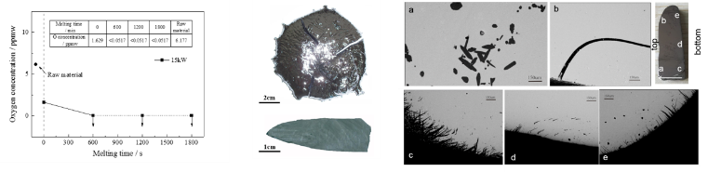
Fig1. Oxygen content during the EBM process and Carbide moved to the area near the bottom the ingot after EBM
Recent Publications
- Y. Tan, S.Q. Ren, S. Shi, S.T. Wen, D.C. Jiang, W. Dong, M. Ji, S.H. Sun, Removal of aluminum and calcium in multicrystalline silicon by vacuum induction melting and directional solidification, Vacuum. 99 (2014) 272-276.
- A. Lotnyk, J. Bauer, O. Breitenstein, H. Blumtritt, A TEM study of SiC particles and filaments precipitated in multicrystalline Si for solar cells, Sol. Energy Mater. Sol. Cells. 92(10) (2008) 1236-1240.
- S.Q. Qin, D.C. Jiang, P.T. Li, S. Shi, X.L. Guo, G.Y. An, Y. Tan, SiC sedimentation and carbon migration in mc-Si by electron beam melting with slow cooling pattern, Mater. Sci. Semicond. Process. 53 (2016) 1-7.
- S.Q. Qin, D.C. Jiang, Y. Tan, P.T. Li, P. Wang, Behavior of carbon in electron beam melted mc-silicon, Vacuum. 121 (2015) 207-211.
- Ch. Kudla, A.T. Blumenau, F. Bullesfeld, et al, Crystallization of 640 kg mc-silicon ingots under traveling magnetic field by using a heater-magnet module, J. Cryst. Growth. 365 (2013) 54-58.
- F.M. Kiessling, F. Büllesfeld, N. Dropka, C. Frank-Rotsch, M. Müller, P. Rudolph, Characterization of mc-Si directionally solidified in travelling magnetic fields, J. Cryst. Growth. 360 (2012) 81-86.

 Biography
I am H. M. Noor ul Huda Khan Asghar PhD, chairman department of physics in Balochistan University of Information Technology, Engineering and Management Sciences (BUITEMS) Quetta -Pakistan as well as I am vice president of new energy materials and technology institute co.ltd. of Dalian university of technology (Qingdao), to be responsible for construction of china-Pakistan international Science and technology corridor.
Email: noorulhudakhan@gmail.com

Notes/Comments:

