Title of the Presentation: Zwitterions/PAN composite membrane filters for metal ions removal from industrial waste water
Speaker Name: Palaniswamy Suresh Kumar
Speaker Affiliation: Environmental & Water Technology
Centre of Innovation (EWTCOI), Ngee Ann Polytechnic, Singapore – 599489

Abstract (300 word limit)
Over 1 billion people, mostly in developing countries, currently lack access to clean drinking water. According to recent World Health Organization (WHO) report, around 70 percent of industrial discharge in developing countries goes untreated and low-income countries are hardest hit by contaminated water supplies and disease. Water pollution by heavy metal ion contamination is extremely poisonous not only to human beings but to all living organisms in general. Electropsun polyacrylonitrile (PAN) nanofiber membranes were prepared through electrospinning process using PAN/DMF as solvent and followed by surface coating through dip coating process. Surface coated PAN membrane was developed to remove divalent metal ions in water which constituting a promising technology in portable water filtration system such as household filtration and water bottles. The prepared PAN nanofiber membranes were hydrolyzed to enhance hydrophilic surface properties (wettability ~ 24o) when compared to controlled PAN membrane (Wettability ~40o). PAN membrane was coated with selective Zwitterionic (Z) polymer for enhanced adsorption/rejection and antifouling functionality. The surface coating on PAN flat sheet membranes are developed through layer by layer dip coating process. Surface, compositional, thermal and wettability analysis of the control PAN and surface coated Zwitterionic (Z) /PAN membranes were confirmed by using scanning electron microscope (SEM), Thermal gravimetric analysis (TGA) and water contact angle measurement. FTIR spectra of Zwitterionic (Z) /PAN membrane filter exhibits a characteristic peaks at 1110 cm⁻¹ and 1040 cm⁻¹ originating from symmetric and asymmetric stretching of O=S=O from sulfonate groups of Zwitterionic polymer was observed. XPS analysis also confirm a predominate S2p (167eV) and N1S (402eV) peaks of the Zwittorionic polymer. Static adsorption capacity of control PAN and surface coated Zwitterionic (Z) /PAN membranes were evaluated using Cu²⁺ metal ion at fixed pH and concentration (pH6 and 300ppm). This study demonstrates the potential of Zwitterionic (Z) /PAN composite membrane as filters to remove the heavy metal ion with antifouling functionality. Developed compact, cost effective membrane filters will provide clean, fresh and safe drinking water, thereby significantly improving the health of population at risk due to poverty and low hygiene.

Image

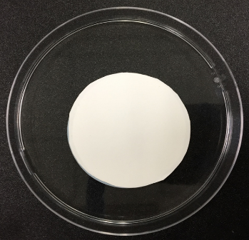
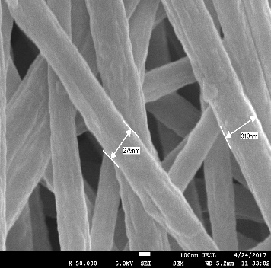

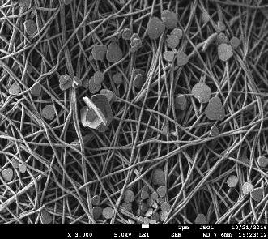
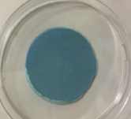
Zwitterionic /PAN membrane filter
(Before and after Cu2+ ion filtration)

Recent Publications (minimum 5)
- P. Suresh Kumar, J. Sundaramurthy, G. Singh, Book Chapter 9: Polymer and composite nanofiber: Electrospinning parameters and Rheology properties, Wiley publications, 2016, 329- 351. ISBN: 978-1-118-96979-3.
- S Sonia, P Suresh Kumar, ND Jayram, Y Masuda, M Devanasen, C Lee, Superhydrophobic and H2S gas sensing properties of CuO nanostructured thin films through successive ionic layered adsorption reaction process, RSC Advance, 2016,6, 24290-24298.
- P. Suresh kumar, J. Sundaramurthy, V. B. Jagadeesh, G. singh, S. Ramakrishna, Hierarchical Electrospun Nanofibers for Energy harvesting, production and Environmental remediation, Energy and Environmental Science, 2014,7,3192-3222
- Naidu Dhanpal Jayram, D Mangalaraj, P Suresh Kumar, G Mohan Rao, Analysis on superhydrophobic silver decorated copper Oxide nanostructured thin films for SERS studies, Journal of Colloid and Interface Science, 2016, 477, 209-219.
- S Poongodi, P Suresh Kumar, Y Masuda, D Mangalaraj, N Ponpandian, Synthesis of hierarchical WO3 nanostructured thin films with enhanced electrochromic performance for switchable smart windows, RSC Advances, 2015, 5, 96416-96427


Biography (150 word limit)
Dr Palaniswamy Suresh Kumar is currently working as Research & Development Scientist, Environmental and Water Technology Centre of Innovation (EWT COI) at Ngee Ann Polytechnic, Singapore. Previously, he worked as Research Fellow at School of Materials Science and Engineering/ Energy Research Institute @ NTU (ERI@N), Nanyang Technological University and NUSCNN, National University of Singapore, Singapore (2010-2013). His main research interests include the synthesis and fabrication of 1D Nanorods, Nanostructured Thin films material for smart coatings, Electrospun nanofibers for energy and environment.
Email: Suresh_Kumar_PALANISWAMY@np.edu.sg

Notes/Comments:

