Slag resistant oxide-graphite ceramic materials for metallurgy
Zebo Babakhanova PhD, Tashkent Chemical-Technological Institute, Uzbekistan

Abstract
Statement of the Problem: Synthesis of novel advanced ceramics with unique physical and mechanical properties, in particular high-temperature materials for metallurgy is an urgent task. The aim of this study was to investigate the possibility of synthesis of advanced ceramics using preceramic polymer as silicone matrix. As result oxide-graphite ceramic refractory nanomaterials were synthesized. Nano-sized oxide particles, such as γ-Al₂O₃ contrary to micro-sized ones, have a distinctive character in that they are capable of reacting directly with the ceramic residue deriving from the heat treatment of a preceramic polymer, either in inert atmosphere or in air upon transformation of Si-based polymers into pure silica. Silicones SILRES® H44 (WACKER), Al₂O₃ (nano, Puralox, γ - modification), Mg(OH)₂, graphite concentrate (Uzbekistan) have been used for the synthesis of oxide-graphite ceramics, applicable in melting and casting of non-ferrous and precious metals. Samples annealing was performed in nitrogen and air at 1550°C/1 hour in a tubular furnace. The mineralogical composition of synthesized materials was set by using XRD. Oxide-graphite refractory’s composition was aluminum oxynitride -34, corundum - 60 and graphite – 6 (in wt. %). The presence of aluminum oxide nitride and corundum enhances the mechanical and thermal properties of ceramic materials. The compositions of the samples synthesized in the air consist in wt. %: corundum - 60 and Al₂SiO₅ - 34. The modulus of elasticity and the mechanical strength was measured by dynamic nondestructive resonance. The density of graphite-corundum material were in the range of 2195-2610 kg/m³, water absorption- 10,489-17,779 %, the bending strength - 61-75 MPa, Young's modulus - 89-107 GPa, refractoriness - more than 1,800ºC. Slag resistance of ceramic composites was tested to the metallurgical slag of Almalyk Mining Metallurgical Complex for 1 hour at 1450 ºC. Visual investigation and SEM analysis showed that the samples were not destroyed (Fig. 1).
Image
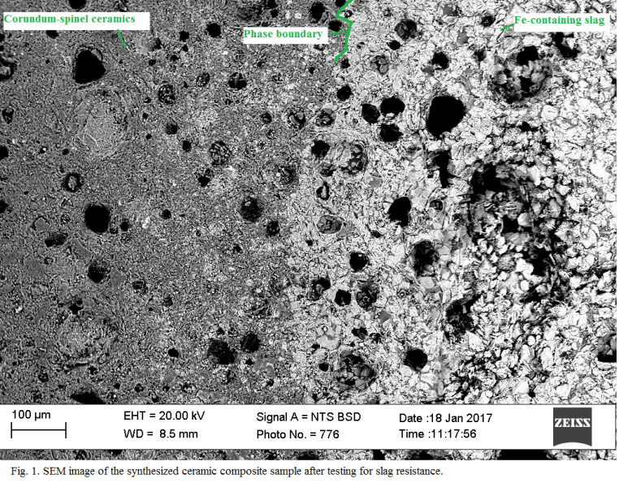
Recent Publications
- Babakhanova Z, Ruzimova Sh., Turgunov Sh (2017) Refractory graphite-containing ceramic materials in the MgO-Al₂O₃-SiO₂ system Universum 2 (35): 5-10.
- Babakhanova Z, Aripova M, Khodjaev N, Khamidov R (2016) The Study оf the Mineralogical Composition and Flotation Parameters of Quartz-Graphitized Schist Chemistry & Chemical Technology. 10: 3: 343-348.
- Babakhanova Z, Aripova M,Ergashev S, Bernardo E, Fiocco L (2016) Оbtaining of advanced ceramics by direct firing of a preceramic polymer and oxide nano fillers The international scientific and technical conference «Аctual problems of innovative technologies in the development of chemical, petroleum-gas and the food-processing industries»: 302-303.
- Fiocco L, Babakhanova Z, Bernardo E (2016) Facile obtainment of luminescent glass-ceramics by direct firing of a preceramic polymer and oxide fillers Ceramics International 42: 6770–6774.
- Babakhanova Z, Aripova M, Bernardo E (2016) The Synthesis of Luminescent Glass-Ceramic Materials Activated with Europium Ions Using Silicon-Organic Compounds (Silicones) Glass and Ceramics, 73(3): 124-127.
- Babakhanova Z, Aripova M (2015) Synthesis of technical ceramic materials using silicon-organic compounds Uzbek chemical journal 3: 16-21.

 Biography (150 word limit)
Zebo Babakhanova has her expertise in materials science and technology of production of advanced glass and ceramics materials. Her work is devoted to the study of the raw material base of Uzbekistan, the development and introduction of new methods and technologies for the production of technical ceramics, in particular the production of refractory and slag-resistant ceramic compositions. At the institute, she actively participates in scientific, educational, administrative and spiritual work. Her PhD thesis was devoted to the study of phase equilibria in two-component systems and the production on their basis of technical glass ceramics. At present, her field of interests led on the development of new methods of synthesizing of ceramic materials that are resistant to agressive media and temperatures. New materials can be recommended for use in metallurgy.
Email: babax2013@yahoo.com

Notes/Comments:

http://www.meetingsint.com/materials-science-conferences/materials-science/abstract-submission

Global Meeting On

Materials Science & Nanotechnology
Dubai, UAE Dec 11-12, 2017

