Direct Synthesis of Nanostructured In-Situ Hybrid Aluminum Matrix Composite
Afsaneh Dorri Moghadam, PhD, University of Wisconsin- Milwaukee, USA.
Emad Omrani, University of Wisconsin- Milwaukee, USA.
Pradeep K. Rohatgi, DSc, University of Wisconsin- Milwaukee, USA.

Abstract
Statement of the Problem: Nanostructured materials have the potential of decreasing the weight and energy absorbing capability of components (e.g in vehicles) due to the ultrahigh strength and strain rate sensitivity. Metal Matrix composites reinforced with very small nano sized particles have the potential to achieve extraordinarily high strengths at low densities, and therefore, can lead to reduced weight and improved operational limits of vehicles, including increasing mobility and survivability of military vehicles. While nanosize particles have been available commercially for few decades, currently there are few manufacturers worldwide that are making nanoparticle reinforced metals due to the difficulties in manufacturing and handling these materials. The objective of this study was to investigate a method capable of economically producing large and complex shapes of metal matrix nanocomposites, in which the ultrafine reinforcement particles were synthesized in liquid metal during manufacturing. Methodology: Initially, an in-situ exothermic reaction was designed to synthesize aluminum oxide (Al₂O₃) and titanium diboride (TiB₂) in an aluminum melt during manufacturing. Microstructural examinations and theoretical analysis indicate that the reaction to form TiB₂ and Al₂O₃ proceeds through several complex non-equilibrium reactions, and henceforth, a multi-stage reaction model is proposed. Furthermore, an up-scalable solidification technique using a high intensity ultrasonic combined with mechanical mixing has been designed to disperse the in-situ formed nanoparticles uniformly in the matrix by a one-step processing route. Findings: The results show that the technique offered a uniform dispersion and improved interfacial bonding between the reinforcement and the matrix, resulting a significant improvement in material strength and performance. Experimental and theoretical analysis shows that the particle size and refining power of nanoparticles is controlled by the viscosity of the melt, rather than precipitation and growth. In addition, it was found that increasing the weight percentage of nanoparticles of TiO₂ resulted in an increase in elastic modulus with good agreement to analytical models. Increasing the weight percentage of reinforcement up to 4 wt% resulted in an increase in the hardness greater than that predicted by the rule of mixtures or the Hall-Petch relationship.

Image

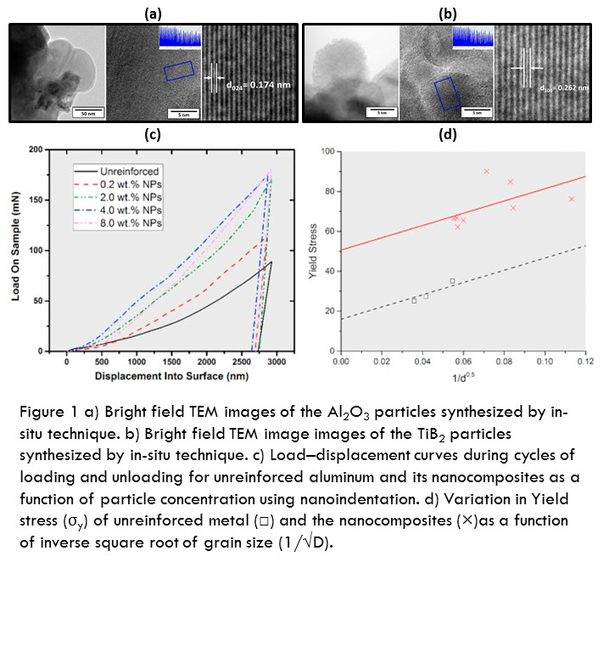
Recent Publications (minimum 5)
- Moghadam, A. D., Omrani, E., Lopez, H., Zhou, L., Sohn, Y., & Rohatgi, P. K. (2017). Strengthening in hybrid alumina-titanium diboride aluminum matrix composites synthesized by ultrasonic assisted reactive mechanical mixing. Materials Science and Engineering: A, 702, 312-321.
- Moghadam, A. D., Ferguson, J. B., Schultz, B. F., Lopez, H., & Rohatgi, P. K. (2016). Direct Synthesis of Nanostructured in Situ Hybrid Aluminum Matrix Nanocomposite. ACS Industrial & Engineering Chemistry Research, 55(22), 6345-6353.
- Moghadam, A. D., Omrani, E., Menezes, P. L., & Rohatgi, P. K. (2016). Effect of in-situ processing parameters on the mechanical and tribological properties of self-lubricating hybrid aluminum nanocomposites. Tribology Letters, 62(2), 1-10.
- Moghadam, A. D., Schultz, B. F., Ferguson, J. B., Omrani, E., Rohatgi, P. K., & Gupta, N. (2014). Functional metal matrix composites: self-lubricating, self-healing, and nanocomposites-an outlook. Jom, 66(6), 872-881.
- Rohatgi, P. K., Afsaneh, D. M., Schultz, B. F., & Ferguson, J. (2013). Synthesis and properties of metal matrix nanocomposites (MMNCS), syntactic foams, self-lubricating and self‐healing metals. PRICM, 8, 1515-1524.

 Biography
Afsaneh Dorri M. received her Doctorate degree in Science at University of Wisconsin- Milwaukee in 2016 and currently working at the Advanced Analysis facility at UWM as a research Associate. Her field of research and expertise is focused on functional autonomous materials including syntactic foam, self-cleaning and self-lubricating nanocomposites. Currently she is working on advanced manufacture and characterization of lightweight, energy absorbing, self-lubricating components. She has coauthored a book chapter and 20 peer reviewed scientific papers in these areas.
Email: afsaneh@uwm.edu

Notes/Comments:

