Activated Carbon-Sulfur composite with PEDOT: PSS-CNT Interlayer as cathode material for Lithium-Sulfur cells.

Manoj M, S. Jayalekshmi*
Division for Research in Advanced Materials, Department of Physics, Cochin University of Science and Technology, Kochi, Kerala, India
*Corresponding author: E-mail: jayalekshmi@cusat.ac.in

The lithium–sulfur concept is considered as the next generation battery technology owing to the high energy density it offers and the easy accessibility of sulfur[1]. Sulfur cathode has a high theoretical capacity of 1675mAh/g against lithium, with the formation of Li₂S. Despite the promising nature of sulfur, the low electrical conductivity, the formation of polysulphides during cycling which dissolve in the electrolyte and the polysulfide shuttle phenomenon limit the practical applications of lithium-sulfur cells[2]. In order to overcome these issues, the electrical conductivity of the cathode material has to be enhanced by the encapsulation of sulfur in an electrically conducting matrix.

In the present work, activated carbon-sulfur composite with a PEDOT: PSS-CNT interlayer, is investigated as the cathode active material. The PEDOT:PSS is a conducting polymer and CNT stands for carbon nanotubes. The interlayer helps to restrict the polysulfides from migrating to the anode and thereby inhibits the polysulfide shuttle phenomenon and also improves the electrical conductivity of the cathode material[1] The electrochemical performance of the activated carbon-sulfur composite has been investigated by assembling coin type cells. The composite with the PEDOT:PSS-CNT interlayer shows an initial discharge capacity almost twice that of the same composite without using the interlayer, with an extended cycling stability, making it a promising cathode material in the field of lithium-sulfur cells.

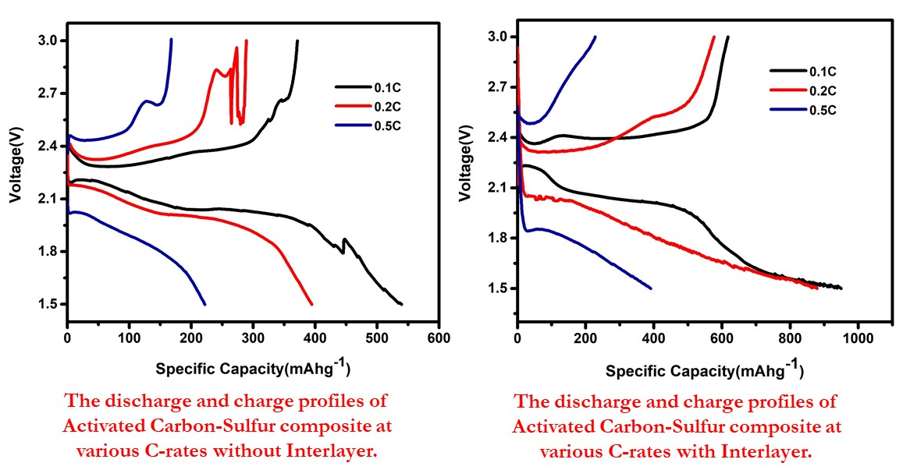

References
1. Z. Lin and C. Liang, J. Mater. Chem. A 3, 936 (2015).
2. A. Manthiram, Y. Fu, S. Chung, C. Zu, and Y. Su, Chem. Rev. 114, 11751 (2014).
RECENT PUBLICATIONS

1. Polyaniline–Graphene Oxide based ordered nanocomposite electrodes for high performance supercapacitor applications M. Manoj, K. M. Anilkumar, B. Jinisha, S. Jayalekshmi : J Mater Sci: Mater Electron.

2. Mn3O4/reduced graphene oxide nanocomposite electrodes with tailored morphology for high power supercapacitor applications Anilkumar KM, Manoj M, Jinisha B, Pradeep VS, S. Jayalekshmi : Electrochimica Acta 236 (2017) 424–433.

3. Development of a novel type of solid polymer electrolyte for solid state lithium battery applications based on lithium enriched poly (ethylene oxide) (PEO)/poly (vinyl pyrrolidone) (PVP) blend polymer Jinisha B, Anilkumar KM, Manoj M, Pradeep V.S, Jayalekshmi S : Electrochimica Acta 235 (2017) 210–222.

4. Poly (ethylene oxide) (PEO) – Poly (vinyl pyrrolidone) (PVP) blend polymer based solid electrolyte membranes for developing solid state magnesium ion cells K.M. Anilkumar, B. Jinisha, M. Manoj, S. Jayalekshmi : European Polymer Journal 89 (2017) 249–262.

5. Transparent flexible lithium ion conducting solid polymer electrolyte Anand B. Puthirath, Sudeshna Patra, Shubhadeep Pal, Manoj M, Aravind Puthirath Balan, Jayalekshmi S. and Narayanan Tharangattu N : J. Mater. Chem. A, 2017, 5, 11152

