Coupling of nanowires in unique architectures for photon management
Usha Philipose, University of North Texas, Denton USA

Abstract (300 word limit)
Statement of the Problem: Poor optical absorption affects the performance of many opto-electronic devices including detectors and photovoltaics. In this regard, low dimensional structures such as nanowires have the advantage of providing: (i) a direct path for charge transport (ii) high carrier collection efficiency in a dense array due to the proximity of photo-excited carriers to charge separation interface; and (iii) higher optical absorption and lower reflection in nanowires compared to bulk materials. These benefits will be significant provided the nanostructures could absorb a significant fraction of the incident light. Light trapping techniques such as surface texturing is not viable for use with nanostructures because the roughened features are much larger compared to the size of the nanostructures. Metal nanoparticles have the ability to confine and guide incident sunlight into absorbers of nanometer length thickness. They support surface plasmon polaritons (SSPs), which are collective oscillations of free electrons at the interface of a metal and a semiconductor material. The SPP modes are localized at the nanostructured metal film surface and can propagate several microns in length with minimum losses. Coupling to the SPPs with a periodic or aperiodic array of semiconductor nanowires will create a concentrator cell structure, resulting in enhanced light absorption and an increase in the injection level of photocarriers.
Image

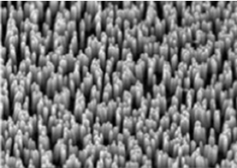
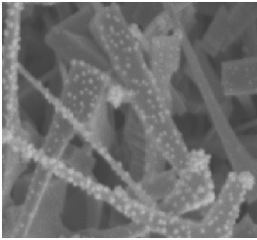
Recent Publications (minimum 5)

- M. Bhargav, S.V. Nair, H.E. Ruda, U. Philipose, “Role of surface in high photoconductive gain measured in ZnO nanowire based photodetector”; Journal of Nanoparticle Research; 17 (2015); 176
- D. George, L. Li, D. Lowell, J. Ding, J. Cui, H. Zhang, U.Philipose, and Y. Lin, “Electrically tunable diffraction efficiency from gratings in Al doped ZnO”, Applied Physics Letters; 110 (2017); 071110
- D. George, L. Li, Y. Jiang, D. Lowell, M. Mao, S. Hassan, J. Ding, J. Cui, H. Zhang, U.Philipose, and Y. Lin, “Localized Surface Plasmon Polariton Resonance in Holographically Structured Al-doped ZnO”, Journal of Applied Physics; 120 (2016); 043109
- A. Zaina, G. David, A. Singh, Y. Lin, U. Philipose, “Hole dominated transport in InSb nanowires grown on high quality InSb films”, Journal of Nanoparticle Research; (2016) 18:361
- A. Neogi, S. Karna, R. Shah, U. Philipose, J. Perez, R. Shimada and Z.M. Wang, “Surface plasmon enhancement of broadband photoluminescence emission from graphene oxide,” Nanoscale 6 (2014), 11310

Biography (150 word limit)
Usha Philipose has her expertise in synthesis and characterization of semiconductor nanowires. Her work involves studying the physics of electron, photon, and phonon confinement as well as spin manipulation in one-dimensional semiconductors and demonstrating their feasibility as nanoscale devices. Her current research focus is on developing nanowire superlattices and nanowire composites as thermoelectrics as well as using various nanoscale architectures for photodetection.
Email: usha.philipose@unt.edu

Notes/Comments:

