Statistical analysis of fatigue test in jute reinforced polyester composites using Weibull distribution
Djeghader D, PhD in Civil Engineering, Jijel University, Algeria

Abstract

The fatigue strength of natural composite material was evaluated under stress cyclic loading with slow speed. The material that was used is a bi-directional jute/polyester composite with 40% in reinforcement. Experimental fatigue results were used to plot S-N curve which is based on Wöhler equation. Two-parameter Weibull probability was used to analysis statistically the fatigue life results of composite samples. Weibull graphics were plotted for each sample using fatigue data. Then, S–N curves were drawn for different reliability levels (Ps = 99%, Ps =90%, Ps =50%, Ps = 36,8% and Ps = 10%) using Weibull data. These S-N curves were introduced for the identification of the first failure time as reliability and safety limits of the material.

Image

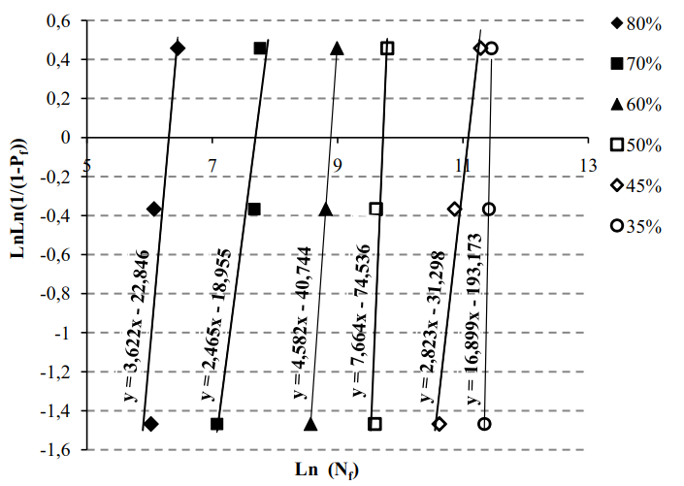
Recent Publications
- Jayantha A E (2006) Effects of static–fatigue (tension) on the tension–tension fatigue life of glass fibre reinforced plastic composites. Composite Structures 74:419-425.
- Jong-Sung K, Kyung-Dong B, Chul L, Yun-Jae K, Woo-Sik K, Ik-Joong K (2017) Fatigue Life Evaluation of Composite Material Sleeve using A Residual Stiffness Model. International Journal of Fatigue 101:86-95.
- Yong W, Weidong Y,Fumei W (2017) Experimental evaluation and modified Weibull characterization of the tensile behavior of tri-component elastic-conductive composite yarn. Textile Research Journal :1-12.
- Khashaba U A (2003) Fatigue and Reliability Analysis of Unidirectional GFRP Composites under Rotating Bending Loads. Journal of Composite Materials 37:317-331.
- 5. Sullivan EV, Zahr Ahmed S. H, Joseph W. N, Carlos H. C (2016) Weibull statistical analysis of Krouse type bending fatigue of nuclear materials. Journal of Nuclear Materials 470:244-250.


Djeghader Djamel has a Doctorate Diploma in Civil Engineering, Option: Materials and Structures. His field of research is devoted mainly to the behavior of composite materials under different stresses types using linear elastic fracture mechanics. The work presented above contains a statistic analysis of cyclic fatigue tests using Weibull distribution function with two parameters. This approach is very important and very significant to designers for identification of the first failure time, as reliability and safety limits at the practical applications depend on the confidence index of the material.
Email: djameldjeghader@yahoo.fr

Notes/Comments:

