Energy Storage Materials for Supercapacitor
S.Selladurai and N.Padmanaban
Dept. of Physics, Anna University, Chennai-25
e.mail: ssdurai@yahoo.com

Energy storage is the key component for creating sustainable energy systems. Current technologies, such as solar photovoltaics and wind turbines, can generate energy in a sustainable and environmentally friendly manner; yet their intermittent nature still prevents them from becoming a primary energy carrier. Energy storage technologies have the potential to offset the intermittency problem of renewable energy sources by storing the generated intermittent energy and then making it accessible upon demand. In addition to energy grid applications, energy storage technologies also have the potential to transform the transportation system.
Scientists have been struggling to develop energy storage solutions such as batteries and capacitors that can keep up with the current rate of electronic component evolution for a number of years. Unfortunately, the situation we are in now is that while we are able to store a large amount of energy in certain types of batteries, those batteries are very large, very heavy, and charge and release their energy relatively slowly. Capacitors, on the other hand, are able to be charged and release energy very quickly, but can hold much less energy than a battery.
Nanotechnology involved Nanomaterials and Graphene application developments though have lead to new possibilities for energy storage, with high charge and discharge rates, which can be made very cheaply. But before we go into specific details, it would be sensible to first outline the basics of energy storage and the potential goals of developing new kind of nanomaterials such low cost metal oxides, conducting polymer, carbon hydrogel, graphene etc., as a hybrid supercapacitor or supercapattery.
Batteries to hybrid supercapacitor or supercapatteries
A battery is electrochemical energy storage medium. Most batteries, while able to store a large amount of energy are relatively inefficient in comparison to other energy solutions such as fossil fuels. It is often said that a 1kg electrochemical battery is able to produce much less energy than 1 litre of gasoline; but this kind of comparison is extremely vague, mathematically illogical, and should be ignored. In fact, some electrochemical batteries can be relatively efficient, but that doesn’t get around the primary limiting factor in batteries replacing fossil fuels in commercial and industrial applications (for example, transportation); charge time.
High capacity batteries take a long time to charge. This is why electrically powered vehicles have not taken-off as well as we expected twenty or thirty years ago. While you are now able to travel 250 miles or more on one single charge in a car such as the Tesla Model S, it could take you over 43 hours to charge the vehicle using a standard 120v wall socket in order to drive back home. This is not acceptable for many car users. Capacitors, on the other hand, are able to be charged at a much higher rate, but store (as already mentioned) somewhat less energy.
Supercapacitors, also known as ultracapacitors, are able to hold hundreds of times the amount of electrical charge as standard capacitors, and are therefore suitable as a replacement for electrochemical batteries in many industrial and commercial applications. Supercapacitors also work in very low temperatures; a situation that can prevent many types of electrochemical batteries from working. For these reasons, supercapacitors are already being used in emergency radios and flashlights, where energy can be produced kinetically (by winding a handle, for example) and then stored in a supercapacitor for the device to use.
While supercapacitors are able to store much more energy than standard capacitors, they are limited in their ability to withstand high voltage. Electrolytic capacitors are able to run at hundreds of volts, but supercapacitors are generally limited to around 5 volts. However, it is possible to engineer a chain of supercapacitors to run at high voltages as long as the series is properly designed and controlled.
Supercapacitors, unfortunately, are currently very expensive to produce, and at present the scalability of supercapacitors in industry is limiting the application options as energy efficiency is offset against cost efficiency. The efficiency of the supercapacitor is the important factor to bear in mind. In the past, scientists have been able to create supercapacitors that are able to store 150 Farads per gram, but some have suggested that the theoretical upper limit for graphene-based supercapacitors is 550 F/g. This is particularly impressive when compared against current technology: a commercially available capacitor able to store 1 Farad of electrostatic energy at 100 volts would be about 220mm high and weigh about 2kgs, though current supercapacitor technology is about the same, in terms of dimensions relative to energy storage values.
Supercapacitors boast a high energy storage capacity compared to regular capacitors, but they still lag behind batteries in that area. Supercapacitors are also usually more expensive per unit than batteries. Technically, it is possible to replace the battery of a cell phone with a supercapacitor, and it will charge much faster. Alas, it will not stay charged for long. Supercapacitors are very effective, however, at accepting or delivering a sudden surge of energy, which makes them a fitting partner for batteries. Primary energy sources such as internal combustion engines, fuel cells and batteries work well as a continuous source of low power, but cannot efficiently handle peak power demands or recapture energy because they discharge and recharge slowly. Supercapacitors deliver quick bursts of energy during peak power demands and then quickly store energy and capture excess power that's otherwise lost. In the example of an electric car, a supercapacitor can provide needed power for acceleration, while a battery provides range and recharges the supercapacitor between surges.
Supercapacitor has Low energy density - typically holds 1/5th to 1/10th the energy of an electrochemical battery, As with batteries, cells have low voltages so serial connections are needed to obtain higher voltages and voltage balancing is required for more than three capacitors.Linear discharge - inability to use the full energy spectrum and, depending on the application, not all energy is available.

Hybrid Supercapacitor
The new devicethat combines the high energy densities of batteries and the quick charge and discharge rates of supercapacitors. The hybrid supercapacitor or supercapatteries is reportedly six times as energy-dense as a commercially available supercapacitor and packs nearly as much energy per unit volume as a lead-acid battery.
Batteries can store a lot of energy in a small and light package, but they can’t charge or discharge very quickly or last a long time the way supercapacitors can. A single device that combines all of these positive attributes could change the entire technological landscape of today, leading to lighter, compact phones and electric cars that charge in seconds instead of hours.The amount of energy that can be stored in such a device depends in large part on the contact area between the electrolyte and the two electrodes: the greater the contact area, the more energy can be stored. Figure 1 represents the technical view of hybrid supercapacitor

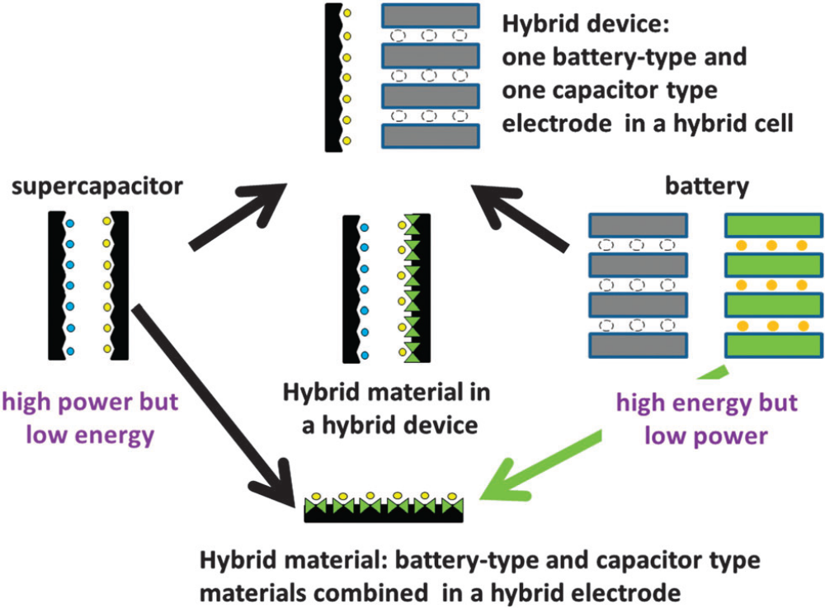
Figure 1. Technical view of hybrid supercapacitor

Since the device performance are strongly depends on the electrode materials, the scientist are focused to develop novel materials for hybrid supercapacitor applications. When compared to traditional carbon based materials pseudocapacitive materials can obviously enhance the specific capacitance and energy density of the supercapacitors via interfacial faradaic reactions to store energy. Thereby, pseudocapacitive materials including RuO₂, MnO₂, and non-capacitive oxides of NiO, Co₃O₄ and their composite systems possess high energy storage capacity have been investigated. But suffer from low rate capability and reversibility due to their dependence on faradic redox reactions to store charge and the low conductivity of the oxide.Therefore, in recent years, the extensive advancements in supercapacitor performance have been due to the optimization of microstructure of the electrode materials in particular, nanocrystalline hetero-structures exemplify an interesting approach in developing nanoscale building blocks for fabricating highly efficient electrodes.
My Research Accomplishment in Supercapacitor
The research lab in Anna University called Solid State Ionics Laboratory under Department of Physics; there is research team which has been successfully managed by Professor S. Selladurai have developed different nanomaterials for hybrid supercapacitor applications. Since the year 2010, Dr.S.Selladurai and his research team developing the better electrode materials to meet the high performance supercapatteries which could have the capability to replace the commercial lead-acid batteries. Initial evaluation of electrode materials with different metal oxides and their composite have proven them as the better choice of materials for hybrid supercapacitor. Typical SEM images of few oxide materials are shown in Figure2. Among them NiO/Co₃O₄ based transition metal oxide showed superior performance towards hybrid devices. In particularly, the NiO/Co₃O₄ based symmetric cell has delivered the specific energy of 19.4 Wh/kg with 1000.8 W/kg power output. Fig. 3 shows the symmetric capacitor model used to characterize the electrode prepared in our laboratory. The cell is also capable of long-term cycling stability with an efficiency of 58% after 25000 cycles with a potential widow of 0 to ±2 V. Similarly, Graphene/NiCo₂O₄ composite have delivered 21.2 Wh/kg specific energy with 600 W/kg power output in 0 to 0.8 V range. Figure 4 shows the NiCo₂O₄ based symmetric cell connected in series to light up LED for 10 - 15 seconds. It is also point to notice that the electrode kinetics is not all same for all the material and depends on the surface area, electrical conductivity and choice of electrolyte. Therefore before take into the commercial product it is necessary to understand the electrode kinetics of the electrode and their active potential region. In this aspect our current research are in progress. Meantime we are having a plan to take our material to existing commercial supercapacitor to replace one of the electrode with our materials and evaluating the device performance which can give as the better idea to reach our goal to make complete hybrid supercapacitor.

Figure 2. SEM images of the recent electrode materials prepared by our group
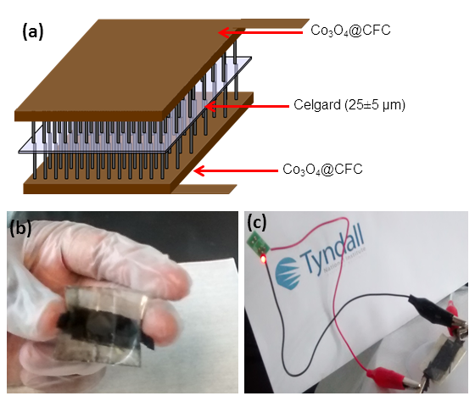
Figure 3(a-c). Fabrication of symmetric Cell with Co₃O₄ material and their performance to light up LED
Figure 4. Fabrication of series connected symmetric Cell with NiCo₂O₄ material and their performance to light up LED
Application of hybrid supercapacitor
Supercapacitors are currently used to harvest power from regenerative braking systems and release power to help hybrid buses accelerate, provide cranking power and voltage stabilization in start/stop systems, backup and peak power for automotive applications, assist in train acceleration, open aircraft doors in the event of power failures, help increase reliability and stability of the energy grid of blade pitch systems, capture energy and provide burst power to assist in lifting operations, provide energy to data centres between power failures and initiation of backup power systems, such as diesel generators or fuel cells and provide energy storage for firming the output of renewable installations and increasing grid stability.

Current and Future Market of hybrid supercapacitor
Leading European manufacturer Skeleton Technologies has launched a new range of Supercapacitors that offers the highest level of energy density on the market.Energy density is a key development challenge for the ultracapacitor market and is fundamental if the technology is to eventually replace battery storage. The record-breaking energy density achieved by the SkelCap 4500 series will allow Skeleton Technologies to maximise opportunities in the heavy transportation and industrial markets where weight and space are at a premium. Still these devices are based on the carbon based electrode materials which have not even reach the energy density of 20 Wh/kg which is far back from batteries.
At the high end of the energy storage spectrum, supercapacitors are being used to increase the efficiency of hybrid electric vehicles in several ways. Today’s hybrid vehicles typically turn off the engine completely when the car comes to a stop, however briefly, and then very efficiently start it again using energy stored in supercapacitors. Toyota is using what it’s learned with the TS040 in a concept car called the Yaris Hybrid-R, which uses a supercapacitor.
Maxwell has also designed a replacement for a conventional vehicle battery using supercapacitors connected across a smaller lead acid battery. The concept behind this application is that power demand spikes, such as starting a car, decrease the overall energy that the battery can produce. Batteries last much longer when the discharge is small and steady. The supercapacitors in Maxwell’s “hybrid” lead-acid battery essentially smooth out energy demands on the battery.
Trains, planes, and automobiles (as well as trucks) account for about 40 percent of today’s $400 million worldwide supercapacitor market, according to market researcher Paumanok Publications Inc. Transportation applications include maglev trains, power and braking recuperation systems, truck lifts, and track switching.
Although China's new energy vehicle power system still gives priority to LiFePO4 battery and Ni-MH battery, supercapacitor has developed part of the new energy automobile market there. According to the research and information released by the New Energy Vehicle Power Battery Industry Development Laboratory, China has produced power batteries for 129,315 various energy saving and new energy vehicles as of July 2014, of which, vehicles equipped with supercapacitor represent about 12.4%. In terms of installation statistics, over 60% of supercapacitors are still dependent on products of Maxwell, LSMtron and other foreign companies.
Supercapacitors are also used to protect CMOS logic and to power electronic toys. Security alarm systems, uninterruptible Power Supply (UPS) systems, and solar power are other common applications.
Until recently, the supercapacitor market has grown largely at the expense of conventional capacitors. Currently, the technology seems ready to invade the lithium-ion battery market share for smart phones and other devices that perform multiple functions more or less simultaneously, and therefore, have similar spiky power-to-available-energy profiles.
Supercapacitors are used in solar arrays and are also are a good fit for micro-energy harvesting applications, which by definition do not require much energy storage. Milliwatts scavenged from a nearby thermal, vibration, or biological sources can power the sensors used for monitoring and controlling motors. Vibrational energy created by rotating machinery, for example, is stored in the supercapacitor after first being converted to electrical energy by a harvesting device. Using supercapacitors can eliminate the need for replacing batteries or the expense of running a power line to a rechargeable battery.
Since solar energy is only available during the day and naturally sporadic because of weather and clouds, a large capacity and fast charge-discharge energy storage system is needed to quickly store the energy of the sun so that it can be used anytime – day or night. It believes that such a solar energy storage system can be built by combining a supercapacitor frontend with a battery backend. This game-changing solution will allow users of solar energy systems to time-shift solar energy to reduce their dependence on, or go completely off, the electric utility power grid.
High power and high energy solar energy storage system is essentially a microgrid design, and a smart-grid design when connected to the utility power grid. Supercapacitors have features that are unmatched by batteries and are critical to the future of distributed renewable power generation. Homes, office buildings, and campuses, can have their own microgrids for localized energy independence. When these microgrids are connected to the power grid, they can be enhanced to become smart-grid nodes to help smooth out the supply and demand of electricity for all constituents on the grid. A tremendous amount of electricity is wasted in today’s “use it or lose it” model – whether it’s from coal, natural gas, solar, wind, or hydro. Efficient, high power and high capacity energy storage systems hybrid supercapacitoronly can turn electricity into a “use it now or use it later” model.

