Smart mesoporous trapper to selectively capture 4-methylnitrosamino-1-3-pyridyl-1-butanone (NNK)
Shuo Hao Li, Xiao Dan Sun, Ying Wang, Jian Hua Zhu*
College of Chemistry and Chemical Engineering, Nanjing University, Nanjing 210023, China

Abstract (300 word limit)
To meet the requirement of controlling tobacco-caused environment pollution, a novel microporous interspaces was fabricated inside the channel of mesoporous silica SBA-15, endowing the mesoporous sorbent to selectively capture 4-methylnitrosamino-1-3-pyridyl-1-butanone (NNK), like microporous zeolite, among tobacco specific nitrosamines (TSNA) in solution. For this aim, the optimal amount of discarded cigarette filters (CF) and ferric nitrate (Fe(NO₃)₃) were dissolved in acetic acid, and then infused into SBA-15 by wet impregnation method. The obtained composite was then simultaneously carbonized at 923 K to transform these precursors into carbon and FeO_{x} particles that subtly tailor the tortuosity of mecsoporous channels and provide electrostatic interaction to induce TSNA entering channel. After the careful channel engineering, the wall of mesoporous channel was modified to have lots of microporous interspaces formed by ferric nanoparticles and adjacent carbon, as if the branching streams in the wide river, forming a kind of hierarchical structure. In the liquid adsorption of tobacco extract solution with the components more than 2000, the mesoporous channel allowed the solution easily passed through while these microporous interspaces in channel wall displayed a new shape-selectivity towards NNK among different TSNA components, which is usually observed only in some micropoorus zeolites like NaZSM-5, and the representative sample Fe_{0.9}CF_{1.2}/S15c owned the excellent performances in different kinds of tobacco extract solutions, the highest removal of NNK could reach 82.5%. This strategy efficiently elevated the capability of mesoporous silica in capturing TSNA in tobacco solution, providing a powerful smart material for environment protection. Besides, the discarded cigarette filters were firstly selected as the carbon matrix precursor and then enhanced adsorption efficiency of TSNA, which had profound significance for resource regeneration and reuse as well as sustainable development.
Image
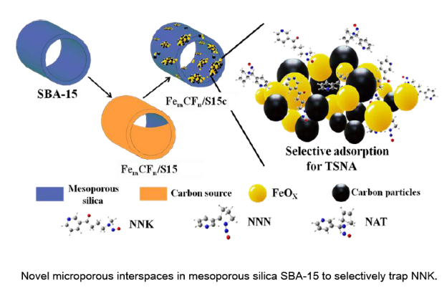
Recent Publications (minimum 5)
- Y.Y. Li, M.M. Wan, X.D. Sun, J. Zhou, Y. Wang, J.H. Zhu (2015)Novel fabrication of efficient solid base: carbon-doped MgO-ZnO composite and its CO2 capture at 473 K. J. Mater. Chem. A. 3, 18535 - 18545.
- X.D. Sun Y.Y. Li, L.J. Wang, D. Wu, S.J. Zheng, W.M. Wang, Y.G. Tong, Y. Wang, J.H. Zhu (2016),Capturing tobacco specific N-nitrosamines (TSNA) in industrial tobacco extract solution by ZnO modified activated carbon. Microporous Mesoporous Mater. 222, 160-168.
3 Y.Y. Li, X.Y.M. Dong, X.D. Sun. Y. Wang, J.H. Zhu (2016) New solid base Cu-MgO for CO2 capture at 473 K and removal of nitrosamine. ACS Appl. Mater. Interfaces, 8, 30193–30204.
4 S.H. Li, X.D. Sun, L.J. Wang, W.B. Gu, W.M. Wang, Z.Y. Yang, Y. Wang, J.H. Zhu (2017) Fabricating hydrophobic nanoparticles within mesoporous channel of silica for efficient TSNA removal. Microporous Mesoporous Mater. 237, 237-245.
5 X.D. Sun, S.H. Li, L.J. Wang, W.B. Gu, C.L. Shi, X.Y.M. Dong, Y.Z. Wang, W.M. Wang, Z.Y. Yang, Y. Wang, J.H. Zhu (2017) Impact of proton: Capturing tobacco specific N-nitrosamines (TSNA) with HZSM-5 zeolite. Chem. Eng. J. 323, 180-190.

 Biography (150 word limit)
Dr. Jian Hua ZHU got his PhD degree in Nanjing University (China) in 1989, and he became the professor of Nanjing University in 1998. With the aim of micro structural controlling and high technical application of novel molecular sieves-based functional materials, Dr. Zhu has his expertise in design and fabrication as well as application of new functional porous materials, including zeolites, mesoporous silica and other porous materials, and his investigation on the application of functional materials focuses the selective adsorption, acidic or basic catalysis and environmental protection. Recently, his interesting is changed to drug release, the lessening harm of tobacco products, new capture of warm CO₂, represented by the novel releaser of heparin, porous MgO-based warm CO₂ sorbents and efficient sorbents of tobacco-specific nitrosamines.
Email: jhzhu@nju.edu.cn
Notes/Comments:

Poster presentation is preferred, if possible.

