Calcination Condition Dependence of Electrical Properties of Fluorine doped Tin Oxide (FTO) Transparent Thin Films

Bhim P Kafle*, PhD, Dept. Chem. Science & Engineering, Kathmandu University, Dhulikel, Kavre, Nepal
Madhav Kafle, MSc., Dept. Physics, Amrit Campus, Tribhuvan University, Kathmandu, Nepal
Armila Rajbhandari, PhD, Central Dept. Chemistry, Tribhuvan University, Kirtipur, Nepal
Gobinda Gyawali, PhD, Division of basic engineering, Sun Moon University, Asan, South Korea

Abstract (300 word limit)

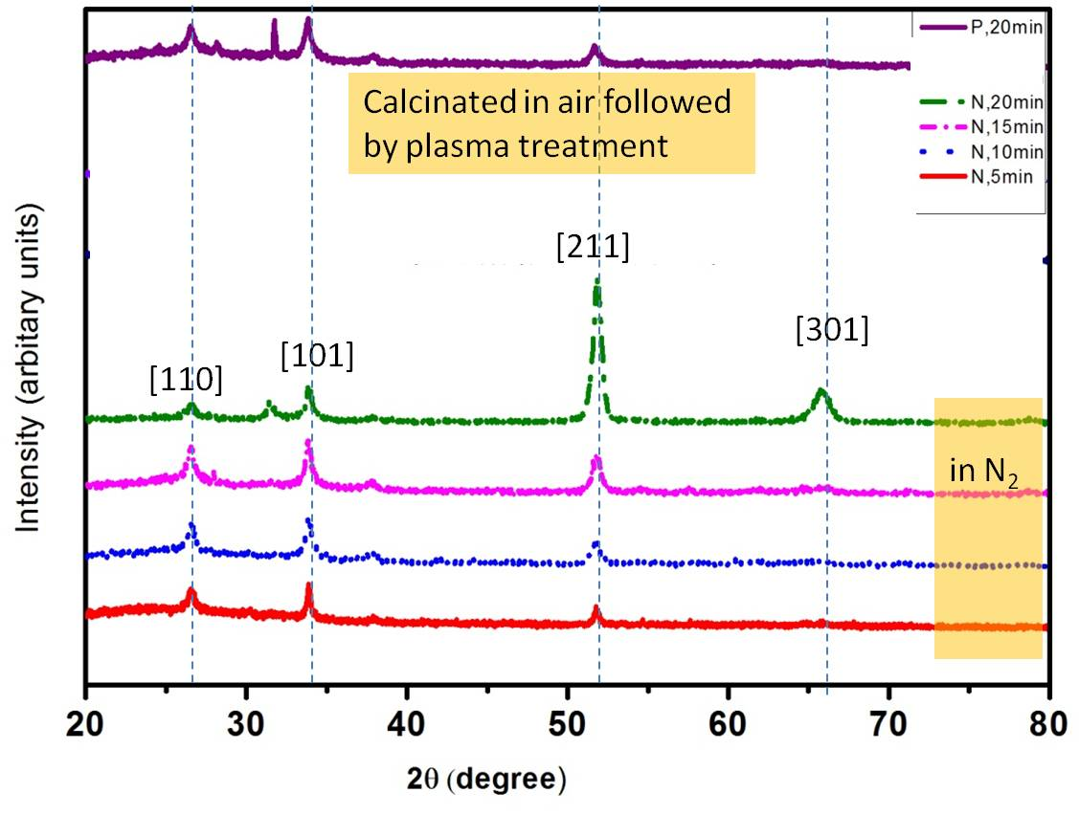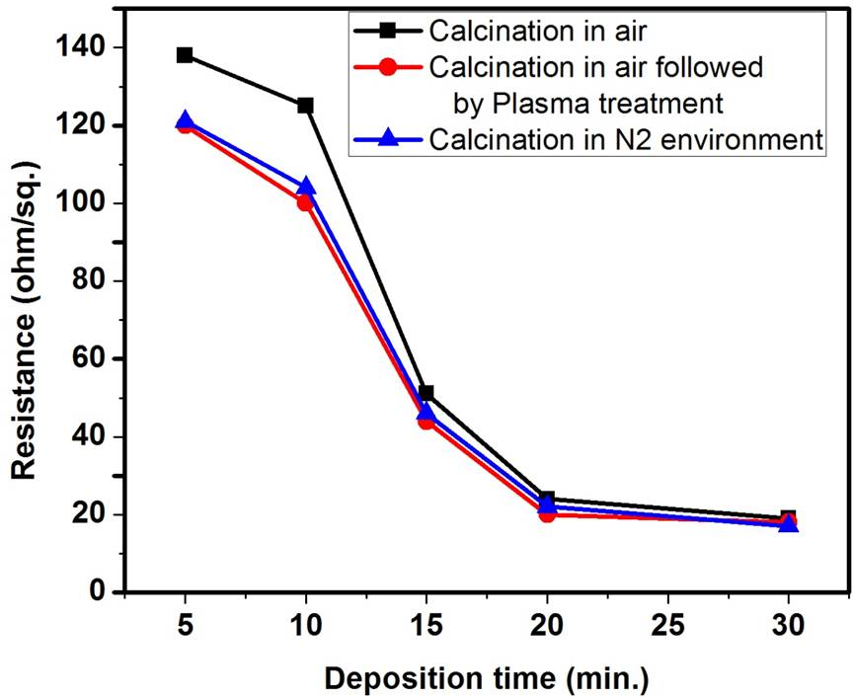In this study, dependence of optical and electrical properties of FTO thin transparent film on calcination conditions (thermal treatment in an oven in aerobic and anaerobic conditions, specifically, in the presence of either air or N₂ gas) were studied. The FTO films were fabricated with low cost home-made spray pyrolysis setup and calcinated at 500 ºC for two different environments for thirty minutes. The homogeneous solution of stannous chloride (Sncl₂.2H₂O) and ammonium fluoride (NH₄F) in distilled water was used as a precursor solution. The films’ structural, surface, optical and electrical properties were measured with XRD, SEM, UV-Vis spectroscopy, and 2-Probe measurements, respectively. The FTO films fabricated by spraying the precursor solution for 30 minutes with F to Sn to ratio of 0.85:1.81 and calcined in the presence of air followed by low temperature plasma treatment yielded the lowest electrical resistance of 17 Ωcm⁻¹ and maximum transmittance of ca. 80 %. Also, the effect of calcination environment and plasma treatment on film’s reflectance will also be discussed.
Image

The FTO films’ structural and electrical properties are shown below. The films show polycrystalline nature.

Left panel shows comparison of XRD of FTO thin films calcinated in air oven followed by plasma treatment, and calcinated in oven with N₂ environment. Right panel illustrates the films’ electrical properties as a function deposition time and calcination conditions.

Recent Publications (minimum 5)
- B. Kafle, S. Acharya, S. Thapa and S. Poudel, Undoped and Fe doped ZnO thin films: A comparative study on structural and optical properties, Ceramics International 42 (2016) 1133.
- B. Kafle, O. Aviv, V. Chandrasekaran, O. Heber, M. L. Rappaport, H. Rubinstein, D. Schwalm, D. Strasser, and D. Zajfman, Electron detachment and fragmentation of laser-excited rotationally hot Al₄⁻, Phys. Rev. A 92 (2015) 052503.
- Andrzej Huczko, Agnieszka Dacbrowska, Olga Łabecdz, Michał Soszynski, Michał Bystrzejewski, Piotr Baranowski, Rita Bhatta, Balram Pokhrel, Bhim Prasad Kafle, Swietlana Stelmakh, Stanisław Gierlotka, and Sławomir Dyjak, Facile and fast combustion synthesis and characterization of novel carbon nanostructures, Phys. Status Solidi B (2014) 1–6.
- B. P. Kafle, H. Katayanagi, S. I. Prodhan, H. Yagi, C. Huang, and K. Mitsuke, Absolute Total Photoionization Cross Section of C60 in the Range of 25 to 120 eV, Revisited, J. Phys. Soc. Jpn. 77 (2008) 014302.
- Bhim P. Kafle, Isaak Rubinstein and Eugene A. Katz, Analytical Model of Electrodiffusion of Metals in Fullerene Thin Films, Jpn. J. Appl. Phys. 44 (2005) 2803.

 Biography (150 word limit)
Dr. Bhim Kafle, (Ph.D. in physics), now is an Assistant professor of physical chemistry at Kathmandu University (KU), head of the Material Science Research Laboratory(MSRL,KU) and a life Member of the Chemical Society of Nepal. He got his B Sc (with physics, chemistry and math as majors), M Sc in Physical Chemistry (Tribhuvan University, Nepal) and also in Solar Energy and Environmental Science (Ben-Gurion University, Israel), Specialist in photochemistry, Doctor's degree (Ph.D.) at Graduate University for Advanced Studies (GUAS, Japan), got “The World Academy of Science (TWAS)” Award in 2012, and a best poster presentation Award from “Electrostatic Storage Devices Workshop (ESD-2011)”, US, 2011. Currently Dr. Kafle’s researches focus on the Spectroscopy of sensitizers for dye sensitized and perovskite solar cells and thin film preparation techniques.

Email: bhim@ku.edu.np

Notes/Comments:

