Abstract
Title: Resonance energy transfer in a system of water-soluble ternary quantum dots AgInS2/ZnS and organic dyes.
Osipova V.A.1, Kuznetsova V.A.1, Tkach A.¹, Baranov A.V.1
¹ ITMO University, Saint Petersburg, Russia
Abstract Body:
Over the past three decades quantum dots (QDs) have become one of the leading lighting materials with efficient and tunable emission. A potential candidate for the replacement of well-studied CdSe and PbS is the quantum dots of ternary compounds such as AgInS2 (AIS) and CuInS2 (CIS) due to the absence of toxic heavy metals. The unique optical properties of ternary QDs, such as high extinction coefficients, the ability to control the luminescence wavelength by changing the size and composition of the nanoparticles, high quantum yield (QY), photostability and long decay times (~ hundreds of nanoseconds) make them promising alternatives for organic dyes and ideal materials for innovative biomedical tools and applications[1].
The excellent optical properties of t-QDs make them potential candidates in donor/acceptor systems for spectrally and time-resolved FRET detection schemes. Concerning this, the aim of our research was to investigate resonance energy transfer in a system of interacting water-soluble ternary quantum dots AgInS2/ZnS and organic dyes with a help of spectral luminescent methods.
As a result, effective non-radiative energy transfer was demonstrated in nanomaterials formed by charged AgInS2/ZnS triple quantum dots (donor) and a dye molecule (acceptor) embedded on polymer microspheres using polymer layer-by-layer method of coating. As the result selected organic dyes exhibit significantly increased luminescence decay times in complexes with QDs, which can be utilized for the time-resolved cell imaging and flow cytometry. This study was supported by the Ministry of Science and Higher Education of the Russian Federation, grant no. 14.587.21.0047 (ID RFMEFI58718X0047).
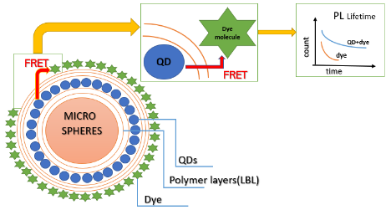
Figure 1. The scheme of complexes of ternary quantum dot(donor) and dye molecule(acceptor) embedded in pores of polymer microspheres in FRET-experiment.
References
1. Girma, W. M., Fahmi, M. Z., Permadi, A., Abate, M. A., & Chang, J.-Y. Journal of Materials Chemistry B, 5(31), 6193–6216, 2017.
Biography:
Viktoriia Osipova is a second-year master student of ITMO University in Saint -Petersburg, her major is “Physics and technology of nanostructures”.

Presenting author details:


Full Name: Viktoriia Osipova Alexandrovna
Contact number: +79992110955
Email Id: iamovaou@yandex.ru
Category: E-poster

