Porous carbon materials for electrochemical capacitive deionization
Chi-Chang Hu*, Chi-Feng Hsieh, Yi-Jing Chen, Chun-Chia Hsu, Ching-Fang Liu
Department of Chemical Engineering, National Tsing Hua University, Hsin-Chu, Taiwan
Abstract:
In this lecture, the most efficient working cell voltage of a capacitive deionization (CDI) system can be precisely determined by a newly designed cell voltage-programming method when the maximum working potential windows of both positive and negative electrodes have been correctly determined. For conducting the cell voltage-programming method, the CDI cell was initially set under the open-circuit state to measure the initial conductivity. Then, 100 mV increase in the cell voltage is applied to the cell for 3-6 min with the conductivity measurement. The cell voltage is repeatedly increased to obtain the ion-removal capacity against cell voltage curve. Also, a novel strategy for both positive and negative electrodes in a CDI cell, consisting of (1) selecting the charge/discharge time ratio close to 1, (2) finding the potential windows, and (3) using the charge-balanced method for determining the optimal mass ratio (denoted as (m+)/(m-)), is proposed to find the optimal cell voltage of a capacitive deionization (CDI) system with a high desalination efficiency and low energy consumption. Finally, a type of nitrogen-doped activated carbons (NACs) is prepared by a combination of acid pre-treatment and thermal nitrogen doping for the positive electrode of asymmetric capacitive deionization (a-CDI) cells. The oxygen content in activated carbon (AC) controlled by the acid pre-treatment significantly affects the doping amount of N atoms from melamine, which enhances the surface negative charge in NACs to promote the salt adsorption capacity (SAC). The NAC with 30% HNO₃ pre-treatment (NAC30) possesses a highly negatively charged surface to exhibit a fast ion desorption rate during discharging. The NAC30 shows the maximum SAC of 24.7 mg/g in the NAC30//AC asymmetrical assembly.
Biography:
Chi-Chang Hu received his BS and Ph.D. in chemical engineering from National Cheng Kung University in 1991 and 1995, respectively. He joined National Tsing Hua University in 2007 and is presently working as university chair professor at Department of Chemical Engineering, National Tsing Hua University. He has published more than 280 SCI publications with total number of citations more than 15,200 and h-index = 66 in June 2020. He has been awarded several prizes (e.g., Thomson Scientific Citation Laureate Award, ISE Tajima Prize, SCEJ Award for Outstanding Asian Researcher and Engineer, and Outstanding Scholar, National Science Council, Taiwan, etc.). His current research projects include design and tailoring of functional materials (including electroplated Cu nanotwined foil) for the applications of supercapacitors, rechargeable metal-air batteries, Li batteries, electrochemical deionization of brackish water, electrochemical sensors, and electro-photocatalytic degradation of dye waste water.
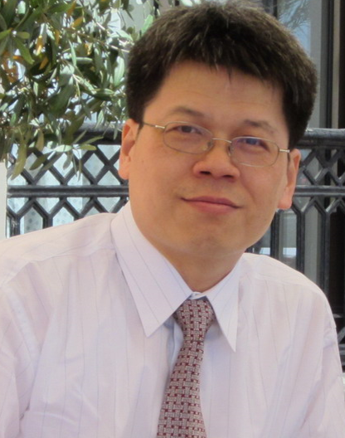
Presenting author details:
Full Name: Chi-Chang Hu
Contact number: +886-3-5736027
Email Id: cchu@che.nthu.edu.tw
Category: Keynote

