Temperature Fluctuation of Porous Asphalt Pavement Designs
Ching-Che Yang and Yu-Min Wang*
Department of Civil Engineering, National Pingtung University of Science and Technology, Pingtung, Taiwan
ABSTRACT
This study explores the extent to which porous asphalt pavement influences pavement temperatures and to study the characteristics of various pavement design, and also to understand the temperature fluctuation or distribution within the pavement cross section.
Three different AC pavement designs: Traditional pavement (section 1), permeable pavement (section 2), semi-permeable (section 3) in the National Pingtung University of Science and Technology (NPUST) Expressway were implemented. The temperature measurements were completed with interval from 6:00 to 24:00 once in every 1-hour and was conducted during the season. Moreover, the measurements was taken at various depths of 25, 40 and 60 cm.
It is found that there are some factors influenced temperature fluctuation such as thickness, air temperature, solar radiation, material reflectance, and wind. The temperature fluctuation with different depths in the section 1, 2 and 3 are followed closely behind the air temperature variations. Subsequently, based on the results, it is shown that the fluctuation at 20 cm depth of pavement is higher than that of 45 cm depth, while at 60 cm depth the variation is relatively stable.

INTRODUCTION
Porous pavements are gaining popularity in the paving industry because of their attractive storm water mitigation and friction properties (Stempihar et al., 2012). According to Golden (2004) from 29% to 45% of the urban surface area is covered with pavements, and this proportion is expected to increase. Wang and Wang (2011) stated that porous pavement is usually designed to handle the 24-h rainfall amount of a 2-year storm. Moreover, porous paving can be used as an alternative to conventional paving and hardstand surfaces within urban developments to reduce stormwater runoff velocity and volume. A number of porous paving types are available including Porous Asphalt or Concrete, Modular Pavers, and Grid or Lattice Systems. Porous pavement designs with have different material can influenced by temperature because Asphalt pavements tend to absorb solar energy and accumulate heat, which results in several negative effects. Thus, Pavement temperature is an important consideration in pavement analysis and design
Temperature is known to be one of the most important factors affecting pavement permanent deformation (Li et al., 2017). At low temperatures, asphalts stiffen and the cracking of asphalt layers is accelerated due to shrinkage. At high temperatures, asphalts soften and the distortion of asphalt layers is increased due to bleeding of asphalt (Ramadhan and Abdul Wahhab, 1997). Pavement temperature periodically changes with the influence of solar radiation and reflectance, air temperature, and wind also significantly impacted by the properties of pavement materials. Therefore, temperature change of different pavements varies vastly even in the same environmental conditions (Hu et al., 2017).
Solar radiation causes an increase in the temperature of asphalt pavements, which consist of asphalt binder and mineral aggregates – both of which have relatively low conductivities. The analysis results by Chen et al. (2016) showed that using low conductivity asphalt mixture in the surface course and high conductivity asphalt mixture in the deeper layer decreased rutting effectively at high temperature and moderate temperature, but increased rutting slightly at low temperature. Using low conductivity asphalt mixture in the pavement, especially in the upper layers could effectively improve the resistance to fatigue cracking at high temperature and moderate temperature, but slightly decrease the fatigue cracking resistance at low temperature.
Research result by Coseo and Larissa (2015) showed in locations where high vertical walls constrained the release of solar radiation, reflective pavements increased air temperatures. In two neighborhoods, reflective concrete increased daytime 3-meter air temperatures by 0.9°C and 0.5°C respectively and had no influence on nighttime temperatures. Unlike reflective pavement, porous pavements permit percolation and may contribute to cooling through evaporation. However, our research illustrated that porous asphalt and porous concrete increased maximum daytime air temperatures by 0.8° C and 0.5° C and did not lower nighttime air temperatures. While porous concrete pavers had significantly warmer midday air temperatures, it was the only cool pavement strategy to yield lower early evening air temperatures relative to conventional asphalt. Even immediately after rain events, the air temperatures above the porous pavements were not significantly cooler. The research result by Kevern, Liv, and Vernon (2012) showed that less energy was stored during heating in the pervious concrete system than the traditional concrete system. This was using similar cementitious mixtures for both pavements (similar cement colors) and where, based on previous research, the pervious concrete surface would have a lower solar reflectance and hence a higher surface temperature under similar solar radiation conditions. It was supported by Haselbach et al (2011) researched that even though pervious concrete may have a much lower Solar Reflactance Index (SRI) than traditional concrete made with similar materials, it can be considered a cool pavement option.
Commonly the use of pavement materials in urban areas, such as cement concrete and asphalt mixtures, have relatively higher solar energy absorption and also possess a higher heat storage capacity that allows them to retain massive heat in daytime and release the heat back into the atmosphere at night (Zhou et al., 2013). Research Kevern, Vernon, and Kejin (2009) showed that the pervious concrete experienced a more rapid rate of heating and cooling than did the traditional concrete and also the daily low temperatures of the pervious concrete were always equal to or cooler than those of the traditional concrete. Kevern, Liv and Vernon (2012) added that the pervious concrete is seen to have higher mid-pavement temperatures at midday than does traditional concrete, but both locations have similar temperatures during the night/early morning. Wu et al. (2018) also stated that during nighttime, compared to concrete pavements the pavements made with asphalt mixtures would emit more heat to the surroundings as a thermal source and elevate the ambient temperature.
Pavement surfaces dissipate heat through convection because of wind movement. Wu et al (2018) stated that windy conditions, the pavements paved with open-graded mixtures manifest remarkable benefits in alleviating the thermal impacts on the environment compared to conventional dense-graded pavements, because the wind could accelerate the thermal exchange between their porous surfaces and the above air, and thus reducing the temperature of the pavements. Moreover, during nighttime, the temperatures in the open graded pavement could also be declined rapidly with the enhanced convections on its porous surface and present lower temperature than that of the atmosphere, consequently improving the cooling effectiveness of the pavement on the surrounding environment (Wu et al., 2017). To examine wind’s influence on air and surface temperatures, Morris, Simmonds and Plummer (2001) measured wind speed, cloud cover, and the UHI intensity in Melbourne from 1971 to 1991. These researchers then divided wind speeds into six categories (0-0.6 m/s, 0.6-1.9 m/s, 2-2.9 m/s, 3-3.9 m/s, 4-4.9 m/s, 5.0 m/s). They concluded that elevated air temperatures were most correlated with light winds (0-0.6 m/s) and clear conditions. Under the lowest wind speeds (0-0.6 m/s) they concluded that the 20-year average of the summer UHI intensity in Melbourne was 1.74° C. They also found that wind speeds over 2.0 m/s produced a statistically significant reduction in Melbourne’s UHI.
It is apparent that pavement temperature is an extremely important factor in pavement analysis and design. Thus, this study explores the extent to which porous asphalt pavement influences pavement temperatures and to study the characteristics of various pavement design, and also to know the temperature fluctuation or distribution within the pavement cross section.
Description Material and Site
Site Location Description
The study area is located in the NPUST Expressway approximately 10 km south of Pingtung City and 5,4 km from The National Highway toward to NPUST campus. In this study, to measure pavement temperature is located 0,3 km test section along the NPUST Expressway as shown in Figure 1.
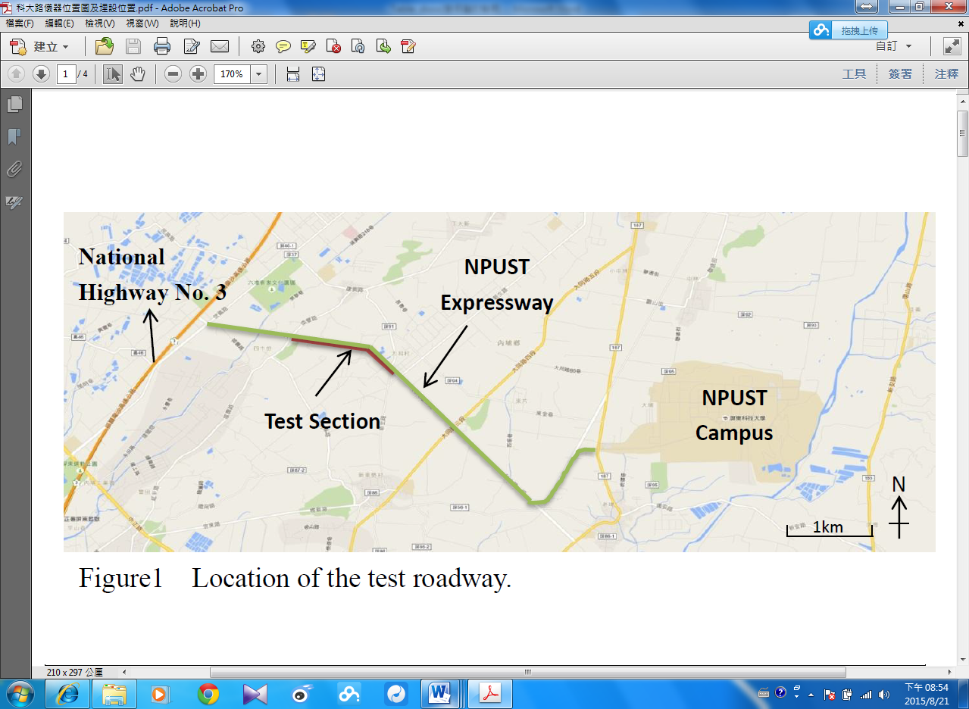
Figure 1. The Location of the Test Section in NPUST Expressway
Field Measurment
The NPUST Expressway was designed with three types of pavement materials namely traditional pavement (section 1), permeable pavement (section 2), semi-permeable (section 3). These three pavement materials were selected to record the temperature fluctuation. The temperature measurements of this study were completed with interval from 6:00 to 24:00 once in every 1-hour and was conducted during the summer season. Moreover, the temperature measurements was taken at various depth (25, 40 and 60 cm). All the climatic, environmental condition and time, for each of these three pavement materials were similar, and the only factor that played a crucial role in temperature differences is the pavement material as shown in Table 2.

Tabel 1. Material Pavement Structures
Thicknes (cm) | Section 1  (Traditional Pavement) | Section 2  (Permeable Pavement) | Section 3  (Semi-Permeable Pavement)
0,1 | Drainage Modified Asphalt Concrete | Drainage Modified Asphalt Concrete | Drainage Modified Asphalt Concrete
0,1 | Dense Gradation Asphalt Concrete Surface (Modification = types) | Drainage Modified Asphalt Concrete | Dense Gradation Asphalt Concrete Surface (Modification = types)
0,5 | Gravel Grading | Permeable Concreate Floor | Gravel Granding
0,5 | Gravel Grading | Permeable Concreate Floor | Stiffening Material (Triangle) Spacing of Ribs = 40 cm
0,2 | Gravel Garding | Filter layer (No4. Sieve : Simple Particle Size) | Gravel Granding  (0,4 M)
0,2 |  | Geotextile t=0.74 mm | Geotextile t=0,74 mm

Result and Discussion
One goal of this study is to compare temperature fluctuation for traditional pavement, permeable pavement and semi permeable pavement with different depths 20 cm, 45 cm and 60 cm. There are some factors influenced to the temperature fluctuation as thickness, air temperature, solar radiation and reflectance, and wind. The temperature fluctuation with different depths are shown in Figure 2,3 and 4 for the same time period. The changes temperature in the section 1, 2 and 3 are followed closely behind the air temperature variations. Subsequently, based on figures 2, 3, and 4, it shown the graph with 20 cm depth of pavement are most fluctuation temperature than 45 cm depth, while at 60 cm depth the graph is relatively stable.
Figure 2. Temperature Fluctuation at 20 cm Depth
Its affected by the thickness and types of pavement as a factors in temperature fluctuation. Stempihar et al (2013) stated that the surface of the curb temperature is asymptotic and the thickness of the pavement plays a reduced role in pavement temperatures. Stempihar (2012) also stated that surface temperatures generally decreased as pavement thickness increased. This trend appears reasonable given the additional material to conduct heat. As a consequence, the maximum surface temperature of a thicker pavement decreases during the day but may cause an undesired increase in the minimum temperature at night.
Generally, temperature in section 1, 2 and 3 higher than air temperature although nowhere near as warm as that of all sections (Fig. 3 and 4). But we found a little different in Fig 2 that section 1 and 2 have the same temperature at night time (16.00 until 22.00) and in section 2 also showed higher temperature than section 1 at night time (16.00 until 22.00). This result was supported by Kevern, Vernon, and Kejin (2009) stated that a comparison of the two pavements other than during winter indicates that although the pervious concrete becomes hotter than the surrounding air temperature during the daytime, much less heat is transferred and stored in the underlying soil than in the traditional pavement. Even though the pervious concrete became warmer than the traditional PCC, at night the pervious concrete was equal to or cooler than the PCC pavement. This finding indicates less heat storage potential and a greater rate of cooling in the pervious concrete versus the traditional system (Kevern, Vernon and Kejin, 2009). The different material also affect in temperature fluctuation. Stempihar et al (2011) stated the type of material and properties of the pavement structure had a greater impact on the minimum nighttime temperatures.

Figure 3. Temperature Fluctuation at 45 cm Depths
In this case section 1 every depths shown high temperature at nigh time, it can assume caused by solar radiation and reflectance are the main factors to promote pavement surface becomes warm. This research was supported by Hu et al (2017) shown that at night, because of solar radiation disappearing, the reflected short-wave solar radiation values of several concrete types are all zero. Therefore, the surface temperature of PCC specimens is higher than those of five kinds of PPCC gradually. And the change trends of the convective heat and long-wave net radiation of several concrete types are contrary to those in the daytime. That is, the convective heat and long-wave net radiation of five kinds of PPCC are lower than those of PCC. And the coarser aggregate particles size of PPCC is, the larger corresponding convective heat and long-wave net radiation are.
Figure 4. Temperature Fluctuation at 60 cm Depths
CONCLUSION
Temperature fluctuation of pavement affected by many factors, such as air temperature, thickness, solar radiation and reflectance, and wind. In the other hand, different material will affect heat on pavement surface temperature.

REFERENCE
Chen, J., Hao, W., Maoyun,L., Liang, L. 2016. Evaluation of pavement responses and performance with thermal modified asphalt mixture. Materials and Design 111 : 88–97
Coseo, P., and Larissa, L. 2015. Cooling the Heat Island in Compact Urban Environments: The effectiveness of Chicago’s Green Alley Program. Procedia Engineering 118:691 – 710
Golden, J.S. 2004. The built environment induced urban heat island effect in rapidly urbanizing arid regions—a sustainable urban engineering complexity. Environ. Sci. J. Integr. Environ. Res. 1 (4) : 321–349
Haselbach, L., Michelle, B., John, T.K. and Vernon, R.S. 2011. Cyclic Heat Island Impacts on Traditional Versus Pervious Concrete Pavement Systems. Transportation Research Record: Journal of the Transportation Research Board. 2240 : 107 – 115.
Hu, L., Yangyang, L., Xiaolong, Z., Shaowen, D. Zhuangzhuang, L., and Hao, H. 2017. Temperature Characteristics of Porous Portland Cement Concrete during the Hot Summer Session. Advances in Materials Science and Engineering. https://doi.org/10.1155/2017/2058034
Kevern, J. T., Vernon, R. S., and Kejin, W. 2009. Temperature Behavior of Pervious Concrete Systems. Journal of the Transportation Research Board. 2098 : 94 – 101
Kevern, J., Liv, H., Vernon, R.S. 2012. Hot Weather Comparative Heat Balances in Pervious Concrete and Impervious Concrete Pavement Systems. Journal of Heat Island Institute International Vol.7-2.
Yi Li, Liping, L., Feipeng X., Lijun, S. 2017. Effective temperature for predicting permanent deformation of asphalt pavement. Construction and Building Materials 156 : 871–879
Morris, C. J. G. Simmond, I., and Plummer, N. 2001. Quantification of the Influences of Wind and Cloud on the Nocturnal Urban Heat Island of a Large City. JOURNAL OF APPLIED METEOROLOGY.https://doi.org/10.1175/15200450(2001)040<0169:QOTIOW>2.0.CO;2
Stempihar, J. J. Tina, P.M., Kamil, E.K., and Rodezno, M.C. 2011. Porous Asphalt Pavement Temperature Effects on Overall Urban Heat Island. Submitted for Presentation and Publication at the 2012 Annual Meeting of the Transportation Research Board.
Stempihar, J.J. Tina, P.M., Kamil, E.K.,and Maria, C.R. 2012. Porous Asphalt Pavement Temperature Effects for Urban Heat Island Analysis. Journal of the Transportation Research Board,2293 : 123–130.
Wu, H., Beibei, S., Zhe, L., Jia, Yu. 2018. Characterizing thermal behaviors of various pavement materials and their thermal impacts on ambient environment. Journal of Cleaner Production 172 : 1358-1367

