Infrared plasmonics on oxide semiconductors
Hiroaki Matsui, The University of Tokyo, Japan
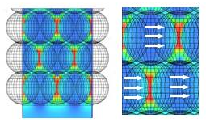
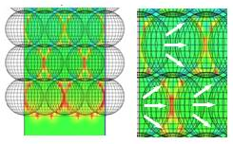
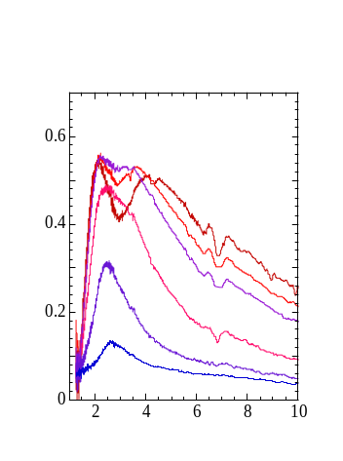

Reflectance
Wavelength (μm)
Peak- II
Peak- I
(a)
Peak-I: Near-IR
Peak-II: mid-IR
(b) E-fields and charge vectors

Abstract
Doped oxide semiconductors have received much attention for emerging surface plasmons infrared (IR) region. Recently, wide-gap oxide semiconductors (ZnO and In₂O₃) have been launched as new plasmonic materials. We focus on plasmonic responses of doped oxide semiconductors with a view to providing valuable strategies for the development of new optical functionalization related to energy-saving technology that plays an important role in realizing smart society. In this study, we investigate plasmonic properties at nanoparticle interfaces on oxide semiconductor nanoparticles (Sn-doped In₂O₃: ITO NPs) for solar thermal-shielding for transparent window applications. In particular, assembled sheets of ITO NPs showed high resonant reflections in the infrared range, relating to electric-field (E-field) interactions in nano-gap space between NPs. Both experimental and theoretical approaches were employed in an eﬀort to understand the plasmonic properties of the NP sheets. This work provides an important principle to design high-efficient thermal-shielding activity.
ITO NPs were fabricated by a thermo-chemical technique based on metal-organic decomposition. The surfaces of NPs were terminated by organic molecules of fatty acids, which could be facilitated the production of E-field interactions between the NPs due to the creation of narrow crevices in the particle interfaces. The E-field coupling along the in-plane and out-of-plane directions in the assembled NP sheets allowed for resonant splitting of plasmon excitations based on dipole modes, leading to selective high reflectance in the near- and mid-IR range, respectively [Figure 1]. That is, the interparticle gaps and their derived from plasmon coupling played an important role for high reflective performance. In addition, the assembled NP sheets could be extended to produce large-size flexible films, which also possessed microwave transmissions essential for telecommunications. This study showed new insight for harnessing IR optical responses on plasmonic technology for solar thermal-shielding applications based on oxide materials.


Image

Figure1. (a) Plasmonic-resonant reflectance in the infrared range in ITO NP sheets with different sheet thicknesses from 22 to 216 nm. An inset picture indicates a cross-section SEM image of the NP sheet. (b) E-field and charge-vector distributions at nanoparticle interfaces in the NP sheet that were simulated using a three-dimensional FDTD method.
Recent Publications
- Matsui H, Hasebe T, Hasuike, N, Tabata H (2018) Plasmonic heat-shielding in the infrared range based on oxide semiconductor nanoparticles of Sn-doped In₂O₃: The effect of particle size and interparticle gap. ACS Appl. Nano Mater. 1:1853-1862.
- Matsui H, Furuta S, Hasebe T, Tabata H (2016) Roles of plasmonic interactions at particle interfaces in the infrared range based on transparent oxide semiconductors. ACS Appl. Mater. & Inter. 8:11749-11756.
- Matsui H, Ho, Y L, Kanki T, Tanaka, H, Delaunay J J, Tabata H (2015) Mid-infrared plasmonic resonances in two-dimensional VO₂ nanosquare arrays. Adv. Opt. Mater. 3:1759-1768.
- Matsui H, Badalawa W, Hasebe T, Furuta S, Nomura W, Yatsui T, Ohtsu M, Tabata H (2014) Coupling of Er light emissions to plasmon modes on In₂O₃: Sn nanoparticle sheets. Appl. Phys. Lett.105: 041903(1)-041903(5).
5. Matsui H, Furuta S, Tabata H (2014) Roles of electron carriers on local surface plasmons in doped oxide semiconductor nanocrystals. Appl. Phys. Lett. 104:211903(1)-211903(4).



Dr. H. Matsui completed his doctorate (Ph. D) in material science at Saga University in 2001. From 1998 to 2001, he also belonged to Advanced Institute of Science and Technology (AIST). From 1999 to 2001, he was a Research Fellow of the Japan Society for the Promotion of Science. In 2001, he was a post-doctoral research fellow, and in 2005, he became projected research associate at ISIR-Sanken in Osaka University. From 2005 to 2008, he joined the Organization for the Promotion of Research on Nano-science and Nanotechnology at Osaka University. In 2008, he moved as specially appointed research associate at University of Tokyo. In 2011, he has been assistant Professor at the University of Tokyo. In 2017, he was promoted to associate Professor at the University of Tokyo.

Email: hiroaki@ee.t.u-tokyo.ac.jp

