Anisotropic crystal growth, optical absorption, and ground state en- ergy level of CdSe quantum dots adsorbed on the (001) and (102) surfaces of anatase-TiO₂
Taro Toyoda,¹ Qing Shen,¹ Keita Kamiyama,² Hisayoshi Kobayashi,³ Yasushi Hirose,⁴ Shuzi Hayase⁵
¹The University of Electro-Communications, Tokyo, Japan; ² Bunkoukeiki Co., Ltd., Tokyo, Japan
³Kyoto Institute of Technology, Kyoto, Japan; ⁴The University of Tokyo, Tokyo, Japan
⁵Kyushu Institute of Technology, Fukuoka, Japan

Owing to the size-dependent quantum confinement effect, semiconductor quantum dots (QDs) have a tunable energy gap and higher extinction coefficients, indicating the possibility of using them as promising sensitizers for sensitized solar cells. Although QDs have such promising properties, the photovoltaic conversion efficiencies of QD-sensitized solar cells (QDSCs) are still lower than those of dye-sensitized solar cells. Usually, TiO₂ nanoparticulate electrodes play a key role in applications to QDSCs, because of a large surface area with a large amount of QD adsorption for light harvesting. In that case, heterogeneity can be appeared which disturb a detailed understanding of the fundamental factors of QDs adsorbed on TiO₂ nanoparticulate electrodes.
The present study focuses on the effect of TiO₂ surfaces with different crystal orientations on optical absorption and ground state energy level in systems comprising CdSe QDs adsorbed on (001) and (102) surfaces of anatase-TiO₂ (A-TiO₂) to get the information for QDSCs. We applied photoacoustic (PA) spectroscopy based on photothermal phenomenon to characterize the optical absorption, not only in the bandgap absorption but in the sub bandgap region. Photoelectron yield (PY) spectroscopy is useful for determining the absolute ground state energy level of QDs. Adsorption time dependence of optical absorption shows that (1) the adsorption rate of CdSe QDs on A-TiO₂(001) is higher than that of A-TiO₂(102) in agreement with our DFT calculations ((001) >> (100 ) > (102)), and (2) the diameter increasing rate of CdSe QDs on A-TiO₂(102) is higher than on A-TiO₂(001), indicating the anisotropic crystal growth. The ground state energy levels of CdSe QDs on A-TiO₂(102) are lower than those on A-TiO₂(001), suggesting the impossibility of the sensitization from the excited state of CdSe QDs to the conduction band of A-TiO₂(102). Lower value of the ground state energy level of CdSe QDs on A-TiO₂(102) (negative polarization) is possibly due to the difference of the permittivity of A-TiO₂(001) and A-TiO₂(102).
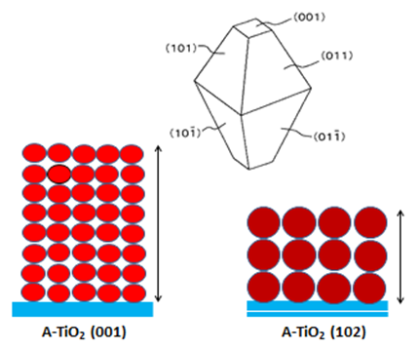

Figure 1: Schematic illustration of the crystal growth of CdSe QDs
on A-TiO₂(001) and A-TiO₂(102) after at adsorption time of 72 h.

Recent Publications
- Toyoda T et al. (2018) Crystal growth, exponential optical absorption, and ground state energy level of PbS quantum dots adsorbed on the (001), (110), and (111) surfaces of rutile-TiO₂ (invited paper). J. Phys. Chem. C DOI: 10.1021/acs.jpcc.7b12675.
- Toyoda T et al. (2017) Dependences of the optical absorption, ground state energy level, and intgerfacial electron transfer dynamics on the size od CdSe quantum dots adsorbed on the (001), (110), and (111) surfaces of single crystal rutile TiO₂. J. Phys. Chem. C 121: 25930-25401.
- Toyoda T et al. (2016) The electronic structure and photoinduced electron transfer rate of CdSe quantum dots on single crystal rutile TiO₂: Dependence on the crystal orientation of the substrate. J. Phys. Chem. C 120: 2047-2057.
- Toyoda T et al. (2016) Adsorption and electronic structure of CdSe quantum dots on single crystal ZnO: A basic study of quantum dot-sensitization system. J. Phys. Chem. C 120: 16367-16376.
5. Toyoda T et al. (2015) Electronic structures of two types of TiO₂ electrodes: inverse opal and nanoparticulate cases. RSC Adv. 5: 49623-49632.



Biography
Taro Toyoda has completed his D.Sc. from Tokyo Metropolitan University and Assistant Research Officer at National Research Council of Canada. After working at Fuji Electric Company and Nippon Mining Company, he was appointed as a Professor at The University of Electro-Communications. His research focuses on basic studies of optical properties in semiconductor quantum dots including photoexcited carrier dynamics and their applications to photovoltaic quantum dot solar cells. He has published more than 200 papers in reputed journals.
Email: toyoda@pc.uec.ac.jp

Notes/Comment

