A study on correlation between corrosion resistance and flexibility in Copper plating.
Hogun Kim, PhD course, Sungkyunkwan University, Korea

Abstract (300 word limit)

Many authors have focused on the development of electroplating conditions in order to improve flexibility of copper foil. There is a lack of research that is correlation between corrosion resistance and flexibility in copper plating. The goal of the present paper is to electrochemically and mechanically evaluate the effect of correlation between corrosion resistance and flexibility in copper plating This study provides the reliable and quantitative data by electrochemical and mechanical measurement after the production of copper foil. The degree of corrosion resistance was varied by varying the rust-preventive solution concentration after plating. In order to evaluate the effect of correlation between corrosion resistance and flexibility in appropriate way it is necessary to measure the delamination area and volume fraction of water uptake by electrochemical evaluation according to the degree of corrosion resistance such as Electrochemical impedance spectroscopy (EIS) test with anti-corrosion properties carried out 3.5wt.% NaCl which is the simulated general corrosive environment. Also, the flexibility of Cu plating was evaluated through repetitive bending test (MIT) to evaluate the mechanical performance. In conclusion, electrochemical measurement (EIS), mechanical measurement (Bending test) and surface analysis (SEM, FIB) showed that copper plating with the higher corrosion resistance could obtain the higher flexibility owing to superior anti-corrosion properties.
Image

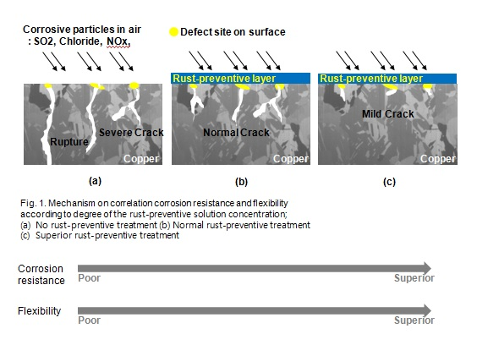

 Biography (150 word limit)
Hogun Kim. I am majored in electrochemistry, and experienced knowhow with various electrochemical tests (Cyclic voltammetry, Galvanostatic test, Potetiodynamic test, EIS and so on). Also, I have understanding manufacture and evaluation of Cu foil by electroplating according to additive types (brightener, suppressor and leveler) and analysis and some synthesis process about additive. I hope to collaborate internationally co-work on electrochemical and copper plating with additives. Please feel free to contact me if you want to study copper plating additives with me.

Email: hoguns@skku.edu

Notes/Comments:

