Plant oil-based aqueous dispersions and smart composites with enhanced benefits

Samy A. Madbouly
School of Engineering, Behrend College, Pennsylvania State University, Erie, PA 16563, USA

Keywords: Plant oils, Multifunctional polymers, Aqueous dispersions, Rheology, Morphology

- Abstract

Replacing petroleum-based polymers by alternative renewable, chemically modified, and cost-effective natural products will have a significant positive impact on the environment and the sustainable polymer industry. Plant oils are widely used as renewable nature materials to obtain new green low-molecular weight monomers suitable for synthesis of sustainable multifunctional polymers and composites with outstanding mechanical, thermal, and dielectric properties. These plant oil-based polymers and composites have similar performance to the petrochemical counterparts. Plant oils and lignin were chemical functionalized to synthesis aqueous- polyurethane dispersion with nanoscale morphology and excellent dispersion stability. The chemically modified plant oils were also utilized to fabricate bio-based norbornenyl-functionalized monomers suitable for ring-opening metathesis polymerization (ROMP) to create novel high temperature plant oil-based thermosets. The aqueous dispersions, polymer films, composites and thermosets were characterized using wide range of analytical techniques, such as, small amplitude rheometer, TEM, DSC, TGA, DMA, etc. This work is a part of global efforts to develop innovative technologies to transform these natural resources into novel monomers and polymers. Some of these technologies have already generated competitive industrial products with comparable properties to conventional petrochemical polymers.

Image:

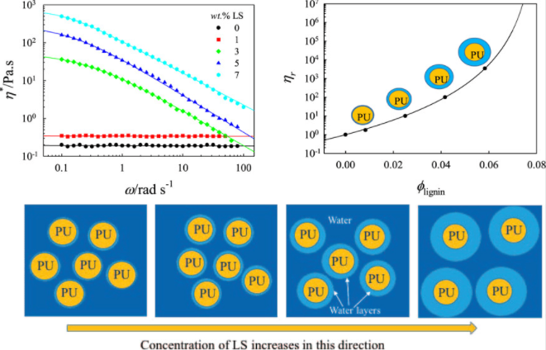
References:

- Madbouly, S.A., 2021. Waterborne polyurethane dispersions and thin films: biodegradation and antimicrobial behaviors. Molecules, 26(4), p.961.

- Madbouly, S.A., 2020. Nano/micro-scale morphologies of semi-interpenetrating poly (ε− caprolactone)/tung oil polymer networks: Isothermal and non− isothermal crystallization kinetics. Polymer Testing, 89, p.106586.

- Madbouly, S.A. and Kessler, M.R., 2020. Preparation of nanoscale semi-IPNs with an interconnected microporous structure via cationic polymerization of bio-based tung oil in a homogeneous solution of poly (ε-caprolactone). ACS omega, 5(17), pp.9977-9984.

Biography:
Dr. Madbouly received his Ph.D. from the Department of Organic and Polymeric Materials, Tokyo Institute of Technology, Japan. He has been awarded the Alexander von Humboldt postdoctoral Fellowship and the Japan Society for Promotion of Science Postdoctoral Fellowship. He served as a senior research scientist University of Southern Mississippi and at the Institute of Polymer Research, GKSS, Germany. He also worked as Research Assistant Professor at Iowa State University and Senor Polymer Engineer at Schlumberger. He published over 110 peer-reviewed journal papers, 8 patents, two book, 21 book chapters, and presented more than 100 talks at national and international meetings and serves as a frequent reviewer and referee.

Presenting author details

Full Name: Samy A. Madbouly
Contact number: +1-814-898-7169
Linked In account: www.linkedin.com/in/samy-madbouly-b85439167/
Session name/ number:
Category: Keynote Speaker
==Passport Number

