The Nobel prized nitric oxide molecule as a noble treatment for nCOVID
Jan Mohammad Mir
Department of Chemistry, Islamic University of Science and Technology, Awantipora- J and K, India-192122
email: mirjanmohammad@gmail.com

A B S T R A C T
In the prevailing coronavirus disease-2019 (COVID) times, scientists are eager to develop vaccine against COVID-19, and careful measures are being taken to develop an effective drug. Meanwhile, several antiviral compounds have been repurposed for the COVID-19 treatment, and drug repurposing has yielded satisfactory results. In the meantime, NO is also under clinical trials to find its potentiality as anticoronavirus. This work aims to describe the therapeutic potential of nitric oxide (NO) for the treatment of deadly (COVID-19). The significance of NO in mitigating the COVID-19 associated symptomatic complications has also been addressed in this work. So, the profound antiviral effects of NO against coronavirus, and also the role it plays in relieving symptomatic severity of COVID-19 are supportive of the fact to declare NO as a therapeutic option for this disease.
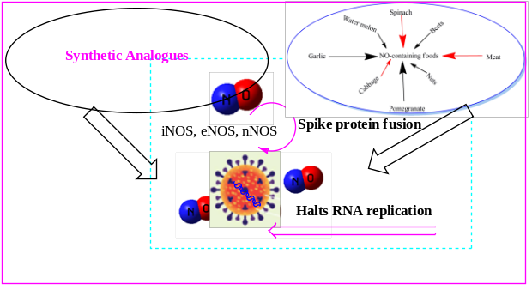
Keyword: corona; COVID-19; NO; oxidation stress; nitrites; nitrates
References
- Mir, J.M., Khan, M.W., Shalla, A.H. and Maurya, R.C., 2021. A Nonclinical Spectroscopic Approach for Diagnosing Covid-19: A Concise Perspective. Journal of Applied Spectroscopy, pp.1-7.
- Mir, J.M. and Maurya, R.C., 2021. Nitric oxide as a therapeutic option for COVID-19 treatment: a concise perspective. New Journal of Chemistry, 45(4), pp.1774-1784.
- Mir, J.M. and Maurya, R.C., 2020. Nitric oxide boosters as defensive agents against COVID-19 infection: an opinion. Journal of Biomolecular Structure and Dynamics, pp.1-7.
- ITOO, F.A. and MIR, J.M., 2021. SURFACTANT MATERIAL PROPERTIES AND CORONAVIRUS SURFACE: A SURFACE INTERACTION FOR COVID-19 TREATMENT AND VACCINATION. International Journal of Chemistry Research, pp.1-6.

Bionote
Dr Jan Mohammad Mir is currently working as an Asst. Professor at the Islamic University of Science and technology, Awantipora-J&K. He bagged his Ph.D. from R.D. University, Jabalpur in 2015 and has very recently completed his D.Sc. degree from the same university. His postdoctoral research mainly involves the molecular modeling and medicinal implications of metal based gasotransmitters. Currently, he is seeking the role of NO, CO and H2S in minimizing the COVID-19 associated severity. He has been a good academician and a researcher. As a young researcher his scientific contributions have got more than 550 citations till now (h-index >16). As per the available details, he has published more than sixty research papers of current scientific temper in various reputed journals covering most of the world famous publishers. He has complied more than seven books and several book chapters till now. Dr Mir is currently serving as editor in Chief of Reviews in Pharmacy and Pharmaceutical Sciences (Prime open access), also serves as associate editor of Journal of Transition Metal Complexes (Bendola Publishers). He bagged several researcher awards including Father Science and INSCA Young Scientist Awards.

Presenting author details


Full Name: Contact number: Dr. Jan Mohammad Mir
DrJanMohammadM1
Category: (Oral presentation)

