Abstract Template

Title: Nanocellulose reinforced Thermoplastic Starch (TPS) Nanocomposite

R.A. Ilyas^{1,2}

¹ School of Chemical and Energy Engineering, Faculty of Engineering, Universiti Teknologi Malaysia, 81310 UTM Johor Bahru, Johor, Malaysia
² Centre for Advanced Composite Materials (CACM), Universiti Teknologi Malaysia, UTM Johor Bahru 81310, UTM Johor, Malaysia

Keywords: Nanocellulose, Thermoplastic starch, Nanocomposite, Mechanical, Water barrier

- Abstract
Over the past decade, nanocellulose (NC), cellulose in the form of nanostructures, has been proven to be one of the most prominent green materials of modern times. This renewable nanofiber has been used in wide range of applications from flexible packaging to advanced bio-scaffolds for tissue regeneration. It is due to its outstanding properties such as excellent mechanical properties, high thermal resistance, good optical properties, high aspect ratio with anisotropic shape, good biocompatibility, high crystallinity, large specific surface area, abundant surface hydroxyl groups for modification, and tailorable surface chemistry. Currently, nanocellulose is widely used to reinforce thermoplastic starch (TPS) to improve the mechanical and water barrier properties of TPS. In this presentation, we explain the outline of current development in this particular field, including the isolation, characterization, behavior, and various applications of nanocellulose reinforced starch biopolymer nanocomposites. Besides that, we hope to impart the audience with some of the excitement that currently surrounds nanocellulose research, which ascends from the renewable source nature of the particles, their fascinating, morphological, mechanical, chemical and physical properties, and the a variety of applications that can be developed from these nanomaterials.

- Image:
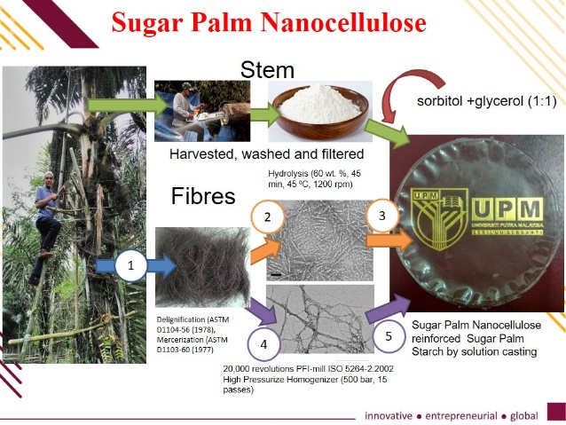

Biography

R.A. Ilyas is a senior lecturer in School of Chemical and Energy Engineering, Faculty of Engineering, Universiti Teknologi Malaysia, Malaysia. He received his Diploma in Forestry at Universiti Putra Malaysia, Bintulu Campus (UPMKB), Sarawak, Malaysia from Mei 2009 to April 2012. In 2012, he was awarded the Public Service Department (JPA) scholarship to pursue his Bachelor’s Degree (BSc) in Chemical Engineering at Universiti Putra Malaysia (UPM). Upon completing his BSc. programme in 2016, he was again awarded the Graduate Research Fellowship (GRF) by the Universiti Putra Malaysia (UPM) to undertake a PhD degree in the field of Biocomposite Technology & Design at Institute of Tropical Forestry and Forest Products (INTROP), UPM. R.A. Ilyas’s research interests include polymer engineering, material engineering, natural fibres, biocomposites and nanocomposites. R.A. Ilyas was the recipient of MVP Doctor of Philosophy Gold Medal Award UPM 2019, for Best PhD Thesis and Top Student Award, INTROP, UPM. In 2018, he was awarded with Outstanding reviewer by Carbohydrate Polymers, Elsevier United Kingdom, Best Paper Award (11th AUN/SEED-Net Regional Conference on Energy Engineering), Best Paper Award (Seminar Enau Kebangsaan 2019, Persatuan Pembangunan dan Industri Enau Malaysia), and National Book Award 2018. R.A. Ilyas also was listed Among World’s Top 2% Scientist (Subject-Wise) Citation Impact during the Single Calendar Year 2019. His main research interests are: (1) Polymer Engineering (Biodegradable Polymers, Biopolymers, Polymer composites, Polymer-gels) and (2) Material Engineering (Natural fibre reinforced polymer composites, Biocomposites, Cellulose materials, Nano-composites). To date he has authored or co-authored more than 238 publications (70 papers published/accepted/submitted in national and international journals, 1 authored books, 11 edited books, 69 chapters in books, 2 research bulletin, 6 Journals Special Issues as Guest Editors and 6 editor/co-editor for conference/seminar proceeding and 61 conference proceedings/seminar papers/presentations.



Full Name: R.A. Ilyas
Researchgate link: https://www.researchgate.net/profile/Ilyas-Ra
Google Scholar link: https://scholar.google.com/citations?user=2fF-FvYAAAAJ&hl=en
Session name/number:
Category: Keynote Speaker
Passport Number: A53373699

