Abstract Template

Title: Potential of Drug molecules as effective corrosion inhibitors

Ashish Kumar,
Department of Chemistry, Faculty of Technology and Science, Lovely Professional University, Phagwara, Punjab, India

Keywords: Corrosion, Metals, Drugs, Inhibitors, Inhibition efficiency, Acidic medium

- Abstract Body (up to 300 words)
Due to the toxicity of widely used corrosion inhibitors and the ever tightening environmental regulations surrounding their use and disposal, there is great interest in replacing harmful inhibitors with effective non-hazardous alternatives. Over the past two decades, extensive research and development have led to the discovery of new classes of corrosion inhibitors, and the importance on the use of several drugs as corrosion inhibitors has grown. The present study investigates the inhibiting effect of several drugs towards the corrosion of different metals in corrosive medium at elevated temperatures. Results of Weight loss method, Potentiodynamic polarization and Electrochemical impedance spectroscopy have been also discussed. The mechanisms governing corrosion inhibition of drugs on various metals have been enlightened by conducting Quantum chemical calculations and molecular dynamic (MD) simulations on the surface of metals. SEM and AFM studies evidenced the formation of a protective film over the metallic surface.

Image:
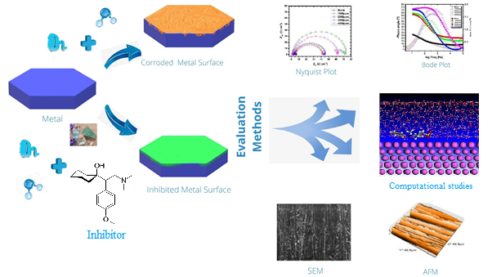
Name: Dr. Ashish Kumar
Linked In account: https://www.linkedin.com/in/dr-ashish-kumar-354265b4/
Seesion name/number: Material Science & Inorganic Chemistry
Category: (Oral presentation/ Poster presentation:
Passport Number:N2514999

Biography:
He is presently heading chemistry department in School of chemical Engineering and Physical sciences. He has been a reviewer of various journals of American chemical society, Elsevier, Springer, Bentham, Taylor and Francis etc and conferences in India and abroad. Published more than 54 research paper in Quality Journals. He has also authored and reviewed diverse chapters in refereed books with Springer nature and Elsevier, Wiley etc. He is editor/Editorial Board member of more than 15 international Journals and keynote speaker and member of technical committee in various international conferences. He also published one book on Engineering chemistry. He also evaluated Ph.D thesis’s from India and Abroad. He himself guided more than 20 (Ph.D / Masters and UG) students. He was recipient of Research Excellence Award from LPU for last FOUR consecutive years.

Presenting author details

