Abstract

Title: Bio-based lubricant Synthesis by Chemical Modification of Linoleic and Oleic Acid Mixture

Sharareh Esmaeili^{1*}, Kambiz Tahvildari², Barat Ghobadian³, Masoud Dehghani Soufi⁴, Tirth Panchal⁵

¹ Young Researchers and Elites Club, North Tehran Branch, Islamic Azad University, Tehran, Iran.
²Professor, Biosystems engineering Department, Tarbiat Modares University (TMU) Tehran, Iran.
³Assistant Professor, Department of Agrotechnology, Abouraihan Campus, University of Tehran, Iran.
⁴Assistant Professor, Organic Chemistry Department, Islamic Azad University, Tehran, Iran.
⁵Advisor, Anand Institute of Studies in Energy Efficiency and Climate Change, Anand, Gujarat, India

Keywords: Biolubricant; Epoxidation; Esterification; Linoleic acid; Oleic acid; IR spectroscopy

- Abstract Body
There are increasing concerns and growing regulations over contamination and environmental pollution. One of the major concerns is pollution caused by mineral oils. As the world oil reserves are dwindling the pressures for ﬁnding alternative replacements are increasing. Vegetable oils are appealing alternatives which are consisted of different fatty acids, but they cannot be applied directly in internal combustion engines because of poor oxidation stability and high pour point value. Biolubricants are a new generation of lubricants which are renewable and biodegradable and are produced from chemical modification of vegetable oils. There are few studies which investigate the feasibility of using mixture of fatty acids as biolubricant feedstock. In this study, epoxidation, oxirane ring opening with palmitic acid and PTSA, esterification reaction with octanol and reaction of the remaining hydroxyl group with stearic acid were applied to modify the oleic and linoleic fatty acids mixture to produce biolubricant.For this purpose, IR spectrums of each epoxide, monoester, diester and triester products were obtained and analyzed. At the end of experiments, monoester with 94% yield, diester with 96% yield, and triester with 98% yield were obtained. Eventually, the physicochemical properties of the final product was comparable with those of the lubricant standard ISO VG10.

Image:
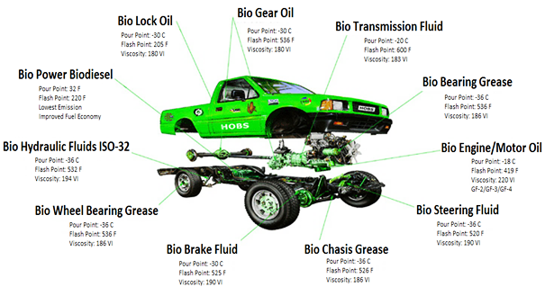
- Reference:

- Zulkifli NW, Kalam MA, Masjuki HH, Shahabuddin M, Yunus R (2013 ) Wear prevention characteristics of a palm oil-based TMP (trimethylolpropane) ester as an engine lubricant. Energy 54:167-73.

- Nihul PG, Mhaske ST, Shertukde VV (2014) Epoxidized rice bran oil (ERBO) as a plasticizer for poly (vinyl chloride)(PVC). Iranian Polymer Journal 23(8):599-608.

- Salimon J, Salih N, Yousif E (2012) Biolubricant basestocks from chemically modified ricinoleic acid. Journal of King Saud University-Science 24(1):11-7

Biography:
Dr. Tirth Panchal has completed his PhD at the age of 26 years from Sardar Patel University and Postdoctoral Studies from Shah-Schulman Center for Surface Science and Nanotechnology, India. He is the Advisor of Anand Institute of Studies in Energy Efficiency and Climate Change, managed by Dr. Jivraj Mehta Institute of Technology. He has published more than 15 articles in reputed journals and books.

Presenting author details


Full Name: Dr. Tirth Panchal
Contact number: +91-9974644374 Twitter account: --
Linked In account: https://www.linkedin.com/in/tirthpanchal/
Session name/ number: Keynote Speaker
Category: (Oral presentation) Keynote Speaker
Passport Number: U0661602

