Crystal growth of Inorganic fluorides and oxide-fluorides for scintillation applications and radiation detection
Gyanendra Ayer, Vladislav Klepov and Hans-Conrad zur Loye
Department of Chemistry and Biochemistry, University of South Carolina, Columbia, South Carolina, 29208

Abstract:
One of the main characteristics of fluorine is its very high electronegativity. This property connected with the low dissociation energy of the molecule and the relatively large bond energies in many fluorine compounds, explains why the chemistry of fluorides differs appreciably from that of other halogens and oxides. The more ionic nature of the fluoride ion and its single negative charge are its prominent difference from the oxides, which allows for obtaining materials with completely new architectures and properties.
Recently, mixed anion oxide-fluorides have emerged as a prospective new class of scintillating materials, which emit light when struck by high energy particles such as X-rays and γ-rays. Scintillators are extensively used in many different fields, including medical imaging, PET, CT scanners, and more recently in homeland security for the prevention of nuclear and radiological terrorism. This presentation will focus on the crystal growth of novel oxide-fluoride materials by the mild hydrothermal synthetic technique for their potential use as X-ray scintillators and luminescent materials.¹

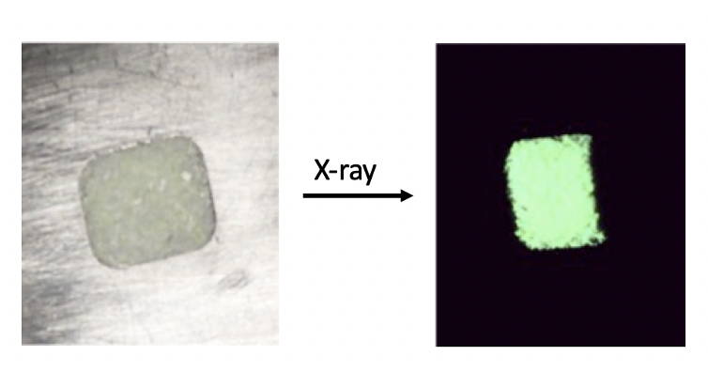
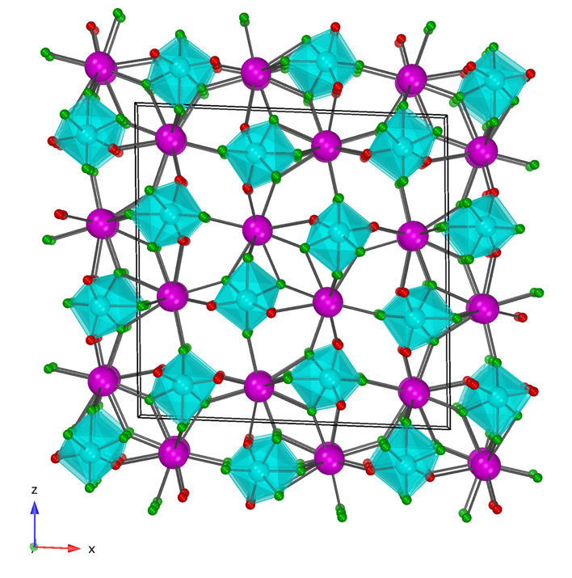

References:
1. Ayer, G. B. et al. Dalton Trans. 2020, 49, 10734–10739
Biography
Name: Gyanendra Bahadur Ayer
Contact number: +18032697778
Linked In account: https://www.linkedin.com/in/gyanendra-ayer-68ba19171/
Category: Oral presentation
Passport Number: 08641242

