Mesoporous Metal Sulfide And Metal Selenide Thin Films

Turker, Y.^{1,2}; Dag, O.¹
¹ Department of Chemistry, Science Faculty, Bilkent University, Ankara, Turkey
² Sabanci Univ. Nanotechnology Research and Application Center, İstanbul, Turkey

Keywords: Mesoporous CdS, Mesoporous CdSe, Liquid Crystal Templating, Evaporation Induced Self-Assembly, Mesoporous Titania, Mesoporous Silica

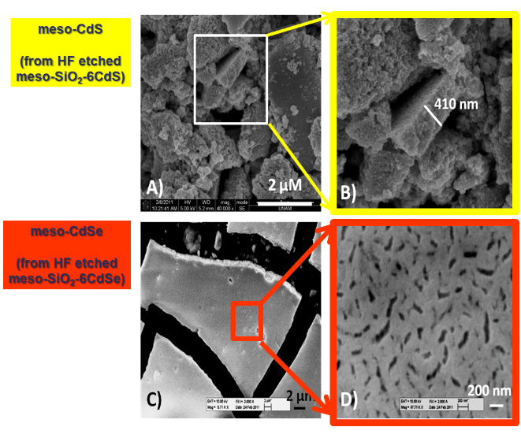
Synthesis of the mesoporous CdS and CdSe by using of liquid crystalline templating (LCT) approach has been investigated. The thermal and structural behavior of the [Cd(H2O)4](NO3)2/surfactant (P85 = ((PEO)26(PPO)40(PEO)26)) binary lyotropic liquid crystalline (LLC) systems have been investigated towards synthesis of the mesoporous cadmium sulfide, CdS, or cadmium selenide (CdSe) directly from the mesostructured CdS (or CdSe) thin films. Moreover, a polymerizing agent, such as titania or silica precursors have been added to salt/surfactant LLC mesophase. Both titania and silica overcame collapse of the mesophase by rigidifying the structure into mesostructured solid and also by providing stability for a thermal removal of nitrates from the media.

References:
- Türker, Y. and Dag, Ö. Journal of Materials Chemistry 2008, 18, (29), 3467.
- Okur, H. I.; Türker, Y.; Dag, Ö. Langmuir 2010, 26, 538.
- Karakaya, C.; Türker, Y.; Albayrak, C. and Dag, Ö. Chemistry of Materials 2011, 23, (12), 3062-3071.
- Türker, Y.; Karakaya, C. and Dag, Ö. Chemistry A European Journal 2012,
- Karakaya, C., Türker, Y. and Dag, Ö. Advanced Functional Materials, 2013, 23, 4002.

Biography

Dr. Yurdanur Turker completed her PhD in 2012 from Department of Chemistry, Bilkent University, Turkey. After several experiences both in academy and industry, she is now a researcher in Sabanci University Nanotechnology Research and Application Center, İstanbul, Turkey.


Yurdanur Turker
Twitter: @TurkerYurdanur
https://www.linkedin.com/in/yurdanur-turker-8aa014a5/
Session name/number

