Polymerization and Polymer Modification in Supercritical Fluids

M.G.H.ZAIDI
Department of Chemistry, College of Basic Sciences & Humanities
G.B.Pant University of Agriculture & Technology, Pantnagar, Uttarakhand-253145, India
e mail: mgh_zaidi@yahoo.com Ph No.+919411159853

Keywords: Nanomaterials, Processing, Supercritical fluids

Abstract
Supercritical fluids (SCFs) are the transient states of matter produced through operating the fluids above their critical point. SCF are inexpensive, non toxic, non flammable media with pressure tunable density, viscosity, diffusivity and surface tension. Density, viscosity and diffusivity are the common physical characteristics of SCFs that they share with liquids (Fig.1). High penetrating power of SCFs is due to their 10² to 10³ times greater densities over liquids, 10 to 10² times reduced viscosities over gases and high rate of diffusion @ 10-3 to 10-4 cm2/s times over liquids. Such unique combinations of physical behavior SCFs are effused across solids leading to swelling or solubilzation ¹. Among SCF, the most investigated are supercritical carbon dioxide (SCC) and supercritical water (SCW) [2-4]. Judicious variations in temperature and pressure equalizes the densities of liquid and gas phases, restricting phase transitions in SCFs regardless to applied pressure [5].

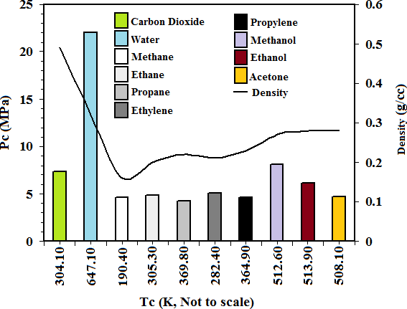

Fig.1. Critical Point and Density Variation in SCF
Applications of SCFs as an alternative media in food processing , chromatography, energy production and drug development was recognized till beginning of 19th century, has now well accepted in processing of materials ⁶⁻¹³.SCFs offers a series of unique methods of particle sizing, development of polymer composites, blends, dispersion of layered silicate, inorganic⁴, graphitic and magnetic fillers into solvents, monomers and their infusion into polymer matrix at ambient temperatures. Polymer functionalized nanostructurd polyelectrolytes for photovoltaic and energy storage applications are successfully synthesized under supercritically controlled conditions. Highly sensitive functional nanomaterials for antibacterial applications sensor and target delivery of drugs are conveniently synthesized in SCC⁷⁻¹³.
The present talk, shall deliver the salient features of SCFs and their applications in particle fabrication, polymerization, preparation of nanocomposites, nanohybrids, nanomaterials for wood preservation, nanocomposites for development of durable composite structures, electroactive nanomaterials for sensing, energy storage, target delivery systems and nanoparticle mediated microbial degradation of commodity plastic materials. Concluding remarks will be presented on simplicity, diversity, and commercial viability of SCFs processing of polymer nanomaterials.
References:
1M. Skerget, Z. Kenz and K. Hrncic 2011 Solubility of solids in sub and supercritical fluids, J. Chem.Eng. Data, 56(4) 694-719
2..Z.Kenz,E. Markocic, M.Lietgeb,M.Primozic, M.Kenz and H.M.Serkjet 2014. Industrial applications of supercritical fluids: A Review Energy,77: 235-243
3. Z. Qian 2019. Developments on CO₂-Utilization Technologies, Clean Energy, 3(3): 85–100
4.F. Cansell, C. Aymonier, A.L.Serani 2003. Review on materials science and supercritical fluids ,Curr. Opinion in Solid State and Mater.Sci. 7(4-5) :331-340
5.J.Vansant and P.W.Koziel 2019. Technical and industrial applications of CO2, 73-104 ISBN 978-3-030-15867-5
6.. R.Noyori 1999. Supercritical Fluids: Introduction Chem.Rev., 99(2) 353-354
7.I. Abdullah M. Asiri and A. Isloor 2019. Supercritical carbon dioxide as green solvent in green sustainable process for chemical and environmental engineering and science, 1st Ed.
8.N. Bhullar, M.G.H.Zaidi, S. Alam, R Singh 2007. Synthesis of C60 caged polyvinyl pyridine in supercritical carbon dioxide. Int. J. Nanosci. Nanotech. 1(3) :64-68
9.M.G.H.Zaidi, T. Agarwal , S.Alam ,A.K.Rai 2011.Synthesis of fullerene (60) polyvinyl pyridine composites in supercritical carbon dioxide. Full., Nanotube and Carbon Nanostr, 19(4 ): 329- 333
10.V.Agarwal, M.G.H.Zaidi, S.Alam, A.K.Rai 2009. Fullerene 60 mediated polymerization of polyacrylic acid in supercritical carbon dioxide, Int. J. Polym. Anal. Charact. 14 (1): 52-67
11. V. Agrawal , S. Vishnoi , M. G. H. Zaidi , S. Alam, A. K. Rai 2010.. Synthesis and characterization of C60-polymethyl methacrylate conjugates in supercritical carbon dioxide. Int. J. Polym.Anal. Charact.,15(5): 267-276
12. M.G.H.Zaidi, S.K.Joshi, M.Kumar D.Sharma and A.Kumar 2013. Carbon Lett , 14(4):218-227
13.M.G.H.Zaidi, P.L.Sah, S.Alam and A.K.Rai 2009. J. Exp.Nanosci.4 (1): 55-66
14. G.Bisht,K.Biplab and M.G.H.Zaidi 2018. Macromol.Res.1-11

Biography:

M.G.H.Zaidi is chemist, educator and researcher. He was born on February 22, 1967 in U.P., India. He is Professor of Chemistry in Department of Chemistry at G.B.Pant University of Agriculture & Technology, Uttarakhand, India. He is known for multidisciplinary research in the area of polymer science interfacing physical, life sciences and engineering. His has expertise on development of supercritically green methods of processing of materials for structural, energy storage, thermal, biomedical, antimicrobial applications, microbial degradation and crop enhancers. He has-advised more over 16 research projects, 27 M.Sc., & Ph.D. published > 100 research articles in journals, conference proceedings & tech reports. And availed 6 patents. He is the part of editorial & reviewer of many reputed journals.

Presenting author details


Full Name: Professor M.G.H.Zaidi
Contact number: +919411159853
Linked In account: https://in.linkedin.com/in/m-g-h-zaidi-3b375126
Session name/ number: Polymer Science & Applications
Category: Plenary/Keynote Speaker

