Abstract
With the growing demand for new products having excellent chemical and biological characteristics with functionality, the engineering of nanocomposites offers a simple, yet versatile platform for the development of hypered compounds with specific and tunable properties. By definition a “nanocomposites” are multiphase materials, where one of the phases has nanoscale additives, which led by the combination of polymeric network, organic molecule or 3D carbonaceous allotropes self-assemblies with nanohypered materials of different origins (organic/metallic nanoparticles, transition metal salt (TMS) and layered double hydroxide (LDH)) through covalent/non-covalent interactions. Dynamic polymeric network can serve as incredible hosts for the impregnation of these dimensionally different nanoparticles. Nanocomposites within the matrix of polymeric network /3D self-assemblies can give increase to new characteristics due to the synergistic contribution of both materials. The new approach intended to use surfactant gels as media for the synthesis and stabilization of nanoparticles. Recent reports have suggested that coupling of polymeric network with nanoparticles is advantageous for both constituents. These newly developed surfactant/nanocomposites have interesting properties including electrical conductivity, thermal robustness, magnetic, phase-selective, redox and near-infrared radiation sensitive properties and so on. This research will highlight some of the most recent advancements in the development of methods, tools, techniques and application of novel nanocomposites. In particular, we intend to correlate various design strategies for the synthesis as well as composite preparation from functional molecules with interesting applications in the areas such as supercapacitors, nanoelectronics, photovoltaic devices, chemical and biosensors, biomedicine and so on. During this research work we predict that this work will enhance the conceptual demonstration of various approaches to develop different nanocomposites and will highlight their applications across various disciplines.
The recent development of nanoscale fillers, such as carbon nanotubes, conductive polymers, transition metal salt (TMS) and layered double hydroxide (LDH)) , allows the functionality of hypered nanocomposite to be controlled and enhanced. However, conventional synthesis methods of polymer nanocomposites cannot maximize the reinforcement of these nanofillers at high filler content. Approaches for the synthesis of high content filler polymer nanocomposites are suggested to facilitate future applications. Nanocomposites are known as multiphase materials, where one of the phases has nanoscale additives ¹. They are expected to display unusual properties emerging from the combination of each component. Many methods have been reported for the preparation of polymer-based inorganic nanoparticles composites. The important ones are intercalation of nanoparticles with the polymer or pre-polymer from solution ², in situ intercalative polymerization ³, hydrothermal , direct mixture of polymer and particulates, template synthesis , in situ polymerization, sol-gel process .
In another hand, there has been considerable research in trying to employ CNTs as reinforcements for nanocomposites, and significant progress has been made. However, the potential of carbon nanotubes as reinforcement in nanocomposite materials has not been fully realized. To harness the unique attributes of carbon nanotubes exhibited at the nanoscale, it is necessary to resolve the issues related to the basic principle of the nanoscale mechanical reinforcement of polymer matrices with carbon nanotubes, as well as the characteristics of the interface between the carbon nanotube and the surrounding polymer matrix. To achieve the optimal reinforcement with carbon nanotubes, it is of great importance to understand the relationship between nanocomposite properties and interfacial characteristics. Great achievements have been made in the field of carbon nanotube– composites during the past few years. However, poor dispersion and weak interfacial bonding remain obstacles for effectively incorporating carbon nanotubes into polymer matrices. There are still significant challenges encountered while exploring carbon nanotubes as filler materials to be overcome. It is often difficult to achieve a uniform dispersion of carbon nanotubes in the polymer matrix, as well as to enable a strong interaction at the interface between the carbon nanotube and the composite matrix. Various attempts have been made to effectively reinforce a composite matrix with carbon nanotubes.
Nanocomposites exhibit a wide variety of unique physico-chemical properties, different from those of their respective bulk counterparts such as, large surface area to volume ratios or high interfacial reactivity, because of their minimal size. The term “nano” is employed to describe the designing and exploitation of materials with structural features in between those of atoms and giant materials, having at least one of its dimensions in the range of 0.1-500 nm (1nm = 10⁻⁹m). A simple comparative representation of the size of nanomaterials with respect to other small particles is given below in Figure 1.1.

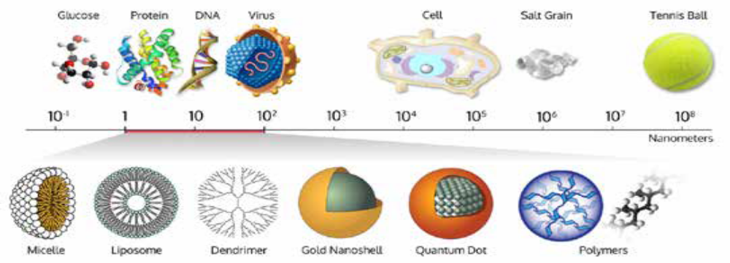

Figure 1.1: A very simple comparative representation of the size of nanomaterials with respect to various biomolecules and inorganic materials

In the past decade, numerous efforts have been focused on the enhancements of the physical and mechanical properties for nanocomposites i.e. polymer/Nps, CNT/LDH, and CS /TPP nanocomposites, and most of such research has concentrated on achieving a high degree of exfoliation and a better dispersion of Nps or improving the interfacial of drugs to the polymer matrices via surface modifications. However, the improvements of the physical and mechanical properties of such polymer nanocomposites are not only limited to the above influences, but also determined by many other factors including size and shape of clays. The relevant modeling work has confirmed the importance of these factors on the properties of polymer nanocomposites, but there is still lack of the experimental data reports on how the size affects the mechanical properties of polymer nanocomposites because of the limited aspect ratios for the natural clays. As compared to the natural clays, synthetic a-titanium phosphate (TiP), tin (IV) nanoparticles shave advantages such as defined chemical structure, high purity, ease to control the size and aspect ratio, large ion-exchange capacity, and high activity for surface and interlayer modifications, and therefore they have been utilized as a model clay to invest the nanofillers effects on the properties of polymer nanocomposites.
Furthermore, Organic polymers such as polypyrrole, poly O-anisidine, polyacrylonitrile, polyacrylamide and CS etc. have been extensively used in the synthesis of nanocomposite materials. Owing to their significant proton dopability, these materials have the prominent features of variable electrical properties, low cost, ease of synthesis, excellent redox recyclability, and thermal and chemical stability. Thus, a number of composite materials have been synthesized by incorporating transition metals such as Sc, Ti, Zr, V, Cr, Mo, Mn, As, Sn, etc. into organic polymers. However, titanium-based organic-inorganic materials were found to have advantages over other materials because of their thermal and chemical stability.

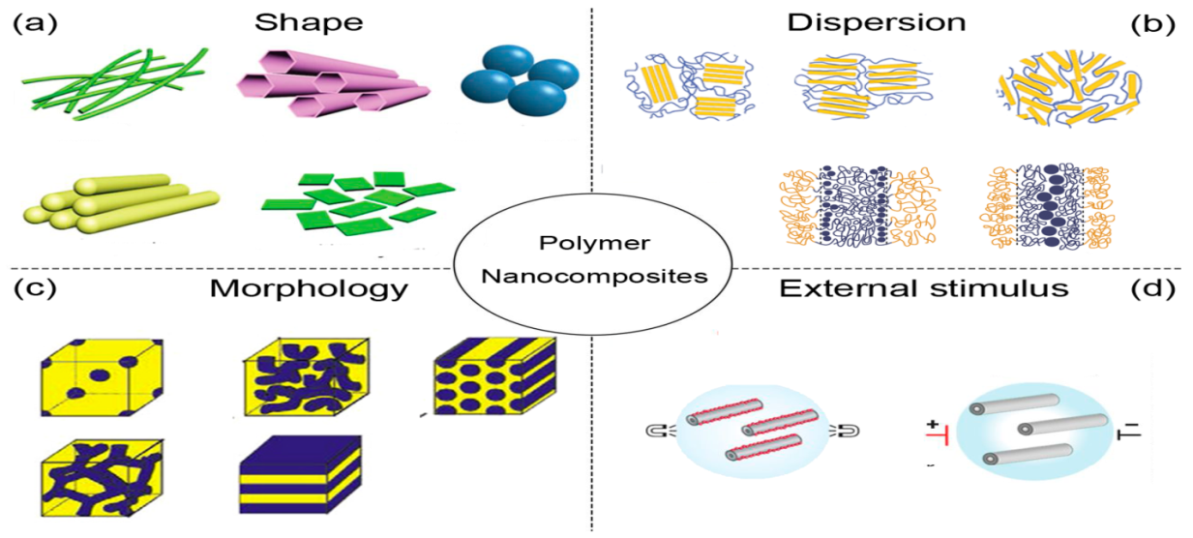
Fig.1: Polymer nanocomposites, where (a) shape (b) dispersion (c) morphology, and (d) external stimulus.

Nanocomposites are as multiphase materials in which one of the phases has nanoscale additives. They are expected to display unusual properties emerging from the combination of each component. According to their matrix materials, nanocomposites can be classified as ceramic matrix nanocomposites (CMNC), metal matrix nanocomposites (MMNC), and polymer matrix nanocomposites (PMNC). In this study, the recent progress in PMNC is reported. Polymers are now most widely used in the field of technical textiles. The widespread use of common organic polymers such as poly olefins, nylons, polyesters and polyurethanes emanates from key features such as lightweight, easy fabrication, exceptional processability, durability and relatively low cost which can be present in different shapes and morphological surfaces Fig.1.

