Zinc based materials as perspective candidates for fabrication of biodegradable implants
Jaroslav Capek, PhD, FZU – Institute of Physics of Czech Academy of Sciences, Prague, Czech Republic

Abstract
Zinc based biodegradable materials were introduced in 2011 and since that time a large number of studies dealing with this topic has been published. Compared to the other candidates for metallic biodegradable implants, namely Mg- and Fe-based materials, Zn-based materials possess the most suitable corrosion behavior. On the other hand, pure as-cast zinc is fragile and does not reach sufficient strength for applications for implantology. Fortunately, suitable alloying and thermomechanical treatment allow us to enhance mechanical performance of zinc alloys to fulfill the basic requirements of medical industry.
In my presentation, I will sum up the current status of Zn-based biodegradable materials and methods allowing preparation of Zn-based materials for implantology. Moreover, some of our results will be shown. Particularly, Influence of alloying, extrusion or equal channel angular pressing on microstructure, mechanical and corrosion behavior, as well as on in-vitro and in-vivo biocompatibility will be discussed.

Image
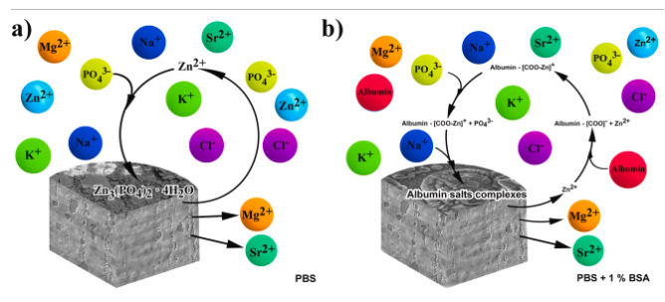
Figure 1: Corrosion mechanisms of Zn-based alloys in a phosphate buffered solution without (a) and with (b) a presence of bovine serum albumine
Recent Publications (minimum 5)
- Vojtech D., et. al. (2011) Mechanical and corrosion properties of newly developed biodegradable Zn-based alloys for bone fixation. Acta Biomaterialia 7:3515-3522.
- Yang H., et.al. (2020) Alloying design of biodegradable zinc as promising bone implants for load-bearing applications. Nature communications 11:Article no. 401.
- Kabir H., et. al. (2021) Recent research and progress of biodegradable zinc alloys ad composites for biomedical applications: Biomechanical and biocorrosion perspectives. Bioactive Materials 6:836-879.
- Pinc J., et.al. (2021) Microstructure evolution and mechanical performance of ternary Zn-0.8Mg-0.2Sr (wt.%) alloy processed by equal-channel angular pressing. Materials Science and Engineering A 824: Article no. 141809.
5. Klima K., et. al. (2021) NZn-0.8Mg-0.2Sr (wt.%) absorbable screws – an in-vivo biocompatibility and degradation pilot study on a rabbit model. Materials 14:Article no. 3271.



Biography
Ing. Jaroslav Čapek, Ph.D is an expert focusing on physical metallurgy and design of metallic materials. His main interest lies in experimental and theoretical investigation of relationships between chemical composition, processing route, microstructure and mechanical properties of metallic materials. Recently, he deals with the design of metallic biodegradable materials for medicine.
Email: capekj@fzu.cz

Notes/Comments:

