TCO and carrier selective materials open circuit voltage and efficiency significance in solar photovoltaic cells

Bablu K Ghosh*, EEE Program, UMS,Sabah-88400, Malaysia
Ismail Saad EEE Program, UMS, Sabah-88400, Malaysia

Abstract
Si and CdTe hetero-junction (HJ) solar cells are most promising in commercial stage photovoltaic (PV) technologies. Their contacts and interface defects related opto-electrical losses are still vital to limit its further technological benefit. Besides pioneer Si and CdTe PV cell, the rapid development of organic and organic-inorganic Perovskite solar cells are also huge energy potential. Enhancement of conduction and lessening recombination the carrier selectivity (CS) by field effect is most significant for majority carrier selection to improve open circuit voltage. The dark carrier injection due to thermal effects and traps are mostly classified as recombination losses [1-2] and it is related to the barrier effect. Temperature and photonic interaction with PV materials the barrier relating to temperature the current density function, J/Jo and associated built in potential $V$ $∝\frac{K_{β}T}{q}In \left(\frac{J}{Jo}\right)$are determining factors of energy losses ΔE= ΔqV.
${V_{oc}=V}_{oc}^{SQ}- V_{oc}^{SC}- V_{oc}^{rd}-V_{oc}^{nrd}$ (1)

The effective charge modulation at the surface is directly proportional to the dielectric constant of the nanostructure back surface passivation layer of high-k dielectrics effects are vital [3-4].
$$Q_{eff} \frac{ϵA}{d} (2)$$Q_{eff} is effective charge density, $ϵ$ is dielectric permittivity, d is thickness, A is area. CS is essential to combat Fermi level pinning (FLP) effects. Careful selection of the material work function with respect to the doping level the contact resistivity is varied with the Schottky barrier height.
$$ρ_{c} exp(\frac{φ_{B}}{\sqrt{N_{d}}} ) (3)$$
The contact resistivity, $ρ_{c},$ barrier height, $φ_{B}$ and doped $N_{d}$ are interrelated. The TCO, emitter and back contact materials proper band edge, permittivity and thermal as well as electrical conductivity has lot of influence on carrier selectivity, contact resistance, Voc and efficiency. The TCO and back barrier passivation thickness and doping effect on both Voc and efficiency variation more specifically can be understand and it is supportive to further progress in diverse materials design and electrical performance of diverse solar cell.



Dr. Bablu K. Ghosh has received his Doctor of Engineering (DE) from Fukui University, Japan in Graduate School of Engineering in 2004 under Monbusho Scholarship. Currently he is working in Electrical and Electronic Engineering program under Faculty of Engineering in University Malaysia Sabah, Malaysia as senior lecturer. He is specialized in EM interaction with materials and Bio system. Currently he is also working on solar photovoltaic system. Before joined in UMS, he was engaged as Radio Engineer, Scientific Officer and Microwave system Engineer. He has good experience in radiation energy interaction with system. He has written about fifty journals and conference papers. He also attended several conferences in USA, Japan, China, Indonesia, and Malaysia and presented his work
E mail: ghoshbab@ums.edu.my

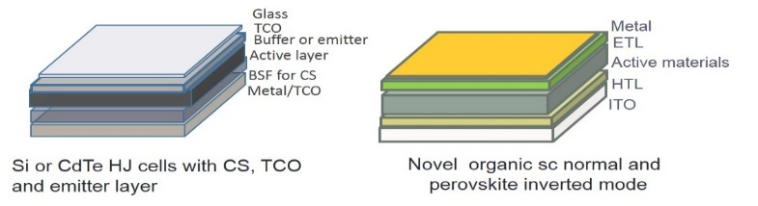
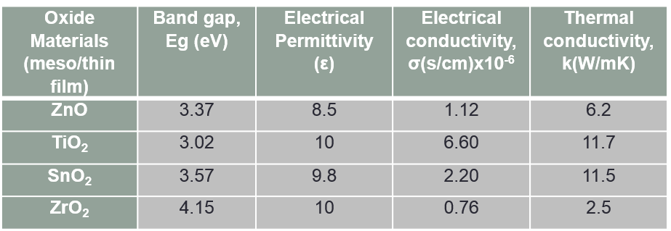
Image
Recent Publications
- Rau, U., Paetzold, U.W. and Kirchartz, T., 2014. Thermodynamics of light management in photovoltaic devices. Physical Review B, 90(3), p.035211.
- Rau, U., Blank, B., Müller, T.C. and Kirchartz, T., 2017. Efficiency potential of photovoltaic materials and devices unveiled by detailed-balance analysis. Physical Review Applied, 7(4), p.044016.
- Ghosh, B.K. and Biswas, T.K., 2019. Emerging solar cells energy trade‐off: Interface engineering materials impact on stability and efficiency progress. International Journal of Energy Research, 43(5), pp.1670-1688.
- Ghosh, B.K., Saad, I., Teo, K.T.K. and Ghosh, S.K., 2020. mcSi and CdTe solar photovoltaic challenges: Pathways to progress. Optik, 206, p.164278.
- Cuevas, A., Wan, Y., Yan, D., Samundsett, C., Allen, T., Zhang, X., Cui, J. and Bullock, J., 2018. Carrier population control and surface passivation in solar cells. Solar energy materials and solar cells, 184, pp.38-47

