Polymeric nanocomposites for electromagnetic radiation absorbing-a challenge of environment pollution to health hazards

Narayan Chandra Das, Rubber Technology Centre Indian Institute of Technology, Kharagpur -721302, West Bengal, INDIA

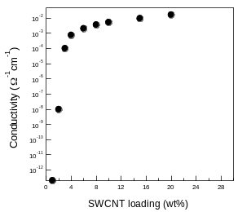
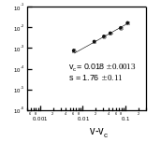
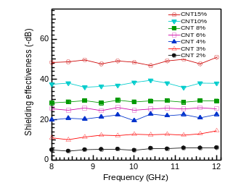
Abstract
The growth in the application of electronic devices across a broad spectrum of military, industrial, commercial and consumer sectors has created a new form of pollution known as radio frequency interference (RFI) or electromagnetic (EM) radiation or EM interference (EMI) that can cause interference or malfunctioning of equipment. Those EM radiation consisting many unwanted radiated signals which not only degrade system or equipment performance, those EM radiation are doing serious effect on human health especially, on nervous system and brain. The possible or suggested effects of EMF on the body are Parkinson's disease, Alzheimer's disease, Cancer, tumors, Headache, fatigue, neurological disorder, etc. One of the simplest methods is to reduce electromagnetic signal by shielding (Fig. 1). Electrical conductive polymeric nanocomposites filled with carbon based conductive filler are becoming popular for microwave radiation absorbing materials because of their light weight, high flexibility, anti-corrosive, easy fabrication into intricate shape by common processing techniques and cost effectiveness. Currently, carbon materials, including carbon fibers, carbon nanotubes (CNTs) and graphene have played a leading role in the investigation and application of microwave absorbing materials due to their low specific mass and high aspect rations, which results in high electromagnetic losses at low filler content along with a reduction of thickness and weight (Fig. 2a-b). In addition, electrical, thermal conductivity as well as microwave absorbing efficiency or shielding effectiveness are strongly depends on type of polymer, filler and its concentration, filler dispersion, polymer blends, processing parameter etc.
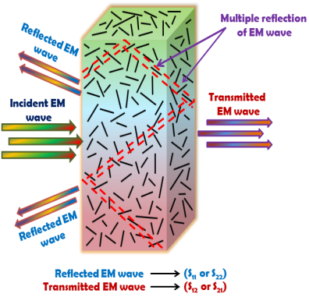

Figure 1: Schematic representation of shielding mechanisms

Figure 2: (a) shows conductivity vs filler loading and (b) indicate EMI shielding effectiveness vs frequency at different filler loading.
Recent Publications
- Ghosh S, Remanan S, Bhattacharjee Y, Ghorai A, Dey T, Das TK, Das NC (2020) A Multifunctional Smart Textile Derived from Merino Wool/Nylon Polymer Nanocomposites as Next Generation Microwave Absorber and Soft Touch Sensor, ACS Applied Materials and Interface, 12(15):17988-18001.
- Ravindren R, Mondal S, Nath K, Das NC (2019) Prediction of electrical conductivity, double percolation limit and electromagnetic interference shielding effectiveness of copper nanowire filled flexible polymer blend nanocomposites”, Composites Part B 164:559-569.
- Ghosh S, Ganguly S, S. Remanan S, Das NC (2019) Fabrication and investigation of 3D tuned PEG/PEDOT: PSS treated conductive and durable cotton fabric for superior electrical conductivity and flexible electromagnetic interference shielding, Composites Science and Technology, 181(8): 107682.
- Mondal S, Ravindren R, Bhawal P, Shin B, Ganguly S, Nah C, Das NC (2020), Combination effect of carbon nanofiber and ketjen carbon black hybrid nanofillers on mechanical, electrical, and electromagnetic interference shielding properties of chlorinated polyethylene nanocomposites, Composites Part B: Engineering 197: 108071.
- Ghosh S, Das NC (2020), Micro-computed tomography enhanced cross-linked carboxylated acrylonitrile butadiene rubber with the decoration of new generation conductive carbon black for high strain tolerant electromagnetic wave absorber, Materials Today Communications, 20:100989.

Biography
Narayan Ch. Das has his expertise in evaluation and passion in developing radiation shielding materials for reduction of environmental pollution and protection our health from radiation. He has developed different kind of polymer based light weight , flexible and cost effect nanocomposites. Those nanocomposites are highly electrically and thermally conductive and and cam be used a commercial materials for outstanding electromagnetic radiation materials. His interdisciplinary research interests include nanomaterials, polymer nanocomposites, rheology and processing of rubber, biomaterials, carbon dots, membrane for water purification, food packaging, SAXS and SANS.
Email: ncdas@rtc.iitkgp.ac.in

