Abstract Template

Title: Solventless synthesis of antimony sulfide, bismuth sulfide, and antimony-bismuth sulfide solid solutions using novel single source route

Tahani Alqahtani,¹ Malik Dilshad Khan,² Paul O’Brien^{1,2}
¹School of Materials, The University of Manchester, Oxford Road, Manchester, M13 9PL, UK.
²School of Chemistry, The University of Manchester, Oxford Road, Manchester, M13 9PL, UK.

Keywords: Rice lines, Salt stress, Microsatellite (SSR) marker, Protein analysis, Gene expression

- Abstract Body (up to 250 words)
Antimony(III) ethylxanthate [Sb(S₂COEt)₃] and bismuth(III) ethylxanthate [Bi(S₂COEt)₃] were used as a single source precursor for the preparation of Sb₂S₃ and Bi₂S₃, respectively, by a melt method at different temperatures. In addition, The thermogravimetric analysis reveals that both precursors exhibit complete decomposition in similar temperature range. Therefore, the mixture of these precursors can be used to produce solid solutions of Bi-Sb-S between the two phases (Bi₂S₃ and Sb₂S₃). A series with varying stoichiometry was synthesized by using different molar ratios (i.e. Sb/Sb+Bi = 0.2, 0.4, 0.6 and 0.8). The XRD peaks at all ratios correspond well to the orthorhombic crystals, where the peaks fall in between those of orthorhombic Bi₂S₃ and orthorhombic Sb₂S₃ for Bi-Sb-S system. The gradual splitting and shift in the peaks position confirms the successful incorporation of antimony into bismuth sulfide. The inclusion of antimony was further confirmed by change in lattice parameters and is in good agreement with the literature values. A decrease of almost 3.5 % in volume was observed as moving from Bi₂S₃ to Sb₂S₃. A change in all lattice parameters indicates that the substitution is random and not in any specific direction. The elemental compositions of all the samples were examined via EDX analysis and ICP- OES, which shows uniform distribution of elements in all samples. The morphology for all the samples was observed using SEM, revealing different morphologies as the composition changes from Bi₂S₃ to Sb₂S₃.¹⁻³

- Image:

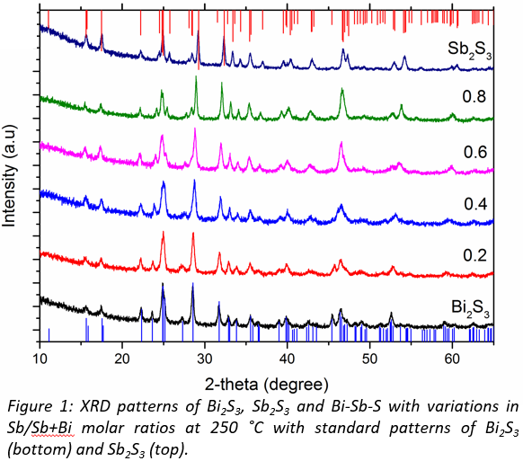

- Reference:
- Messina, S., Nair, M.T.S. and Nair, P.K., 2007. Antimony sulfide thin films in chemically deposited thin film photovoltaic cells. Thin Solid Films, 515(15), pp.5777-5782.
- Kaltenhauser, V., Rath, T., Haas, W., Torvisco, A., Müller, S.K., Friedel, B., Kunert, B., Saf, R., Hofer, F. and Trimmel, G., 2013. Bismuth sulphide–polymer nanocomposites from a highly soluble bismuth xanthate precursor. Journal of Materials Chemistry C, 1(47), pp.7825-7832.
- Kyono, A. and Kimata, M., 2004. Structural variations induced by difference of the inert pair effect in the stibnite-bismuthinite solid solution series (Sb, Bi) 2S3. American Mineralogist, 89(7), pp.932-940.
- Biography:
Tahani received MSc degree in Nanotechnology and Microsystems at Heriot-Watt University. She is currently studying her PhD at the University of Manchester with Prof. Paul O'Brien where her work focuses on metal chalcogenides for photovoltaic applications.

- Presenting author details

Full Name: Tahani Alqahtani
Contact number: +447460126668
Twitter account:
Linked In account:
Session name/ number:
Category: (Poster presentation)
Passport Number:

