Principle of “Time” Theory and relation between past, present and future
Author: Sahriar Ahamed, 44, GNB Khal Road, Khulna, Bangladesh.

Abstract
We all know the unit of TIME is known as Year, Month, Week, Day, Hour, Minute, Second. But take a look how we calculate year. Definition of the year shows that the earth’s one rotation around the sun is known as a year. A year can be divided in to 12 bigger parts. Every parts are known as months. There are more division in the year such as days. As we know, there are almost 365 days and some fractions of a day in one year. Now come to the definition of day. Day is a full rotation of the earth on its own axis. And day is divided in to smaller units known as hours. 24 hours make a day. Hours are also divided in to small units known as minute and seconds and many more. So, basically we are counting the earth’s rotation around the sun as a year and rotation of the earth on its own axis is known as day. So, what we are calling as the unit of time- is actually the unit of rotation of the earth.
Basically, Time has a constant. Take a deep look in TIME. The space between past and present is zero. Without giving any space or margin time is getting past from present. The moment everything is becoming present on the same moment it’s becoming past. So, arising from the future the present is becoming the past without any margin or space. Thus we can say that the “present = 0 “ or Pr= 0 (where Pr= present). Now where ever you are in the universe the same thing will happen to you. If you stay in USA or UK, or Kenya or even in Bangladesh. If you stay on the moon or Jupiter or on the Neptune the same thing will happen with you. The present will become the past without any margin or space. The moment it is present; on the same moment it will become the past. If you be on the another Milky way , certainly the same will happen to you too and in the black hole you will notice that the present is becoming the past without any margin or space Or Present =0 in short Pr=0. Thus it is the universal constant for the time by the way of its nature.
Moreover, if we put the figure that has been given by Albert Einstein on a graph chart, we can notice that the Future side of the diagram is on the positive side and the past falls in the negative side of the graph. Thus we may say that past = - (negative) and future = + (positive)
By adding up Past + Future or a negative value with positive we will get 0 (zero) That means the value of present . So, the equation comes as below:
Negative + positive = 0 ,
Or, Past + Future = Present ( putting the value as got earlier)
Or, Ps + Fr = Pr (where, Ps= past, Fr = Future , Pr= Present)
This is how we can calculate the numerical characteristic of time the 4th dimension.
So, if we continue reading the as usual that year, month, day, hour, minute, second are the unit of measuring TIME. The problem will arise.

Image:

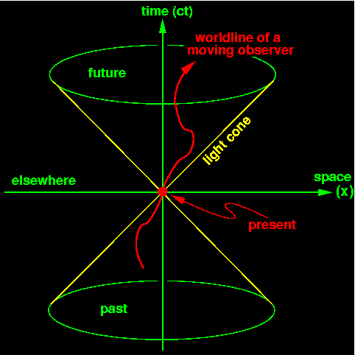

Recent Publications (minimum 5)
- https://www.tsijournals.com/articles/theory-of-time-dilation-twin-paradox-and-its-limitation-13895.html
- https://www.arcjournals.org/international-journal-of-advanced-research-in-physical-science/volume-7-issue-2/
- https://www.sryahwapublications.com/open-access-journal-of-physics/volume-2-issue-4/5.php
- https://www.tsijournals.com/articles/quantum-rotation-is-not-time-13943.html
- https://www.arcjournals.org/international-journal-of-advanced-research-in-physical-science/volume-6-issue-6/3
- https://www.sciencepubco.com/index.php/IJAA/article/view/20599
- https://www.morebooks.de/store/gb/book/theory-of-relativity-of-time-and-of-evaluation-of-human-civilization/isbn/978-3-659-75070-0
- https://www.morebooks.de/store/gb/book/theory-of-gate-way-in-case-of-traveling-time/isbn/978-613-9-44574-5


Sahriar Ahamed
Biography
Sahriar Ahamed, is an individual researcher. And doing research by personal fund without affiliation to any institute for more than 8 years, having 2 books and many theories published around the world in different international journal. Currently living in Khulna, Bangladesh with family and related with social service, research and education
Emailahamedsahriar@gmail.com

