One-step synthesis of molybdenum carbide (Mo₂C and MoC) nanoparticles for electrochemical water splitting
Sanjay Upadhyay, TIET Patiala, India
OP Pandey*, Ph.D., TIET Patiala, India (*Corresponding author)

Abstract

The increasing population of the world demands more efficient and renewable energy sources as our energy sources are limited. Hydrogen is a renewable, environmentally friendly, and cost-effective source of energy that has the potential to replace our traditional energy sources such as fossil fuels. Electrochemical water splitting is a clean and cost-effective way to produce hydrogen on a global scale by hydrogen evolution reaction (HER). However, a highly active and efficient electrocatalyst is required for this reaction to occur. To date, platinum (Pt) is the most active catalyst towards HER, however, the high price and low abundance limit its large-scale applications. Many research groups are trying to develop new alternative electrocatalysts having high electrochemical performance, high stability, and low cost. Molybdenum based compounds such as molybdenum carbide (Mo₂C) has a similar electronic structure to that of Pt and can be used as a catalyst for HER. In this study, pure phase Mo₂C and MoC nanoparticles have been synthesized via in-situ carburization and reduction route in a single step. The reaction parameters such as reaction temperature and reaction time have been optimized to get pure phase Mo₂C and MoC nanoparticles. The morphological, structural, and surface characteristics have been investigated for the pure phase of Mo₂C and MoC. For example, X-ray diffraction (XRD) measurements have been performed to get information about the structure and phases obtained. X-ray photoelectron spectroscopy (XPS) analysis has been done to investigate the chemical composition of the as-synthesized samples. Also, the electrochemical HER performance has been studied in detail for the as-synthesized compounds.
Image
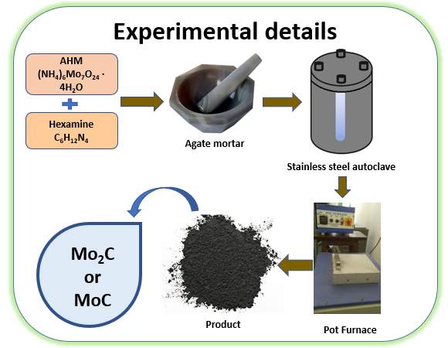
Figure 1: Schematic illustration for the preparation of Mo₂C and MoC nanoparticles.
Recent Publications (minimum 5)
- Mir RA, Sharma P, Pandey OP. (2017) Thermal and structural studies of carbon coated Mo₂C synthesized via in-situ single step reduction-carburization. Sci Rep. 7:1–12.
- Mir RA, Pandey OP. (2020) An ecofriendly route to synthesize C-Mo₂C and C/N-Mo₂C utilizing waste polyethene for efficient hydrogen evolution reaction (HER) activity and high performance capacitors. Sustain Energy Fuels. 4:655–669.
- Sidana HK, Mir RA, Pandey OP. (2018) Synthesis of molybdenum nitride (Mo₂N) nanoflakes via in-situ reduction-nitridation. J Alloys Compd. 736:255–265.
- Mir RA, Pandey OP. (2018) Influence of graphitic/amorphous coated carbon on HER activity of low temperature synthesized Β-Mo₂C@C nanocomposites. Chem Eng J. 348:1037–1048.
- Mir RA, Pandey OP. (2019) Waste plastic derived carbon supported Mo₂C composite catalysts for hydrogen production and energy storage applications. J Clean Prod. 218:644–655.5.

Sanjay Upadhyay
Sanjay Upadhyay is a Ph.D. student at the school of physics and materials science, Thapar Institute of Engineering and Technology, Patiala. He received his master’s degree from Kumaun University, Nainital. His research focuses mainly on the advanced functional nanomaterials for electrochemical water splitting and supercapacitors.
Email: bannudsanjay@gmail.com
OP Pandey
OP Pandey is a senior professor in the school of physics and materials science, Thapar Institute of Engineering and Technology, Patiala. He received his Ph.D. degree in metallurgical engineering from Indian Institute of Technology (BHU) Varanasi. He has worked extensively in the area of advanced functional nanomaterials for various applications such as electrocatalysis, photocatalysis, and Photoluminescence. He has published more than 300 research papers. He frequently gives invited lectures at many international meetings.
Email: oppandey@thapar.edu

Notes/Comments:

