Mechanical and Tribological Behaviour of 3D Printed Polymers

Mir Irfan Ul Haq,PhD, School of Mechanical Engineering,Shri Mata Vaishno Devi University, Jammu and Kashmir, India-182320
Ayesha Farzana Kichloo, School of Mechanical Engineering,Shri Mata Vaishno Devi University, Jammu and Kashmir, India-182320
Ankush Raina, School of Mechanical Engineering,Shri Mata Vaishno Devi University, Jammu and Kashmir, India-182320

Abstract (300 word limit)

With the advent of 3D printing technologies, the development of new structural parts from engineering applications has increased rather than just prototyping. The current paper focusses on different PETG based samples. Different process parameters by Fused Deposition Modelling were used to print the carbon fibre reinforced samples. The effect of the carbon addition on the mechanical properties such as tensile and flexural behaviour was studied. Further, the effect of these properties on the friction and wear behaviour of these materials was studied. SEM analysis of these samples was done to study the worn surface morphologies and the modes of fracture in the various mechanical tests. The research concluded that addition of the carbon substantially helps to improve the mechanical and tribological behaviour of these materials.

Image
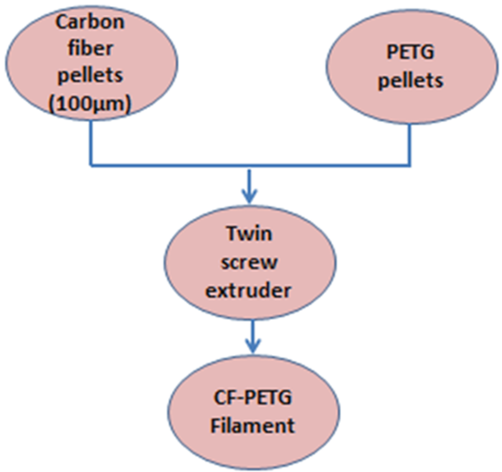
Recent Publications
- Ranganathan, Soundararajan, and C. Pradeep. The effect of print orientation and infill density for 3D printing on mechanical and tribological properties. No. 2020-28-0411. SAE Technical Paper, 2020.
- Hanon, Muammel M., Robert Marczis, and László Zsidai. "Impact of 3D-printing structure on the tribological properties of polymers." Industrial Lubrication and Tribology (2020).
- Hsueh, Ming-Hsien, Chao-Jung Lai, Shi-Hao Wang, Yu-Shan Zeng, Chia-Hsin Hsieh, Chieh-Yu Pan, and Wen-Chen Huang. "Effect of Printing Parameters on the Thermal and Mechanical Properties of 3D-Printed PLA and PETG, Using Fused Deposition Modeling." Polymers 13, no. 11 (2021): 1758.

Biography (150 word limit)
Dr. Mir Irfan Ul Haq is an Assistant Professor at the School of Mechanical Engineering, Shri Mata Vaishno Devi University. He has previously worked at the R&D wing of Mahindra and Mahindra. He obtained Master of Engineering in Mechanical System Design (Gold Medalist) from National Institute of Technology Srinagar. He has carried out Ph.D. in the area of tribology at SMVD University. He is actively involved in teaching and research in the field of materials, tribology and 3D printing. His research interests include lightweight materials, New Product Development and Additive Manufacturing. He has published 40 research papers in SCI and Scopus indexed journals. Moreover, he has been awarded research project grants from agencies such as DST and NPIU AICTE. He has attended several conferences and workshops both in India, USA and Singapore. He is member of reviewer boards of various international journals, apart from chairing technical sessions in various international and national conferences.
Email: haqmechanical@gmail.com

Notes/Comments:

