Micellar Catalysis Strategy of Cross-Condensation Reaction: The Effect of Polar Heads on the Catalytic Properties of Aminoalcohol-Based Surfactants
Zakaria Hafidi^{1*},Mohamed Ait Taleb^{2,3}, Abdallah Amedlous⁴ and Mohammed El Achouri¹

¹ Laboratoire de physico-chimie des matériaux inorganiques et organiques, Centre des Sciences des Matériaux, Ecole Normale supérieure-Rabat, Mohammed V University in Rabat.
² Equipe de Matériaux, Catalyse & Valorisation des Ressources Naturelles, Université Ibn Zohr, BP 8106, 80000 Agadir, Morocco.
³ Equipe de Chimie Bio-Organique Appliquée, Université Ibn Zohr, BP 8106, 80000 Agadir, Morocco
⁴ Laboratoire de Matériaux, Catalyse et Valorisation des Ressources Naturelles, URAC 24, FST Mohammadia, Université Hassan II-Casablanca, Casablanca, Morocco

Abstract
The effect of the polar head and the concentration of quaternary ammonium surfactants (C₁₄EtOH, C₁₄iPrOH, C₁₄PrOH, where, 14 = carbon number iPrOH = iso-propanol, EtOH = ethanol, PrOH = propanol) in micellar catalysis for the cross-condensation reaction (Claisen–Schmidt) was investigated. The reaction in the Micellar-NaOH system with different concen-trations of surfactants above the critical micelle concentration from 15 to 30 mmol between benzaldehyde and acetophenone was used as a model of reaction for this study. The examination of the effectiveness of the catalytic activity reveals that the compound C₁₄EtOH has the best yield (80% of the desired product), followed by C₁₄iPrOH and C₁₄PrOH. The results were interpreted according to the solubilization capacity, droplet size analysis of reagents (benzaldehyde and acetophenone) in the micellar medium and stability of reaction intermediate (enolate) by the electrostatic interactions generated by positive charge of N⁺ quaternary ammonium atom. Therefore, the quantum calculations carried out by DFT method for surfactants in the aqueous medium, show that electrophilicity degree and the reaction yield% for three cationic surfactants varies in the same following order: C₁₄PrOH < C₁₄iPrOH < C₁₄EtOH.

Image
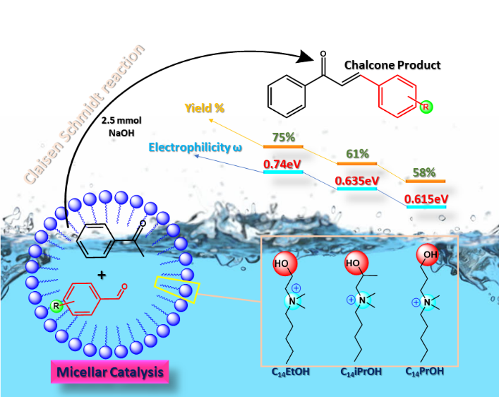
Recent Publications (minimum 5)
- B.S. Kitawat, M. Singh, R.K. Kale, Robust Cationic Quaternary Ammonium Surfactant-Catalyzed Condensation Reaction for (E)-3-Aryl-1-(3-alkyl-2-pyrazinyl)-2- propenone Synthesis in Water at Room Temperature, ACS Sustainable Chem Eng. 1 (2013) 1040–1044. doi:10.1021/sc400102e.
- M. Vashishtha, M. Mishra, D.O. Shah, Organobase catalysis using 1-(2-pyrimidyl) piperazine in micellar medium: An approach for better performance and reusability of organobase, Green Chemistry. 18 (2015) 1339–1354. doi:10.1039/C5GC01966D.
- Grieco, Paul A., Philip Garner, and Zhen-min He. "“Micellar” catalysis in the aqueous intermolecular diels-alder reaction: rate acceleration and enhanced selectivity." Tetrahedron Letters 24.18 (1983): 1897-1900.
- Holmberg, Krister. "Organic reactions in microemulsions." Current opinion in colloid & interface science 8.2 (2003): 187-196.
- Zayas, Hazit A., et al. "Thermoresponsive polymer-supported L-proline micelle catalysts for the direct asymmetric aldol reaction in water." ACS Macro Letters 2.4 (2013): 327-331.


Zakaria Hafidi Third cycle doctorate in organic synthesis I am currently working on the synthesis of new surfactants based on Ester quaternary and their application as antibacterial agents. I have a publication in the journal surfactants and detergent indexed in web of science and Scopus and also I have other article being submitted
Email: zakariahafidi21@gmail.com

