Abstract

Title: Multi-Scale Design for Structural Energy Devices

Xinhua Liu, Billy Wu
E-mail: x.liu15@imperial.ac.uk

¹Dyson School of Design Engineering, Imperial College London, London, UK

Keywords: supercapacitor, lithium-ion battery, 3D printing, electrospinning, polymer gel, X-ray Tomography

- Abstract Body
Energy devices, such as supercapacitors, Lithium-ion batteries, have now become the most critical component for electric vehicles (EV) and consumer electronics with improvements in energy and power density. The key aspects of a battery pack which define its performance are mainly the electrode and electrolyte chemistry selection, single cell performance and battery management.
This talk will discuss the issues and challenges of the batteries and how to develop high performance batteries via multi-scale design, including the electrode/electrolyte material selection and structure design, the scaffold design for structural devices, and the battery pack design[1,2]. Advanced X-ray tomography technology is employed here for structure characterization and further understand the degradation mechanism[3].
Guidance in materials, manufacturing technology and pack design will be given. More focus will be given to the highly engineered electrospinning technology which can produce nanostructured functional materials, specifically carbon nanofibres/nanotubes, for fabrication of various electrochemical applications. The model based battery pack design will also be discussed to understand overall performance of lithium-ion battery pack due to cell-to-cell variations, thermal gradients and/or cell interconnects.
- Image:

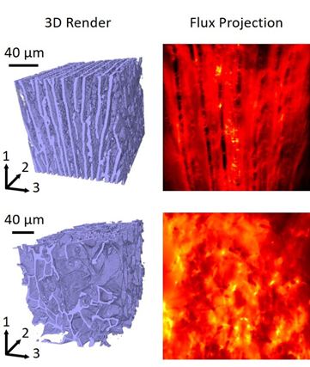

- Reference:
- Liu, X., Wu, D., Wang, H., & Wang, Q. (2014). Self‐recovering tough gel electrolyte with adjustable supercapacitor performance. Advanced Materials, 26(25), 4370-4375.
- Liu, X., Ai, W., Marlow, M. N., Patel, Y., & Wu, B. (2019). The effect of cell-to-cell variations and thermal gradients on the performance and degradation of lithium-ion battery packs. Applied Energy, 248, 489-499.
- Liu, X., Taiwo, O. O., Yin, C., Ouyang, M., Chowdhury, R., Wang, B., ... & Cooper, S. J. (2019). Aligned Ionogel Electrolytes for High‐Temperature Supercapacitors. Advanced Science, 6(5), 1801337.
- Biography:
Xinhua Liu has completed her PhD from Tongji University and Postdoctoral Studies from Dyson School of Design Engineering, Imperial College London, UK. She has great interests in material science and electrochemical engineering, working to develop scalable technologies to produce energy materials for various energy applications. With a great interest in design high performance batteries and battery packs from micro-scale to grid level, Xinhua has published more than 30 papers in recent five years including Advanced Materials, Advanced Science.

- Presenting author details


Full Name: Xinhua Liu
Contact number: 44 7491265031
Twitter account: @XinhuaLiu5
Linked In account: Xinhua Liu
Session name/ number: TBD
Category: (invited keynote presentation)
Passport Number: E48437287

