Synthesis and characterization of two new magnetic nanosorbents
J.C. García Mesa, P. Montoro Leal, M.M. López Guerrero, E. Vereda Alonso, A. García de Torres and J.M. Cano Pavón
Dpt. Analytical Chemistry, Faculty of Sciences, University of Málaga, Campus de Teatinos, 29071 Málaga (Spain)

Two new magnetic nanosorbents based on functionalised magnetic nanoparticles (MNPs) combined with graphene (GO) sheets were synthesised: 1,5-bis(di-2-pyridyl) methylene thiocarbohidrazide (DPTH-MNP@GO) and 1,5-bis(2-pyridyl-3-sulfophenyl) methylene thiocarbohidrazide (PSTH-MNP@GO).
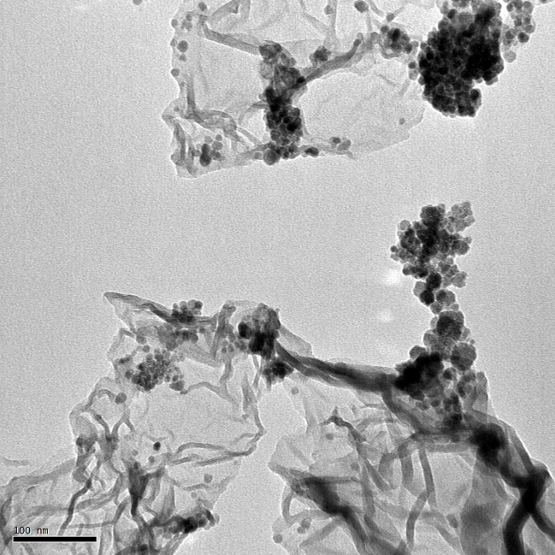
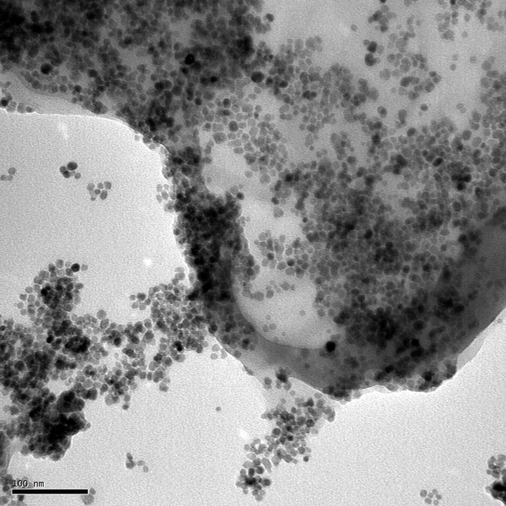
Several procedures of synthesis were assayed and the products were characterised using different techniques, such as scanning and transmission electron microscopies (SEM and TEM), X-Ray photoelectron spectroscopy (XPS), Fourier transform infrared spectroscopy (FT-IR) and mass spectrometry (MS). Figure 1 shows the TEM images of two of the products synthesised
Figure 1. TEM images of DPTH-MNP@GO (a), PSTH-MNP@GO (b)
As can be seen DPTH-MNP@GO shows smaller monodispersed MNPs disperse homogeneously on the whole RGO surface.
In order to use these new nanomaterials in the extraction and preconcentration of elements (Pt, Pd, Rh, Ir, Os, Au, Ag, Hg, As, Sb, Bi, Pb, Co, Zn, Cr, Ni, Cu, Cd), the adsorption capacities for these elements were determined. The sorption capacity of the resin was determined in batch by inductively coupled plasma optical emission spectrometry (ICP-OES). The best results were obtained by the magnetic nanosorbent DPTH-MNP@GO to retain Pt, Pd, Rh, Ir, Os, Au, Ag, Hg, Sb, Bi.

