Utilizing the Endocannabinoid System, Heart Coherence Breathing techniques and consistent Mindful Practices may be the key to long term preventative care, movement of historically Marginalized Communities and forming a unified whole person, family, community, and planet!
Sarah Larsen, MD, Miracle Makers Academy, USA
Sarah Larsen, MD, Miracle Makers Academy, USA

Abstract (300 word limit)

Statement of the Problem: Are humans prone to constant change in genetic expression based on environment? How can medical practices utilize an old genome which is millions of years old that is fixed and genetic expression that is not fixed and adaptive DNA affected by a changing world? This dualistic DNA expression may provide the key with homeostasis, adaptability, plasticity, extended live, and resilience even when adversity is present.
The three practices listed in the title are leading to the highly beneficial expression of DNA, RNA, and live extension according to current research.
Utilizing the Endocannabinoid System (ECS) and the feedback loop it has with multiple systems in the human body especially the Central Nervous System is key to transgenerational healing and gene expression. ECS has been researched for about 40 years by allopathic research institutions creating conclusive evidence for an holistic approaches. Holistic approaches were first recorded and traced back to ancient China about 5000 years ago where extracts of the marijuana plant were used for cramps and pain relief,
Research demonstrates three processes when implemented prevent, treat and innovative to improving physical, emotional wellbeing, an extension of life expectancy! Lasting transformation and peaceful nonviolent practices can be adopted
Even in those with post traumatic stress disorder (PTSD), adverse childhood experiences (ACE), and challenged socioeconomic demographic. These approaches affected the hypothalamic-pituitary-adrenal axis. The fight or flight response. When the CNS is optimally functioning humans advance. Conclusion & Significance: Studies show multiple neurologic reasons why humans create the genes that encode proteins that cause disease. DNA, the molecular machines of life, and the gene regulatory networks that specify a humans potential for the given environment can be altered by three practices. This can be the key to lasting transformation of best medical practices for a number of challenges to the human plight.

Image: 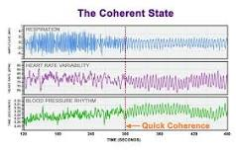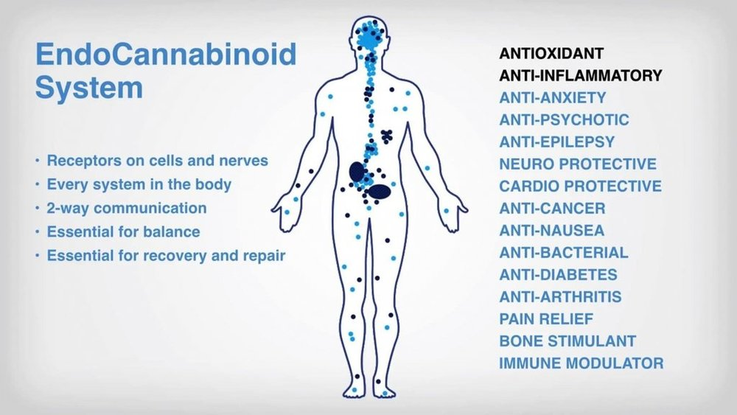

Recent Publications (minimum 5)
Int J Mol Sci. 2018 Mar; 19(3): 833.

Published online 2018 Mar 13. doi: 10.3390/ijms19030833
PNAS October 30, 2018 115 (44) 11215-11220; first published October 15, 2018 https://doi.org/10.1073/pnas.1803630115

The Epigenetics of the Endocannabinoid System - NCBI
www.ncbi.nlm.nih.gov › pmc › articles › PMC7037698

Cultural Trauma and Epigenetic Inheritance
Lehrner, A., & Yehuda, R., Development and Psychopathology, 2018
International Center for the Study, Prevention and Treatment of Multigenerational Legacies of Trauma
Yael Danieli, PhD, at yaeld@aol.com
International Handbook of Multigenerational Legacies of Trauma
Danieli, Y. Springer, 1998
Intergenerational Perceptions of Mass Trauma’s Impact on Physical Health and Well-Being
Bezo, B., & Maggi, S., Psychological Trauma: Theory, Research, Practice, and Policy, 2018

Biography (150 word limit)
Sarah Larsen M.D. - A Third Generation Palm Reader, Medical Intuitive, and Transformational Leader. Since she received a degree as a Medical Doctor from the Medical University of the Americas, she has taught tens of thousands of people to heal themselves, elevate the way they think, speak, and ultimately how they live.
Her areas of expertise and training include:
Allopathetic (Western Medicine), Ayurvedic Medicine, Epigenetics, Edgar Cayce Medicine, Gersion Therapy, Homeopathy,
Energy Healing, & Anthroposophic Medicine.

Notes/Comments:

