Lifestyle disease and social context: Tackling Obesity in Children
Dr. Roma Sarnaik, MBBS, Master’s in Physical Activity and Health, Master’s in Nutrition in Practice, India

Abstract

Obesity is a common health issue worldwide. In addition, newer generations are turning obese at younger ages, at a faster rate and remaining obese for extended years, compared to older generation. This is because they are not meeting the physical activity guidelines and are in turn storing the excess food they consume as fat deposits in their bodies, which leads to numerous health complications in the long run. These health complications make the process of tackling obesity even more difficult, affecting the quality of life of the child. The current lockdown due to covid-19 has made the situation more challenging.
Childhood obesity shows socioeconomic inequality and costs a huge amount to the healthcare system. Social marketing initiatives across the globe have shown a positive trend in helping people lead healthier lifestyles. Nudging is one of the recent and most effective ways to make better choices at a subconscious level. When applied along with other behavior change theories, it can have significant benefits.
Recent childhood obesity prevention and treatment programs have targeted parents, showing that parents can act as a factor of change in a child’s obesity prevention/ treatment journey. Moreover, social marketing can play a crucial role in achieving target behavior changes to improve health. A multi-level approach to obesity prevention and treatment is shown to have maximum results. Targeting different aspects of children’s lives with the involvement of their close ones can have enormous benefits. This will in turn lead to healthier and disease-free future generations.

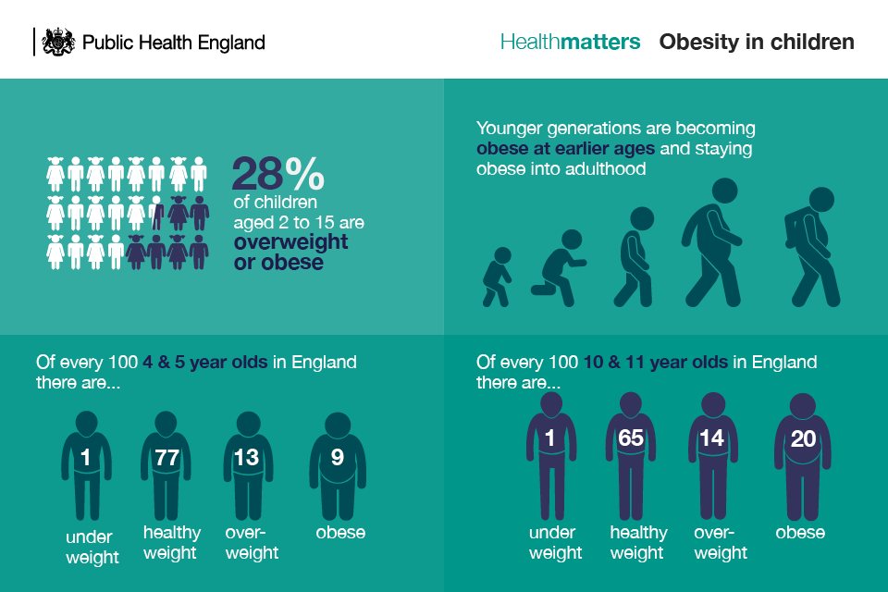

 Biography
Dr. Roma Sarnaik is an expert Lifestyle Medicine Consultant and Counselor, skilled in Healthy Behavior Change Counselling and Sustainable Lifestyle, Fitness consultation for various health conditions, Nutritional consultation for various lifestyle diseases, Health and Wellness consulting. She is a strong Healthcare services (MBBS) professional with Masters’ degree focused on Nutrition in Practice and Physical Activity and Health from (Leeds) England. She has pursued multiple subspecialty courses in Nutrition, Wellness and Chronic Diseases from British Nutrition Foundation and British Society of Lifestyle Medicine. She is the founder of Dr. Roma’s Lifestyle Medicine and is currently practicing in Nagpur, India. Having herself experienced the enormous benefits of lifestyle medicine, her aim is to help as many people as possible in the coming years and “make healthy living normal”.

Email: drromasarnaik@gmail.com

Notes/Comments:

