Treating type 2 diabetes as a problem of insulin resistance:

Use of low-carb and intermittent fasting in India
Roshani Sanghani, MD, Endocrinology
(American Board of Internal Medicine), Mumbai, India

Abstract
India is facing an alarming increase in the type 2 diabetes epidemic. While genetics do play a role, lifestyles including processed food, refined carbohydrates, sedentary patterns, poor quality sleep, lack of strength training, protein-deficient diets and chronic stress have accelerated the disease trends in the last decade. Treating type 2 diabetes as a problem primarily of insulin resistance means shifting the focus from lowering glucose to lowering insulin, using the twin-cycle hypothesis[1]. The fact that a low-carbohydrate approach is a viable way to reduce the prescription burden is an established treatment principle endorsed by the American Diabetes Association[2]. The use of therapeutic fasting to reverse insulin resistance has now been reported[3]. We share our clinical experience with this case report of a 58-year-old male with a history of type 2 diabetes since 2005. When we first evaluated him in November 2019, he weighed 110 kg, and his HbA1c was 13.2% despite taking 70 units of basal insulin and 50-55 units of bolus insulin three times a day (total daily dose ~220 units). His fasting C-peptide level was 1.95 ng/ml confirming pancreatic beta-cell function. He commenced a low carbohydrate diet under close medical supervision, with protein intake of 0.8-1.0 gram per kilogram reference body weight over three main meals, from both plant and animal sources. With the addition of healthy unprocessed fat, his appetite reduced, and we started him on intermittent fasting. Over the next six months, we stopped his insulin dose and kept him on metformin alone. He experienced one episode of hypotension and presyncope attributed to low sodium intake, after which we tapered his anti-hypertensive medication. He has lost 23 kilograms, started exercising, the HbA1c has dropped to 8.2% and the triglycerides are down from 184 mg/dl to 83 mg/dl.. We now have him on a fasting regimen of 36 to 48 hours while consuming approved fasting fluids. We are confident that his blood work will be even better at the next evaluation.

Image
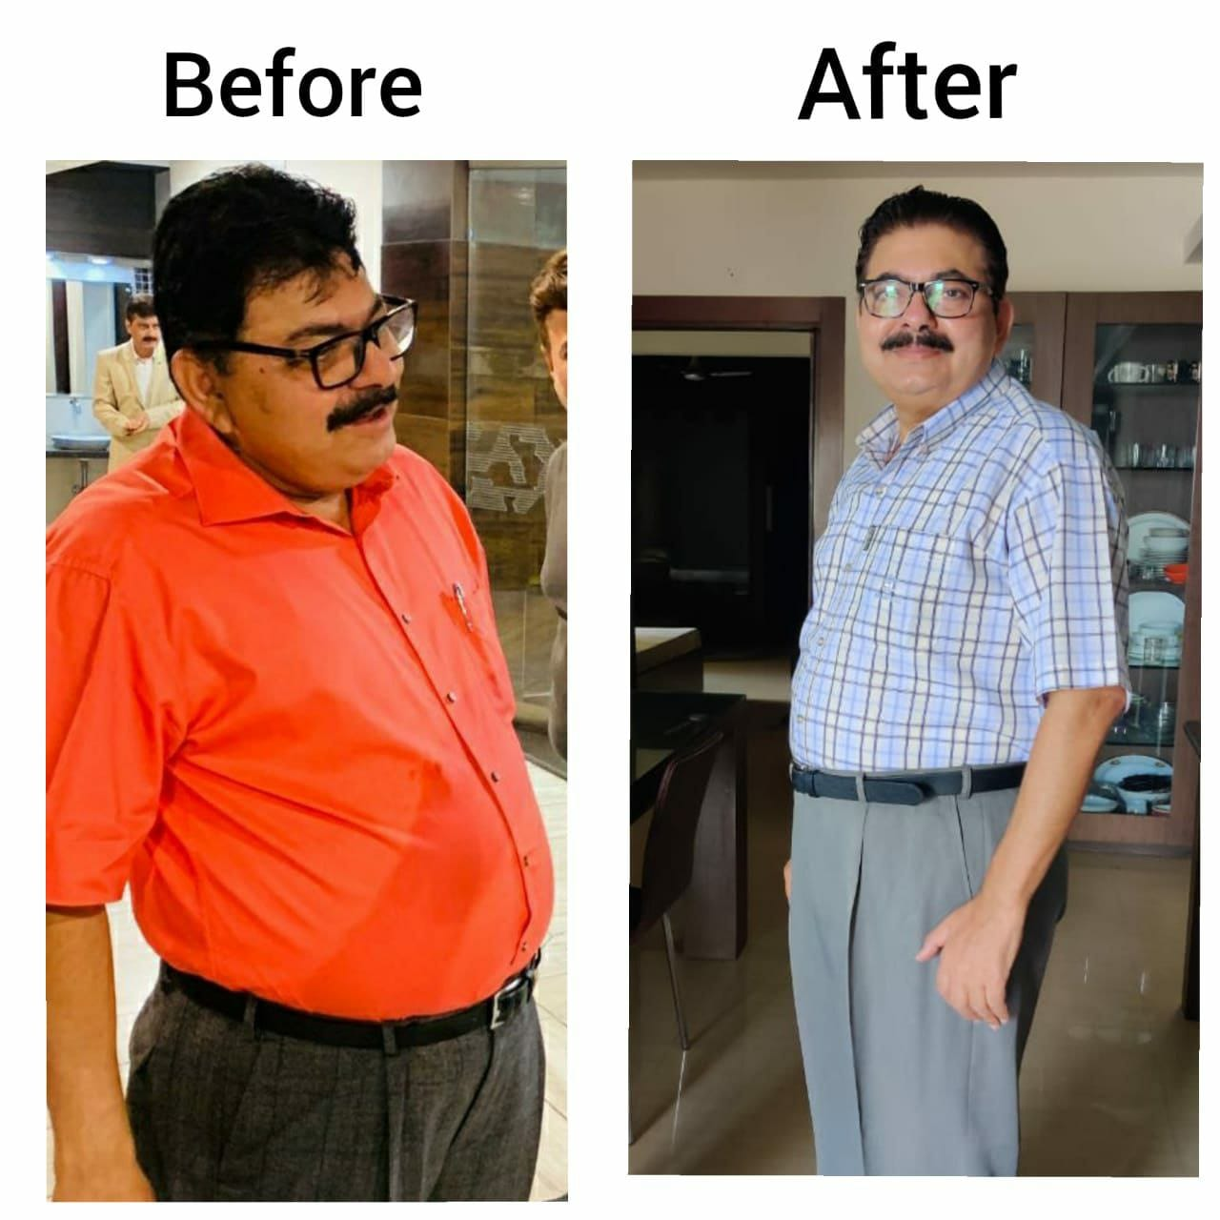

Biography
Dr Roshani Sanghani is an American Board Certified endocrinologist with over 15 years of international clinical experience. She is the founder of Aasaan Health Solutions, LLP, a lifestyle medicine based endocrine centre, in Mumbai, India. She also practices telemedicine and her passion is to help clients to reverse insulin resistance and related conditions like Type 2 diabetes, PCOS, obesity, fatty liver and hypertension through solutions aimed at nutrition, sleep, exercise, intermittent fasting, stress management and mindfulness. She believes that behaviour change is all about helping clients understand the emotions driving their habits and using medical expertise integrated with a coaching style of patient empowerment. Her clinic motto is “Better Health, Less Medication”.
Email: connect@aasaanhealth.com

Notes/Comments

