Oral Health and its local and systemic effects on chronic disease development: Bacterial dysbiosis, bacterial translocation and inadequte border control add to new mechanisms of disease development.

Pete Williams M.Med.Sci. CSCS IFMCP, Functional Medicine Associates London

Abstract.
As medicine moves to a systems biology approach to chronic disease management, the emerging literature on the oral microbiome and oral health cannot be ignored. In many chronic diseases such as obesity, type 2 diabetes, alzhiemers, cancer and rheumatoid arthritis there is a translocation of oral bacteria from the mouth into different areas of the body. This causes immune activation, inflammation and oxidative stress and contributes to the disease progression if unchecked.
This lecture briefly explores the links between various chronic diseases and oral pathogenic bacteria, the influence on appropiate barrier control (oral, gastrointestinal and blood brain barrier) and the mechanisms that may drive these barriers to be compromised. It will blend patient examples and propose new concepts of thinking as far as treatment strategies.

Image: Periodontal pathogens on oral testing.
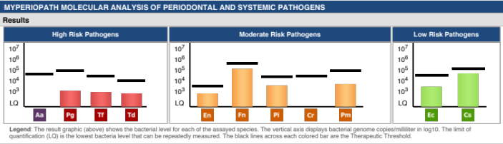

Recent publications:

- Bale BF, Doneen AL, Viigerust DJ (2017) High risk periodontal pathogens contribute to the pathogenesis of atherosclerosis. Postgrad Med J 93: 215-220.
- IIievski V et al (2018) Chronic oral application of a periodontal pathogen results in brain inflammation, neurodegeneration and amyloid beta production in wild type mice. PLoS ONE 13 (10): e0204941
- Van de Guchte et al. (2018) Humans as holobionts: implications for prevention and therapy. Microbiome 6:81
- Deo PM & Deshmuck R Oral microbiome: Unveiling the fundamentals (2019) J. Oral Maxillofac Pathol Jan-Apr: 23(1): 122-128
- Tetz G (2020) Bacteria DNA promotes Tau aggregation. Nature Scientific reports 10:2369
__________________________________________________________________________________________


Biography: Founder of Functional Medicine Associates Pete is an exercise and medical scientist with an expertise in applying “Systems Biology” to chronic disease. In 2013 he was in the first cohort (worldwide) to be awarded Institute for Functional Medicine Certified Practitioner status and has represented the Institute for Functional Medicine as a Clinical Innovator. Pete has had over 20 years of experience applying Functional Medicine in clinical practice. He is Bredesen trained and over the last 5 years he and his team have become increasingly interested in brain health, cognitive decline and neuroinflammation, with an interest in border control, genetics, microbiome and the “exposome”

Email: pete@fm.associates

