A Swimming Coach’s Approach to Permanent Lifestyle Change
Ruben J Guzman, MPH, LMP, United States

Abstract

Do you want the rest of your life to be the best of your life? Yes?

Imagine, how do you want your health and life to be?

Filled with vitality, energy, fun? Free of pain? Freedom of mobility? Yes?

But, where are you now?

Have you got health issues, concerns, difficulties perhaps?

What will it take for you to go from where you are now to where you want to be?

Do you have a plan? But, more importantly, do you have a plan that’s proven to work?

Chances are you don’t.

I have a proven plan for you. And, I'm living proof. 25 years ago, I was 55 pounds heavier, with high cholesterol, high blood pressure and high blood sugar. I had issues, and the nurse practitioner told me I had issues, but I didn’t care. I was depressed. Then, after my friend called me "chubby" one day while I was coaching my swimmers, I had to get mad at myself and take control of my health. I then decided to USE what I had learned from all those years of being a competitive swimmer and a coach. Applying what I had learned, I lost all the weight in about a year and completely changed my lifestyle. I have been healthy and fit ever since. But, more importantly, I have been teaching hundreds to do the same for themselves for over 24 years. I offer no short cuts or easy fixes. But, what I do offer WORKS if you work the process. It’s no mystery and it’s no secret.

I suggest that there are FOUR STEPS to creating a permanent lifestyle change:

> Begin from within – rewire the subconscious and change mindset, thinking and consciousness.

> Learn a proven strategy – cannot continue to do the same things expecting different results.

> A new system for support and accountability to sustain mindset and behaviors.

> Create consistency and new habits through disciplined, committed actions and behaviors.

Image
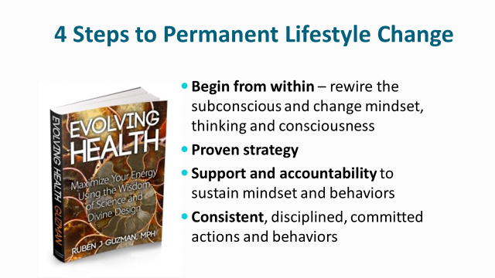

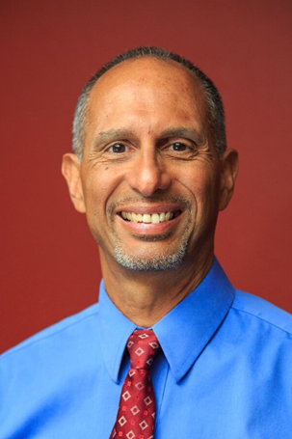

Ruben J Guzman, MPH, LMP is the author of Evolving Health and living proof of what it takes to lose weight, eat healthy and stay fit. Ruben possesses over 40 years of experience in the health field: attended 3 years at the UC Davis School of Medicine, holds a Master’s degree in Public Health from UCLA specializing in behavioral sciences/health promotion, and is a Board Certified Lifestyle Medicine Professional from the American College of Lifestyle Medicine. He has helped many of his clients to completely reverse their diabetes, heart disease and cancer markers. Ruben has also professionally coached swimming for over 40 years, having developed many champions and championship teams. He is the author of The Swimming Drill Book, the internationally best-selling primer for competitive swimming technique. Having gone through his own health challenge and then losing 50+ pounds in 1995, Coach Ruben provides a living demonstration of what it takes to enjoy a lifestyle filled with energy, vitality and productivity.
Email:coachruben@coachruben.com

