Resveratrol encapsulation for a new application in Age-Related Macular Degeneration

Alaimo A¹, Buosi FS¹, Chaufan G¹, Di Santo MC¹, García Liñares G², Pérez OE¹

¹ Department of Biological Chemistry, Faculty of Exact and Natural Sciences, University of Buenos Aires. IQUIBICEN-CONICET. Argentina.
² Department of Organic Chemistry, Faculty of Exact and Natural Sciences, University of Buenos Aires. UMYMFOR-CONICET. Argentina.

Abstract

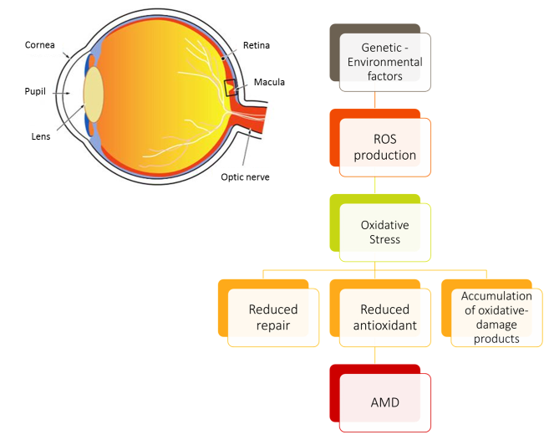
Age-related macular degeneration (AMD) is a progressive retinal disease and is the leading cause of visual impairment in elderly people in western countries, for which there is still no cure. Genetics, environmental insults, and age-related issues are risk factors for the development of the disease, and, all these risk factors of them are linked to the induction of oxidative stress. In addition, degeneration of retinal pigment epithelial cells (RPE) is a crucial causative factor responsible for the onset and progression of AMD.

With the population aging, AMD will gradually become in a globally prevalent disease. The decline in the quality of life among affected patients highlights a critical need for developing preventive strategies. In this sense, phytochemicals with both antioxidant and anti-inflammatory properties may have a potential role in the prevention and treatment of this ocular disease. Particularly, there is an increased interest in the therapeutic effects of Resveratrol (RSV). RSV (3, 5, 4’-trihydroxy-stilbene) is a naturally occurring polyphenolic compound from the stilbenes family, mainly found in black grape and peanuts. Previous studies have demonstrated the various beneficial effects of RSV on human health, including its neuroprotection, anti-inflammatory action, potent antioxidant activity and antiaging effects. Our research line is focused in investigating the protective effectiveness of RSV in an in vitro model of AMD. In addition, we are designed and developed argentinean chitosan-based nanocarriers for RSV encapsulation to overcome physicochemical and pharmacokinetic limitations such as poor oral bioavailability, low water solubility and photosensibility.

To date, our findings denote that RSV represents an attractive natural bioactive for therapeutic intervention against aging diseases associated with oxidative stress such as AMD.

Image

Recent Publications
- Ao J, Wood JP, Chidlow G, Gillies MC, Casson RJ (2018) Retinal pigment epithelium in the pathogenesis of age-related macular degeneration and photobiomodulation as a potential therapy? 46:670-686.
- Andrade S, Ramalho MJ, Pereira MDC, Loureiro JA. (2018) Resveratrol Brain Delivery for Neurological Disorders Prevention and Treatment. Front Pharmacol. 9:1261.
- Kompella UB1, Amrite AC, Pacha Ravi R, Durazo SA. (2013) Nanomedicines for back of the eye drug delivery, gene delivery, and imaging. Prog Retin Eye Res. 36:172-98.
- Prudkin Silva CP, Martinez JH, Martinez KD, Farias ME, Coluccio-Leskow F, Perez OE. 2018. Proposed molecular model for electrostatic interactions between insulin and chitosan. Nano-complexation and activity in cultured cells. Colloids Surf A Physicochem Eng Asp. 537: 425-34.
- Alaimo A, García-Liñares G, Bujjamer J, Gorojod RM, Porte Alcón S, Baldessari A, Grecco HE, Kotler ML. Toxicity of blue led light and A2E is associated to mitochondria dynamics impairment in ARPE-19 cells. Implications for Age-related Macular Degeneration. Arch of Toxicol. Under review.


Biological Chemistry PhD. Birth date: 31st July 1981. Young assistant Researcher at the National Scientific and Technical Research Council (Spanish: Consejo Nacional de Investigaciones Científicas y Técnicas, CONICET), the Argentine government agency which directs and co-ordinates most of the scientific and technical research done in universities and institutes. I am a highly motivated and innovative cellular and molecular biologist with specialization in mitochondria biology, molecular genetics, cell biology, biochemistry and nanotechnology. Enthusiastic team player adept at providing leadership while also learning from fellow team members. Effective communicator that can conceptualize complex biological to audiences with varied expertise.
Email: agusalaimo@gmail.com; aalaimo@qb.fcen.uba.ar
Notes/Comments:

Autonomous City of Buenos Aires, January 17th 2019

Dear Lifestyle Related Diseases and their Management Strategies Committee

I am post-doctoral/young researcher at the Institute of Biological Chemistry of the School of Sciences of University of Buenos Aires (IQUIBICEN–UBA).
I would like to present my research as first author in the Lifestyle Related Diseases and their Management Strategies Congress that will take place in Paris, France between 27-28 March 2019. Argentina is suffering a big financial problem that highly and directly affect to Science Research. Our fundings are poor and they are only destiny in buying the more necessary reagents and we cannot pay any registration. I will solve the cost of air travel from Buenos Aires-Paris-Buenos Aires by my own. Therefore, it would be extremely valuable for me to complete the possible attendance to this high level Congress by giving the opportunity to access for an exception for the payment registration.

Thank you for your time and consideration

Yours faithfully,



Agustina Alaimo, PhD,
Postdoc/Assistant Researcher of CONICET
Buenos Aires, Argentina
School of Sciences, IQUIBICEN, CONICET
Ciudad Universitaria, Pab II
5411-4576-3342
agusalaimo@gmail.com
aalaimo@qb.fcen.uba.ar

