Empowering Diabetes Care: Development and Evaluation of a Smart Medication Reminder and Glucose Tracking App for Patients in Uganda
Angela R. Wells* | City University of Seattle Washington School of Business Healthcare Informatics and International Management, Seattle, WA, USA | Angela.Wells16@yahoo.com
Leonard Kurusagireh Bakahika | Health Science Management North Umbria University of United Kingdom, Uganda | bakakuru@yahoo.co.uk
Muhindo Reuben | Kases Diabetes Empowerment Consultant Limited, Uganda | reubenmuhindo91@gmail.com
Steven Tsongo | Kitagwenda Medical Center, Uganda | tsongosteve@gmail.com
Justus Ahimbisibwe | Kitagwenda Medical Center, Uganda | Justusahimbisibwe@gmail.com
Zacchaeus Oluwole | Full stack IoT Engineer and Solution Architect, Nigeria. | zacchaeusoluwole@gmail.com
Philip Adewuyi | Department of Electrical Engineering, Wigwe University, Nigeria | solaadewuyi@gmail.com
*Corresponding author

Abstract
Diabetes management is a considerable public health challenge in Uganda, as rising incidence rates necessitate novel solutions to assist patients in their daily health regimens. This study introduces a Smart Medication Reminder and Glucose Tracking Application tailored for diabetes patients in Uganda. The application incorporates reminders for medication compliance, daily glucose tracking, and tailored health advice, enabling individuals to manage their condition more efficiently. The application mitigates literacy and accessibility difficulties encountered by numerous patients in the region through an intuitive interface and support for local languages. Moreover, the application's data analytics functionality enables healthcare personnel to remotely track patient compliance and glucose levels, thereby permitting prompt interventions. The findings of a pilot study demonstrate enhanced medication adherence and improved glycemic control among participants, underscoring the potential of mobile health technologies to advance diabetes management in Uganda. This study highlights the significance of culturally pertinent digital health solutions in managing chronic diseases in resource-constrained environments.
[Put the information from above into the table below. If one of the rows does not apply to this paper, you can delete the row or leave it blank.]
Aim/Purpose | To provide a solution to lack of proper diabetes management amongst the Ugandan populace who fail to take their medications as and when due and lack access to proper blood sugar status information.
Background | This paper provides a smart medication reminder and glucose tracking application for diabetes patient in Uganda
Methodology | The application incorporates reminders for medication compliance, daily glucose tracking, and tailored health advice, enabling individuals to manage their condition more efficiently. The application mitigates literacy and accessibility difficulties encountered by numerous patients in the region through an intuitive interface and support for local languages. Moreover, the application's data analytics functionality enables healthcare personnel to remotely track patient compliance and glucose levels, thereby permitting prompt interventions.
Contribution | The use of mobile applications for diabetes management is significant to bringing about the desired control of diabetes spread and emergencies.
Findings | The findings of a pilot study demonstrate enhanced medication adherence and improved glycemic control among participants, underscoring the potential of mobile health technologies to advance diabetes management
Recommendations  for Practitioners | This technology should be adopted for improved diabetes management and control.
Recommendations  for Researchers | Efforts should be made to integrate this technology to basic vitals taking procedures to save and resources.
Impact on Society | Pressure on public health facilities would reduce significantly.
Future Research | Integrating a video and voice procedure of the application’s usage and data interpretation to all categories of users.
Keywords | diabetes, smart medication, glucose level, health app, patient empowerment, public health

Introduction
Diabetes is a condition in which the blood glucose is too high as a result of insulin problems (ElSayed et al., 2023). This results in too much sugar in the blood and always leads to health problems. These problems could be nerve damage, which is also known as neuropathy. Neuropathy could make the fingers, hands, toes, and feet numb or tingling, burning or shooting pains (Elafros et al., 2022). In short, there are two types of diabetic complications; chronic complications and acute complications (Anaabawati et al., 2021). The chronic complications include eye problems, foot problems, heart attack and stroke, kidney problems, nerve damage, gum disease, related conditions like cancer, sexual problems in women, and sexual problems in men. When there are acute complications, there are hypos (when blood glucose are too low); hypers (when blood glucose are too high); Hyperosmolar Hyperglycemic state (a life-threatening emergency), and Diabetic Ketoacidosis (DKA) which is also a life-threatening emergency due to build-up of ketones (Susanti & Bistara, 2022).
Unfortunately diabetes cannot be cured by any presently known medication (Guedes & Pecoits‐Filho, 2022). However, it can be managed (Calli & Kartal, 2021). Part of the means of managing the disease include but are not limited to healthy eating, exercise, and medicine (Alam et al., 2021). Out of the listed methods of managing diabetes, many people that suffer from diabetes, many times find it difficult to eat healthy and exercise due to economic and inherited unhealthy lifestyle tradition, especially, in Uganda (Patrick et al., 2021). The last way of managing diabetes is using medication, which can bring about the needed results (Hahr & Molitch, 2022). However, due to lifestyle and shortage of nurses or home supports for diabetes sufferers, many forget to take their medications on a regular basis (Ingenhoff et al., 2023). However, the results of conventional methods of diabetes treatment and other non-digital methods did not show significant improvements despite the efforts of government and non-profit organizations in reducing and controlling the rate of critical emergencies in Uganda (Moor et al., 2022). Glucose tracking is another activity that is important to observe in the management of diabetes. This glucose tracking or blood sugar monitoring is carried out with the use of a glucose meter which determines the glucose levels in cells’ fluid (Kibirige et al., 2023). On the other hand, Continuous Glucose Monitoring (CGM) is more desirable as it involves automatic estimation of blood glucose level throughout the day and night (Battelino et al., 2023). CGM uses a sensor that senses the glucose level in the blood and a transmitter which sends the receiver or App on a smartphone. This feature makes CGM more compatible with App without extra provisions for additional devices (Pullano et al., 2022).
This identified problem led to the development of smart medication reminder and glucose tracking App for patients in Uganda whether in the rural or urban centers of the country.
The rest of the paper is divided into the following sections: materials and method, results, discussion, and conclusion.

Materials and Method

Study Population and Eligibility
50–100 diabetic patients (Type I & II) were targeted as subjects for the investigation. This study considered the eligibility criteria to include people diagnosed with diabetes for at least 1 year, people who owned an Android Phone or their family members capable of running offline tracking, and people willing to use the app for 10 weeks. This implies that the project ran for ten weeks, from February 5, 2025, to April 15, 2025, targeting improved medication adherence, glucose tracking, and health outcomes for patients with Type 1 and Type 2 diabetes in Uganda with exact locations being Ebenezer Clinic and Diagnostic Centre, Ibanda Main Street and Ebenezer Wellness Centre, Jubilee Street.

Inclusion and Exclusion Criteria
Participants were required to have a confirmed diagnosis of Type 1 or Type 2 diabetes for at least one year and own an Android smartphone (or have a family member with one) while patients with severe complications requiring hospital admission were excluded.

Participant Enrollment
Nineteen diabetic patients were identified. Seventeen met the inclusion criteria and were trained and enrolled in the app. Two were excluded due to their preference for paper records over digital tracking, reflecting a conservative mindset. of the 17 enrolled. However, three missed follow-up appointments and could not be reached. Two could not record blood sugar levels due to lacking glucometers and inability to afford private testing. Twelve completed the 10-week evaluation, despite minor challenges.

The App Interface and Features
The app welcome interface is shown in Figure 1. It comes with the name Diabetes Manager which displays two buttons: one for smart pills that is solely responsible for reminding the patient of the time of taking medications, the second button is the blood sugar information user interface where useful data are entered for thorough evaluation and interpretations. The Diabetes Management App is designed to assist users in tracking their glucose levels, managing appointments, and receiving smart pill reminders. Developed using Flutter, this Android application provides a seamless experience through features like glucose level tracking, data deletion, PDF export capability, trend visualization with syncfusion charts, pill reminder system with notifications and local storage.
For the smart pills section, its feature helps users schedule and track their medication intake. In case of wanting to stop the alarm generated through activation pill taking interval timer, two ways could be used, that is, via Notification bar at the top of the phone. Select the option labeled “Stop the alarm” to stop the alarm. The second way is via the App where an option for stopping or snoozing is available allowing the user to stop the alarm or snooze the alarm to silence it for one minute before it rings again. There is also the appointment section with features that allow users to set reminders for their medical appointments. The appointment reminder alarm can be stopped via the notification bar where the stop option is selected and two, via the app. Blood Sugar Section: Allows users to track glucose levels over time. Data Management: Users can delete old data or export it as a PDF. Trend Visualization: Utilizes Syncfusion Charts for data analytics and insights. The Diabetes Management App ensures a smooth and user-friendly experience by integrating smart notifications, real-time tracking, and easy access to essential health data.
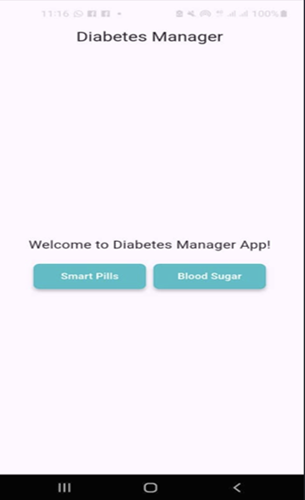
Figure 1. The welcome page

Results
In addition to the medication time alert sound that the App sends, consistent usage of the glucose tracker App is plotted as a graph. This allows the App user to consistently monitor the progress recorded in terms of diabetes management as shown in Figure 2.
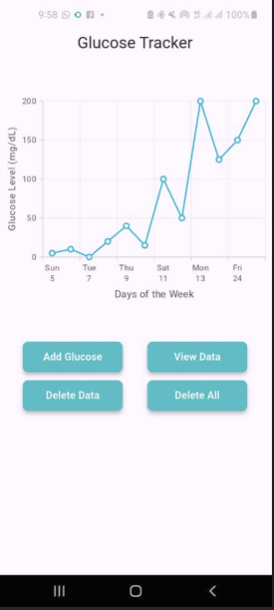
Figure 2. Glucose tracker
Glucose tracker is of the App interface is displayed in Figure 2. This would monitor the amount of sugar in the blood and make adequate readings possible. Figure 3 shows the sample of the displayed glucose data on the App.
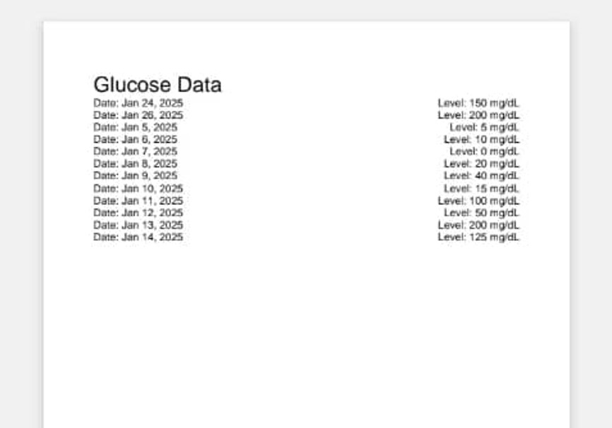
Figure 3. Glucose data on the App

Discussion
The results obtained from the App usage show that the participants were eager to use the functionalities of the App. Moreover, it makes their adherence to taking of their medicine promptly easy. The response as to the contribution of the App has made a contribution to the overall goal of managing the healthy lifestyle of people with diabetes. The App with consistency in the habit of users inherently became a part of their lifestyle. The direct reading and interpretation of results per individual bythe individual makes this App simple to use and attractive to all irrespective of gender, race, religion, and language affinity. Again, majority of the App users indicated interest in using this App reminder frequently. For the glucose tracking section, some participants in the survey confirmed that they were not used to checking their glucose level prior to the introduction of the App. Upon the introduction of the App to them, they could track their blood glucose with ease and consistency. In terms of accuracy in the results obtained with the use of the App, it was confirmed that the App’s result was accurate when compared with the use of glucometer (glucose meter).
In terms of logging the glucose level in the App, the respondents confirmed the simplicity of the process with the App. In the area of navigating the App’s features, the respondents stated that the App was simple to navigate. Its features were not clumsy and ambiguous. This is a testament to the core principle of App design for acceptability and wide applicability. Moreso, the App’s notification was easy to understand for all users. Furthermore, the crashes in the operational features of the App were not frequent showing its reliability and ruggedness. This would make the App withstand the test of time. It was discovered that the users prefer the usage of the App as medication reminder to glucose tracking. This is an indication of lifestyle of a typical Ugandan as it relates to the use of modern technology. From the point of view of the App users, the App is complete in terms of performance as it were. Invariably, the usage of the App, especially to track glucose suffers a setback when glucose strips were not available. In addition, smart phones are required for the deployment of the App.

Conclusion
The developed smart medication reminder and glucose tracking App has been able to assist newly diagnosed patients in Uganda who were known to struggle with poorly controlled blood sugars and often experiencing hypoglycemia without recognizing it. The App’s frequent glucose tracking feature addressed this by enabling early detection of trends. Patients could now identify hypoglycemic episodes promptly, reducing risks and improving management. One notable case involved a patient with recurrent complications and high random blood sugar levels. Previously, without records, it was difficult to pinpoint whether the issue was low-potency medication or acute hyperglycemia. Most sufferers attributed the worsening of their conditions to a busy schedule. Within four weeks of app usage, recorded data revealed the drug’s inadequacy. After switching to a more effective molecule, the next visit showed fasting blood sugars consistently between 94 mg/dL and 126 mg/dL which was a marked improvement. So, the App has been able to encourage individuals to take their diabetes medications as and when due. The progress made is monitored on the glucose tracking feature of the App. However, there is need for mindset shift as some participants resisted digital records due to their conservative attitudes. Future efforts should prioritize education and awareness of the populace to encourage the adoption of this new technology. Lack of access to smartphones is a limitation for many potential participants who lack smartphones, limiting inclusivity. If the economic climate is good, provision of affordable devices could broaden the wider reach of the effort to manage diabetes effectively amongst the people of Uganda. The technical improvement of the App in terms of updating is a possibility. The data unit flexibility is also a desire as the App currently uses only mg/dL which confuses illiterate patients unfamiliar with conversions. Adding mmol/L or a conversion tool could improve usability. Decimal precision feature is desired as the App currently rejects decimal points, logging readings like 98.5 as zero. Enabling decimal input would enhance accuracy and user trust. These adjustments could be addressed in a subsequent study to refine the app’s effectiveness.

References
Alam, S., Hasan, M. K., Neaz, S., Hussain, N., Hossain, M. F., & Rahman, T. (2021). Diabetes Mellitus: Insights from epidemiology, biochemistry, risk factors, diagnosis, complications and comprehensive management. Diabetology, 2(2), 36–50. https://doi.org/10.3390/diabetology2020004
Anaabawati, M. A., Rumahorbo, H., & Pujiastuti, R. S. E. (2021). Effectiveness of cognitive behavioral therapy and muscle relaxation on fasting blood sugar levels among type 2 diabetes mellitus: A systematic review. International Journal of Nursing and Health Services, 4(2), 153–161.
Battelino, T., Alexander, C. M., Amiel, S. A., Arreaza-Rubin, G., Beck, R. W., Bergenstal, R. M., & Phillip, M. (2023). Continuous glucose monitoring and metrics for clinical trials: An international consensus statement. The Lancet Diabetes & Endocrinology, 11(1), 42–57. https://doi.org/10.1016/S2213-8587(22)00319-9
Calli, D., & Kartal, A. (2021). The relationship between self-efficacy of diabetes management and well-being in patients with type 2 diabetes. Nigerian Journal of Clinical Practice, 24(3), 393–399. https://doi.org/10.4103/njcp.njcp_280_18
Elafros, M. A., Andersen, H., Bennett, D. L., Savelieff, M. G., Viswanathan, V., Callaghan, B. C., & Feldman, E. L. (2022). Towards prevention of diabetic peripheral neuropathy: Clinical presentation, pathogenesis, and new treatments. The Lancet Neurology, 21(10), 922–936. https://doi.org/10.1016/S1474-4422(22)00188-0
ElSayed, N. A., Aleppo, G., Aroda, V. R., Bannuru, R. R., Brown, F. M., Bruemmer, D., & Gabbay, R. A. (2023). Introduction and methodology: Standards of care in diabetes. Diabetes Care, 46(1), 1–4. https://doi.org/10.2337/dc23-Sint
Guedes, M., & Pecoits‐Filho, R. (2022). Can we cure diabetic kidney disease? Present and future perspectives from a nephrologist’s point of view. Journal of Internal Medicine, 29(2), 165–180. https://doi.org/10.1111/joim.13424
Hahr, A. J., & Molitch, M. E. (2022). Management of diabetes mellitus in patients with CKD: Core curriculum 2022. American Journal of Kidney Diseases, 79(5), 728–736. https://doi.org/10.1053/j.ajkd.2021.05.023
Ingenhoff, R., Munana, R., Weswa, I., Gaal, J., Sekitoleko, I., Mutabazi, H., & Nalwadda, C. K. (2023). Principles for task shifting hypertension and diabetes screening and referral: A qualitative study exploring patient, community health worker and healthcare professional perceptions in rural Uganda. MC Public Health, 23(1), 881. https://doi.org/10.1186/s12889-023-15704-w
Kibirige, D., Sekitoleko, I., Lumu, W., & Nyirenda, M. J. (2023). Type 2 diabetes progression in an adult Ugandan population with new-onset diabetes: An observational prospective study. BMC Primary Care, 24(1), 214. https://doi.org/10.1186/s12875-023-02169-4
Moor, S. E., Tusubira, A. K., Wood, D., Akiteng, A. R., Galusha, D., Tessier-Sherman, B., & Schwartz, J. I. (2022). Patient preferences for facility-based management of hypertension and diabetes in rural Uganda: A discrete choice experiment. BMJ Open, 12(7), e059949. https://doi.org/10.1136/bmjopen-2021-059949
Patrick, N. B., Yadesa, T. M., Muhindo, R., & Lutoti, S. (2021). Poor glycemic control and the contributing factors among type 2 diabetes mellitus patients attending outpatient diabetes clinic at Mbarara Regional Referral Hospital, Uganda. Diabetes, Metabolic Syndrome and Obesity, 3123–3130. https://doi.org/10.2147/DMSO.S321310
Pullano, S. A., Greco, M., Bianco, M. G., Foti, D., Brunetti, A., & Fiorillo, A. S. (2022). Glucose biosensors in clinical practice: Principles, limits and perspectives of currently used devices. Theranostics, 12(2), 493. https://doi.org/10.7150/thno.64035
Susanti, S., & Bistara, D. N. (2022). Relationship between stress level and increased blood sugar levels in patients with diabetes mellitus. Jurnal Keperawatan Respati Yogyakarta, 9(3), 181–186. https://doi.org/10.35842/jkry.v9i3.692

Authors
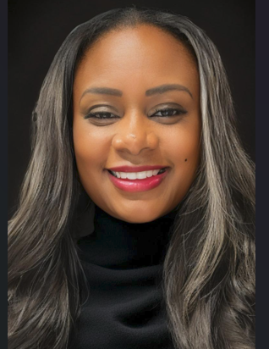
Prof. Angela Wells, MBA, Cloud Engineer is a healthcare technologist, educator, and developer of the Smart Pills Medication Reminder App, designed to improve medication adherence and diabetes management in underserved communities. With over 26 years of experience in healthcare leadership and informatics, she has spent the past 10 years as a Professor of Healthcare Administration at City University of Seattle, where she also teaches Healthcare Administration and MBA programs. Angela has taught and mentored students across the globe in countries like Australia, China, Vietnam, Dubai, Mexico, Uganda, and Nigeria. She serves as the CEO cum Technology Specialist at CyberFemmeHubs and Technical Advisor to the Kathmandu Institute of Child Health (KIOCH) in Nepal. Prof. Angela is a seasoned global collaborator with the University of Port Harcourt Teaching Hospital in Nigeria where she is advancing AI-powered BMI diagnostic tools and inclusive healthcare technologies which have been acclaimed to be first in the continent. Prof. Angela is also a Louisiana Rotarian District 6190 CASA volunteer, and a passionate advocate for women and children health and inclusive leadership. Prof. Wells led a project titled “Smart Medication Reminder App” deployed to the undeserved in rural communities in Uganda which received Gian Marco Moratti Award 2025 for leaders for Sustainable Economy in Italy. This well-deserved award was organized by E4Impact Foundation, Milan, Italy.
Prof. Well continues to be a trailblazer in the field of robotics and AI-driven projects to aid healthcare delivery especially for women in undeserved communities across the globe. Prof. Wells is a philanthropist per excellence. Indeed, she is a blessing to humanity.

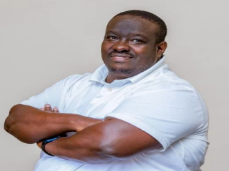
BAKAHIKA Leonard Kururagireh is the in Uganda who is keen on adavncing healthcare accessibility and drive using modern technology. He was a key player in the development of Smart Pills Medication Reminder App, designed to improve medication adherence and diabetes management in underserved communities. He is founder and medical director of Ebenezer Wellness Center in Uganda. Dr. Barahika is a recipient of Gian Marco Moratti Award 2025 as a leader for Sustainable Economy for his project titled “Smart Medication Reminder App” in Uganda. This well-deserved award was organized by E4Impact Foundation, Milan, Italy.

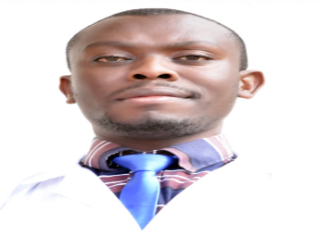
MUHINDO Reuben, a medical practitioner at Kases Diabetes Empowerment Consultant Limited in Uganda. He is keen on advancing healthcare accessibility and drive using modern technology. He was a key player in the development of Smart Pills Medication Reminder App, designed to improve medication adherence and diabetes management in underserved communities.

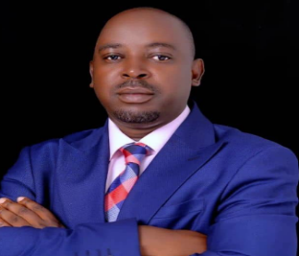
JUSTUS Ahimbisibwe, a medical practitioner at Kitagwenda Medical Center Uganda. He is keen on adavncing healthcare accessibility and drive using modern technology. He was a key player in the development of Smart Pills Medication Reminder App, designed to improve medication adherence and diabetes management in underserved communities. His passion for accessible healthcare across Afican region is unparalled.


Zacchaeus OLUWOLE is an IoT Engineer and Solution Architect, Cross platform apps/HMI expert, Embedded Systems, AI, IoT Security, Backend & Cloud, Flutter, Rust, Python, C, and a well-rounded researcher. He has a Bachelor’s degree in Mechatronics Engineering from Federal University, Oye Ekiti, Nigeria. Engr. Zacchaeus is a recipient of Gian Marco Moratti Award 2025 as a leader for Sustainable Economy for his contribution to the project titled “Smart Medication Reminder App” in Uganda. This well-deserved award was organized by E4Impact Foundation, Milan, Italy.

Engr. Dr. Philip ADEWUYI is a seasoned lecturer of Electrical and Electronics Engineering. He had his National Diploma in Electrical and Electronics Engineering from the Federal Polytechnic Offa, Nigeria. He obtained his Bachelor of Technology Degree in Electrical/Electronics Engineering in 2008 from Ladoke Akintola University of Technology, Nigeria. His Master of Science is in Electrical/Electronics Engineering with specialization in Control Systems in 2014 from University of Lagos, Nigeria. He bagged his PhD degree in Electrical/Electronics Engineering with specialization in Control Systems Engineering from Ladoke Akintola University, Nigeria in 2021. Engr. Adewuyi worked with Mechelec Nigeria Limited, Lagos and has handled various industrial and domestic designs, execution, and general project handling from project idea conceptualization to final commissioning across Nigeria. He has taught Engineering courses across all levels and departments in the university having risen from the rank of Teaching Assistant to Senior Lecturer. He has attended various workshops, conferences, and facilitates for The Nigerian Society of Engineering. He is a member of Engineering Regulatory Monitoring Team of Council for the Regulation of Engineering in Nigeria. He is a reviewer of reputable local and international journals. He has held the positions of Acting Director of Skill Development Centre, Acting Head of Department, members of various university committees, member of Senate, and currently the Acting Dean of Student Affairs at Wigwe University, Nigeria which he joined in 2024. Dr. Philip has supervised several students at both undergraduate and postgraduate level. He loves farming, traveling, and collaborating.

