Are you Breathing Fresh? Coping With, and Prevention of, COPD
Suzanne B Zacharia, BSc, EFT Tapping Master Practitioner & Trainer, Director, Energy Practitioners Association

Abstract (300 word limit)
Statement of the Problem: Smoking, environmental pollution, workplace hazards, and now COVID-19 can lead to chronic breathing difficulty. Whilst new medications are still being investigated, current medications for chronic breathing difficulty, such as COPD, have side effects that can limit quality of life. Limitations on quality of life in chronic illness can lead to increased psychological stress and therefore decreased quality of life.
Aim: The purpose of this presentation is to inform and educate about the use of Emotional Freedom Techniques for the prevention and management of chronic respiratory disease.
Methodology & Theoretical Orientation: This presentation is based upon scientific research and studies collated to explain the findings of EFT practitioners and self-helpers with regards to the prevention and management of chronic respiratory disease.
Conclusion & Significance: Emotional Freedom Techniques (EFT/Tapping) is an effective intervention that can assist with both the prevention of chronic respiratory disease from, for example, smoking, and with the management of chronic disease.

Image
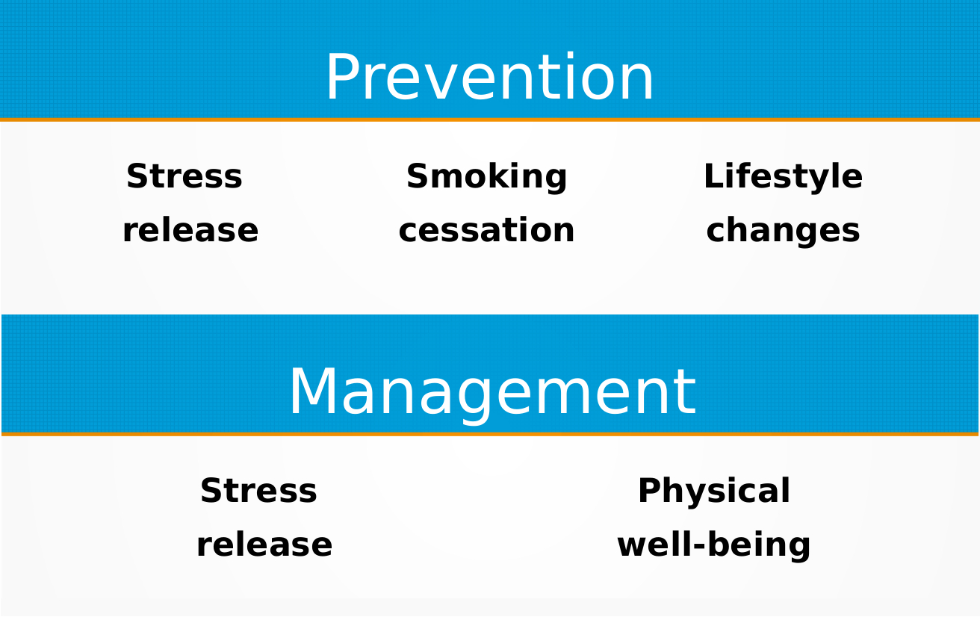
Recent Publications
- Stapleton, P., Porter, B., 2013, Quitting Smoking: How to Use Emotional Freedom Techniques, International Journal of Healing and Caring, 13 (1)
- Maharaj ME. Differential Gene Expression after Emotional Freedom Techniques (EFT)⁠ Treatment: A Novel Pilot Protocol for Salivary mRNA Assessment. Energy Psychology:⁠ Theory, Research and Treatment. 2016;8(1):17-32.⁠
- Bach D., Groesbeck G., Stapleton P., Sims R., Blickheuser K., Church D. Clinical EFT (Emotional Freedom Techniques) improves multiple physiological markers of health. J. Evid. Based Integr. Med. 2019;24:1–12. doi: 10.1177/2515690X18823691.
- Wang, C., Zhou, J., Wang, J. et al. Progress in the mechanism and targeted drug therapy for COPD. Sig Transduct Target Ther 5, 248 (2020). https://doi.org/10.1038/s41392-020-00345-x
- Mahima Kalla, Margaret Simmons, Anske Robinson & Peta Stapleton (2018) Emotional freedom techniques (EFT) as a practice for supporting chronic disease healthcare: a practitioners’ perspective, Disability and Rehabilitation, 40:14, 1654-1662, DOI: 10.1080/09638288.2017.1306125

Biography (150 word limit)
Suzanne Zacharia has her expertise in the conduction of Emotional Freedom Techniques (EFT/Tapping) practitioner sessions, and especially in chronic disease. Her own experience was in helping herself overcome the many challenges of COPD, which started at the tender age of 26 and led to a journey of complementary and alternative health, searching for a solution to fill the gaps in the medical treatments given. An online blog of EFT self-treatments attracts clients with respiratory and other chronic diseases, providing a wealth of experience and observations. Email: suzanne@newagelondon.com

