Stimulating self-change in older people’s lifestyle through role models

Jane Thurnell-Read, M.Sc. www.upliness.net

Abstract

Large numbers of older people suffer from chronic ill health and fear of falling. A quarter of people over 65 suffer from depression. On average people experience ill health and limitation for the last 20% of their lives. Health and social policies widely recommend that older people need to change their behaviour, both for their own sake and because of the strain on health and social services.

Reaching this group is not difficult administratively, but changing their behaviour is. Exhortation and the presentation of information has limited success. Medical practitioners are often too busy to devote the time needed to mentor the necessary changes.

Some older people lack the knowledge, but most lack the belief that they can improve their health and lifestyle. They may believe that this is because of genetic or familial predisposition. They may think that they are too old to make change worthwhile, or that change is expensive and arduous.

Everyday role models are an important part of changing people’s behaviour whatever the age. This paper will look at strategies for finding real life role models, and the most effective ways to present them to older people.

Image: common ideas about ageing
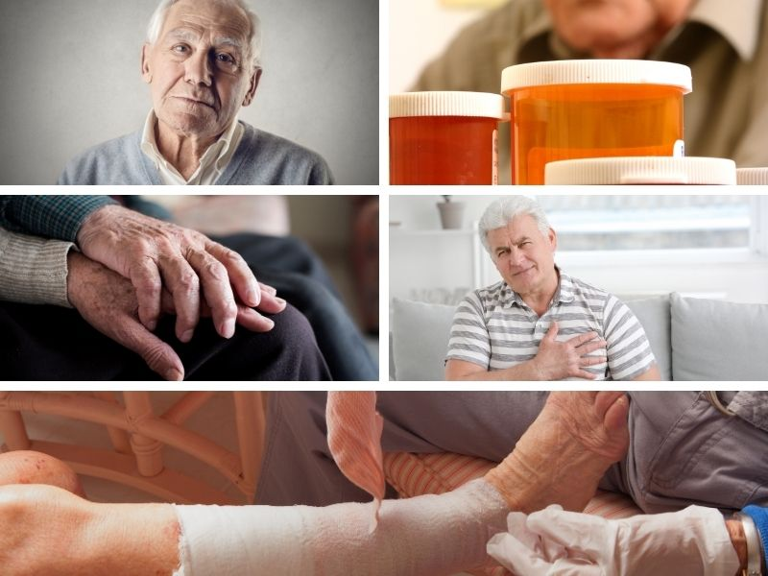
References
- Nervik et al The value of role models in design of social media for elderly. 23rd International Conference of the European Federation for Medical Informatics
- Heidrich and Riff, The Role of Social Comparisons Processes in the Psychological Adaptation of Elderly Adults, Journal of Gerontology, Volume 48, Issue 3
- Jopp et al Who Is Your Successful Aging Role Model? The Journals of Gerontology: Series B, Volume 72, Issue 2
- Prof. Dr Andreas Kruse, The Elderly Can Be Good Role Models, Heidelberg University interview
- Kelly M et al Should nurses be role models for healthy lifestyles? Results from a modified Delphi study. Journal of Advanced Nursing; 73: 3

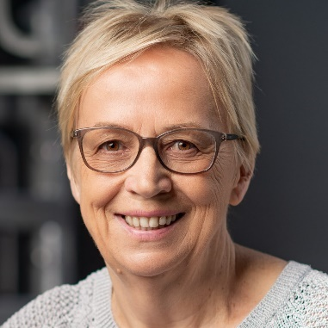
Jane Thurnell-Read is a former university lecturer in sociology. She subsequently became a widely-respected CAM practitioner and international teacher and author. Now in her seventies she runs an online membership website www.upliness.net, encouraging people to live enthusiastically and healthily for their whole lives. An important element of this is an extensive and growing collection of interviews with real life “ordinary people” who are living well and breaking down stereotypes. She will give a TEDx talk in Norwich UK in 2021 entitled “Older, fitter, stronger”.

jane@janethurnellread.com

