Lifestyle and being obese: Strategies and maintenance for a long-term weight loss success.
Nadine Hamdar- Dietitian - Germany

Abstract (300 word limit)

Obesity is considered as one of the main leading risk factors in early death as it is responsible for 4, 7 million of premature deaths each year. To induce and maintain weight loss, randomized controlled trials that compared different type of diet and activity interventions were examined. Some high-quality evidences show that low-energy diets are effective for the treatment of obesity. However, very-low-energy diets are more effective for drastic weight loss than low-energy diets but the weight loss cannot be maintained on the long term. On the other hand, physical activity seems to play a critical role in maintaining weight loss in obese people. It also helps to preserve the lean muscle mass. Another factor which was also associated with long-term weight control included the continued patient–practitioner contact. Studies show that a lifestyle modification in obese people by combining an adequate diet, a regular physical activity and a behavior therapy could lead to a loss of around 10% of their initial body weight in 30 weeks.
The main challenges when it comes to lifestyle changes and obesity are the weight gain in the future and the maintenance of the healthy lifestyle changes. This article provides an overview of the new strategies for effective management of obesity on the long-term through lifestyle modification. There is high-quality evidence to confirm that intensive lifestyle modification not only lead to a significant weight loss in obese people but also prevents the progression of type 2 diabetes and reduce the cardiovascular risk factors.
Keywords: Lifestyle, obesity, modifications, diet, physical activity, weight loss, challenges, strategies, maintenance.

Image
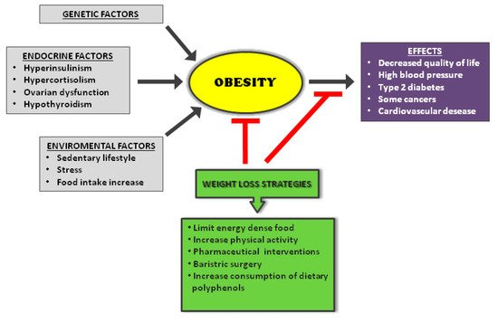
Figure 2. Causes and consequences of obesity with weight loss strategies.

Recent Publications (minimum 5)
- Vesely, J. and DeMattia (2014), Obesity: Dietary And Lifestyle Management, 425:11-15.
- Riccardo Dalle Grave, Simona Calugi, Marwan El Ghoch, (2013), Lifestyle modification in the management of obesity: achievements and challenges, 18, pages339–349.
- THOMAS A. WADDEN,MEGHAN L. BUTRYN, CHRISTOPHER WILSON (2007), Lifestyle Modification for the Management of Obesity, 132:2226 –2238.
- Bunc V and Skalská M (2015) Using Walking as a Tool for Fitness and its Influence on Obesity and Overweight Individuals. Jacobs Journal of Obesity 1(1):010.
- Stevens J, Oakkar E E, Cui Z, Cai J and Truesdale K P (2015) US adults recommended for weight reduction by 1998 and 2013 obesity guidelines, NHANES 2007-2012. Obesity 23(3):527-531.

 Biography (150 word limit)
My name is Nadine Hamdar I am from Belgium and live actually in Germany. I am a dedicated, ambitious and passionate dietitian. I believe that my organization and communication skills help me in my job to communicate complex information and adapt it to my patients. I am also a person who is always positive and wakes up every day with a mission and a dream; which is to help people to develop healthier diets and lifestyles with the objective of improving their health and make them look and feel the best way they can. Above all, I take pride in my work and like to maintain high standards at all time. I have written this article in the aim to show the new strategies to fight obesity and how the weight loss can be maintain on the long-term. Many obese people struggle with their weight but also to keep their weight loss on the long-term. In this article, I will give you the key to success.
Email: nadine.hamdar@hotmail,.com

Notes/Comments:

