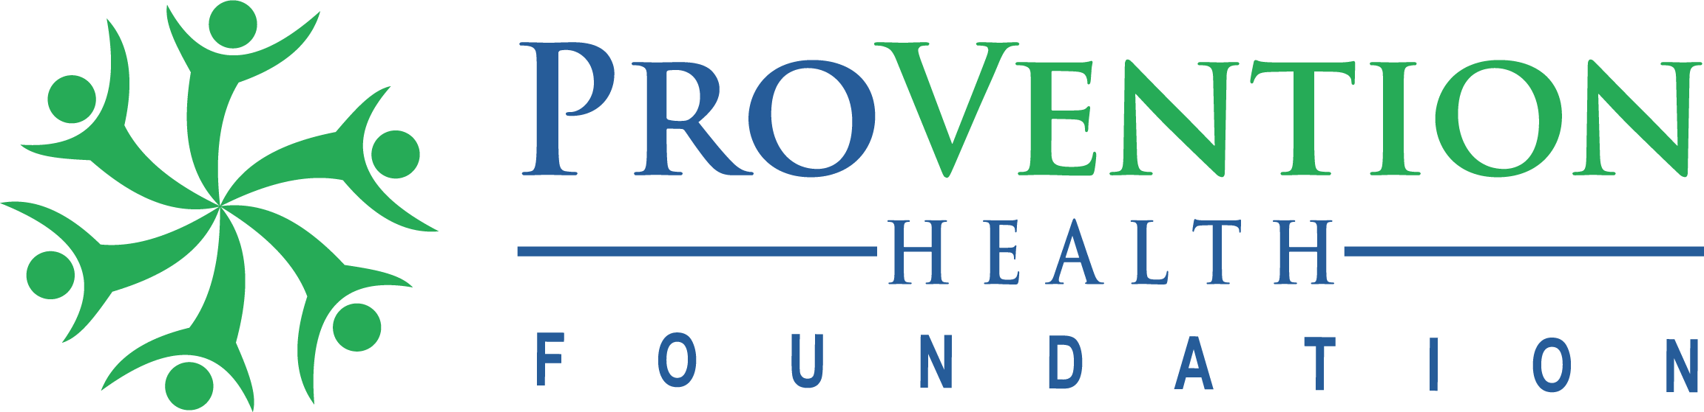
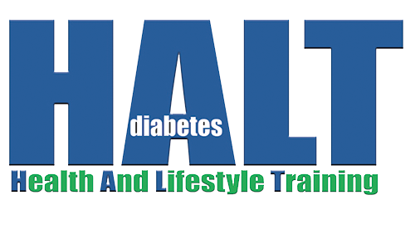

The Problem:

The National Diabetes Prevention Program—or National DPP—was created in 2010 to address the increasing burden of prediabetes and type 2 diabetes in the United States. This national effort created partnerships between public and private organizations to offer evidence-based, cost-effective interventions that help prevent type 2 diabetes in communities across the United States.
One key feature of the National DPP is the CDC-recognized lifestyle change program, a research-based program focusing on healthy eating and physical activity which showed that people with prediabetes who take part in a structured lifestyle change program can cut their risk of developing type 2 diabetes by 58% (71% for people over 60 years old).

Fast Facts on Diabetes

Diabetes
- Total: 34.2 million people have diabetes (10.5% of the US population)
- Diagnosed: 26.9 million people, including 26.8 million adults
- Undiagnosed: 7.3 million people (21.4% are undiagnosed)

Prediabetes
- Total: 88 million people aged 18 years or older have prediabetes (34.5% of the adult US population)
- 65 years or older: 24.2 million people aged 65 years or older have prediabetes

The Solution:

HALT: Online DPP Delivery Platform

After working for nearly a decade to scale and sustain the National Diabetes Prevention Program (DPP), ProVention Health Foundation’s leadership recognized a need to complement the existing landscape of DPP delivery options.

THE MISSING PIECE
Missing among the in-person DPP classes and full-service online DPP companies, was the ability for trained, DPP lifestyle coaches to simply offer an asynchronous, online learning opportunity to those who could not attend in-person classes and/or who could not afford the online options.

THE SOLUTION
ProVention partnered with a software company that was willing to license its CDC-approved DPP video curriculum and fully-integrated online DPP delivery platform (complete with messaging tools, photo-food logging, dashboards, data collection and mobile apps) to state health departments and other state-wide, coordinating bodies.

This new offering is a called HALT (Health And Lifestyle Training) and is categorized as a technology platform that allows DPP-trained, lifestyle change coaches to provide to locally-led, online delivery of the DPP at prices that were previously unavailable.

Because ProVention is a nonprofit foundation, it is able to establishes a low-cost, Master Licensing agreement with a central entity (such as a state health department) which in turn is allowed to grant sublicenses to any qualifying DPP delivery organization in its state — completely free of charge. ProVention is the only organization in the nation that offers a self-service DPP delivery platform with unlimited sublicenses.

EXPANDING DPP DELIVERY PROVIDERS
In addition to affordability and heightened participant access, this model also allows increased opportunity for organizations to begin offering the DPP to their populations. In Maryland for example, over 30 different organizations are currently using the HALT platform and half of them are brand new to DPP delivery.

AFFORDABLE SUSTAINABILTY
Following the first year of the Master License agreement, it is reasonable to require each participating DPP delivery organization to contribute a small amount of money toward renewal of the Master License agreement, thereby sustaining access to the DPP indefinitely at a fraction of the cost of any other online delivery option.

A UNIFIED APPROACH:
While the HALT platform offers the most expansive and affordable access to the DPP with the highest level of convenience, ProVention understands that some patient populations are best served through in-person classes. Such classes afford greater opportunity for one-on-one accountability and friendship development. Similarly, some organizations do not have trained DPP lifestyle change coaches and therefore cannot offer the DPP online or in-person. These organizations and communities are best served through online DPP delivery companies that provide full-service options. Therefore, ProVention Health Foundation sees the value of all three categories of DPP delivery to address the burgeoning need of those at risk for diabetes.

