Changing Your Life by Changing Your Behaviors: The Secret to a Longer and Disease-Free Life Lies Within Your Lifestyle Choices
David C. Batman, MSC, MB.CHB., D.R.C.O.G., D.I.H., MFOM, FFOM

Abstract (300 word limit)
As the world battles the current coronavirus pandemic, we have also been facing another global crisis that is far less discussed: the prevalence, cost, and mismanagement of chronic disease. Globally, about one in three adults suffer from multiple chronic diseases¹. Common chronic conditions consist of obesity, diabetes, heart disease, depression, and hypertension². These types of chronic conditions (and others) are extremely costly at both the individual-level and employer-level and are taxing on healthcare systems. As conditions worsen, pain increases leading to fatigue and inability to work. Disengaged employees and absenteeism is expensive for any employer. With each additional chronic condition, annual healthcare costs increase between 80-300%³. And those with chronic conditions are at a much higer risk for COVID-19 complications and the mortality rate is 12 times higher⁴. Many factors influence the possibility of developing a chronic condition, such as a sedentary lifestyle, poor diet, alcohol / substance abuse. The good news is that 70% of overall risk is due to these lifestyle behaviors⁵. Therefore, if you’re looking for the secret to a longer and healthier life, it lies within your daily habits. Now is the time to take control of your health and wellbeing by adopting healthy habits that stick because preventing chronic conditions is far easier than managing or reversing them. This session will explore: how you can change your attitudes and daily behaviors to lead a healthier life and how you can empower your employees to do the same; COVID-19 biggest risk factors; how a holistic wellbeing vendor can help address these challenges.

Image
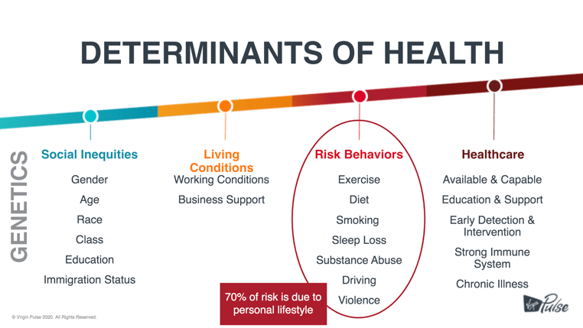
Recent Publications (minimum 5)
- Cother Hajat and Emma Stein (2018) The global burden of multiple chronic conditions: A narrative review. The National Center for Biotechnology Information (NCBI)
- (2019) About chronic diseases. The Centers for Disease Control and Prevention
- Amelia Adler-Waxman (2017) This is the biggest challenge to our health. World Economic Forum
- Lindsey Tanner (2020) Coronavirus death rate is higher for those with chronic illness. The Journal of Emergency Medical Services (JEMS)
- Christopher Murray (2017) Health effects of dietary risks in 195 countries, 1990-2017: a systematic analysis for the Global Burden of Disease Study 2017. The Lancet


Biography (150 word limit)
Dr. David Batman has been a registered medical practitioner for over 47 years and a Consultant in Occupational Medicine for over 30 years. He spent 20 years as Head of Occupational Health, Safety and Employee Wellbeing for Nestle in the UK and Ireland and has special interests in mental health at work, risk assessments, rehabilitation and resettlement of employees. He specializes in advising on lifestyle preventative approach to medicine, developing resilience and management of mental health issues. Dr. Batman previously served as Chief Medical Officer for Global Corporate Challenge (GCC) and is now a valued member of the Virgin Pulse Science Advisory Board.
Email: David.Batman@VirginPulse.com

Notes/Comments:

