Abstract Submission

Title: What is Whole-Food Plant Based Nutrition, and why/how should I prescribe it?

Thomas, Renae, MD.
Family and Preventive Medicine Resident, Loma Linda, CA

Keywords: Plant Based, Nutrition, Disease Prevention, Chronic Disease, Caloric Density, Nutrients of Concern, Nutritional Prescriptions

- Abstract Body
The number one cause of death in the USA is the standard American diet, with the majority of calories coming from highly processed ‘food-like’ products and animal-based products. We have overwhelming evidence through large-scale, peer-reviewed studies including epidemiologic, ecologic, case-control, case-series, and RCTs supporting reductions in chronic diseases, auto-immune and rheumatological conditions, digestive distress, dermatological conditions, pain syndromes, risk factors, and all-cause mortality, with increases in the consumption of whole, plant foods. There is additionally substantial evidence, both theoretically and clinically, that nutritional patterns based on whole plant foods can meet all required macro and micronutrients necessary for humans to thrive. A shift to nutritional prescriptions, either alone, or as adjuvant therapy to traditional medical treatments will help patients to optimize their health. These should be supplemented with the principles of motivational interviewing, education, resources and tools to succeed, goal setting, helpful tips, and regular follow-up to ensure and support successful lifestyle change. Lifestyle medicine and its associated pillars of health provide the foundation for advice to move beyond ‘eat better and move more’, and to supply valid treatment options that are often at least as effective as current standard of care, and the power of dietary change cannot be underrated or ignored any longer. It isn’t just food anymore… this is the future of medicine!

- Image:

- Reference: Numerous, available on request

- Biography:
Dr Renae Thomas (B-BMed (nutrition and exercise physiology), MBBS hons, MD) first became interested in the power of lifestyle choices before she even started school, while observing her father incorporate health-promoting changes (and heal!) shortly after he was diagnosed with metastatic cancer. She continues to have a passion for nutrition, physical activity, social connections and stress reduction, and how these influence disease prevention, often reversal, as well as ongoing maintenance of health. Renae recently migrated from Australia to Loma Linda, California – one of the world's Blue Zones.

Dr Thomas is currently a senior resident in Loma Linda University Health’s Family and Preventive Medicine residency combined program, which includes a Lifestyle Medicine Specialty track, and a Master’s in Public Health (Population Medicine). She completed an internship at True North Health Centre in 2016, is a published co-author on vegetarianism and cancer with lead Adventist Health research Dr. Michael Orlich, vice-president of the American College of Lifestyle Medicine Trainees, on the lifestyle track committee for the American College of Preventive Medicine, on the international advisory committee for Doctors for Nutrition, a PCRM (Physicians Committee for Responsible Medicine) spokesperson, McDougall Starch Solution and Dietary Therapy graduate and a qualified yoga teacher.

- Presenting author details
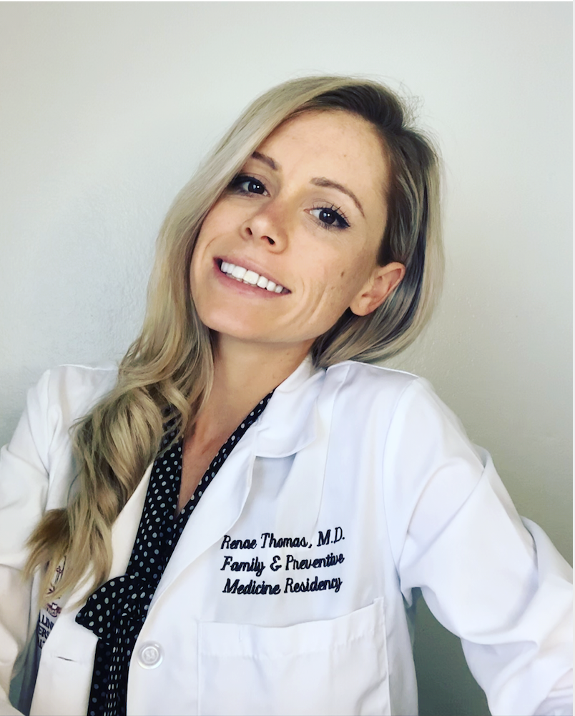

Full Name: Renae Thomas
Contact number: (909) 213-2457
Instagram account: @drrenaethomas
Website: https://drrenaethomas.com
Linked In account: https://www.linkedin.com/in/dr-renae-thomas-md-2b71b0aa/
Session name/ number: What is Whole-Food Plant Based Nutrition, and why/how should I prescribe it?
Category: (Oral presentation/ Poster presentation): Oral Presentation
Passport Number: Available on request

