Impact of Nonlinear Impairments on Power Budget and Transmission Power Penalties in High Capacity Long Haul Optical Networks
Yousaf Khan¹, Farman Ali² and Amjad Ali³
- University of Engineering and Technology Peshawar- Pakistan
2. Iqra National University Peshawar- Pakistan
3. University of Technology Noshera-Pakistan

Abstract:
Fiber-optic communication systems predominantly when employ in the nonlinear regime, generally do not perform truly as theory would speculate. This paper researched the theoretical model, power budget and transmission power penalties of the high capacity long haul optical network under the influence of nonlinear impairments. The presume model is affirmed using important nonlinear factors like effective area, launch power, received power, refractive index and length of the fiber. The power budget and transmission performance of the high capacity long haul optical network are analyzed on the basis of bit error rate and optical signal noise to ratio against launch power, length of the fiber, effective area and nonlinear refractive index. The simulation results manifest significant impact of nonlinear impairments on power budget and transmission power penalties of the high capacity long haul optical networks.
Keywords: Long haul Optical Networks, Power Budget, Power Penalties, Nonlinear Impairments and Bit Error Rate (BER) and Optical Signal to Noise Ratio (OSNR).
Corresponding Author:y.khan@uetpeshawar.edu.pk

- Introduction:
In recent times, the demand of multimedia traffic with high capacity and long-range transmission has increased. Optical fiber communication technology is one of the key source which can be used to support the high-capacity, large traffic, long-distance transmission and high data
rate due to less weight, low cost, normal size, and better latency rate. Moreover, a fiber can carry a large number of channels with better efficiency. However, if a system is designed to support high capacity and long-haul communication, due to some noises of nonlinearity it will degrade the overall efficiency of the optical fiber communication network. Such losses of the transmission system are known as nonlinear impairments [1, 2, 3]. Hence, in modern communication systems the issue of nonlinearity remains the main objective that could improve the performances of the optical networks. Without suppression of the nonlinearity, transmission distance and capacity cannot be increased. There are two main types of nonlinear impairments – the Kerr effect and the inelastic scattering. The first type of nonlinear impairments consists of self-phase modulation [4], cross-phase modulation [5], cross-polarization modulation [6] and four waves maxing (FWM) [8] while the second type of nonlinear impairments consists
of stimulated Raman scattering and stimulated Brillion scattering in which part of the optical wave power is absorbed by the optical medium [9]. These types of nonlinear effects can be neglected because they manifest only at input powers higher than the typical values used in
optical communication systems.
The proposed network is further optimized to improve power budget therefor supporting more bandwidth and transmission range. The optical power budget in a fiber-optic communication link is the allocation of available optical power (launched into a given fiber by a given source) among various loss-producing mechanisms such as launch coupling loss, fiber attenuation, splice losses, and connector losses, in order to ensure that adequate signal strength (optical power) is available at the receiver. In optical power budget attenuation is specified in decibel (dB) and optical power in dBm. All loses from source to detector comprise the total loss (Pt) in system with addition link power margin consider the losses due to component aging and temperature fluctuations. Usually a link margin of 5-8dB is considered while estimating link power budget [10-11].
A number of analyses are done up till now by researchers to maintain the system
performance including nonlinear effects in system network. One of them is the digital subcarrier multiplexed (SCM) signals for a single channel discussed by [12]. The second way is nonlinear signal-to-noise interaction which is investigated using first-order perturbative description of
digital back-propagation mentioned in [13]. The third approach is using direct detection technique to investigate the effect of optical fiber communication nonlinearity on the power budget [14]. The fourth technique is nonlinear compensation using Fourier transform framework presented by [15, 16]. Another proposed model worked on nonlinearity using phase noise tracking algorithm discussed in [17]. All these above-mentioned ways still have a number of challenges and limitations in term of complexity and system cost. Therefore, a constructive design of long-haul communication setup is required. This paper investigates the theoretical and simulation model of key nonlinear factors such as effective area, launch power, received power, nonlinear refractive index and fiber length. The impact of nonlinear impairments on the Power budget and transmission power penalties of the high-capacity long-haul optical network is the novel aspect of this research.. The analysis is carried out using key parameters of bit error rate (BER) and optical signal-to-noise ratio (SNR).The rest of the paper is organized as follows. Section 2 describes the mathematical model of the proposed scheme. Section 3 mentions the network architecture and simulation study of the proposed structure. Section 4 demonstrates the results and discussion while Section 5 concludes the findings.

2. Theoretical Model:
Nonlinearity in optical fiber relates to key parameters which includes effective area of the optical fiber, nonlinear refractive index, length of the fiber, order of the susceptibility, electric field, amplitude of the electric field, attenuation, phase shift of the pulse, intensity of the optical, order of the dispersion and some other components which are discussed here[18-19].
The phenomenological equation of the nonlinear interaction in optical fiber communication is
$\frac{i∂A}{∂Z}- \frac{iβ_{2}∂^{2}A}{{∂t}^{2}}- \frac{β_{3}∂^{3}A}{{∂t}^{3}}+ γ{\left|A\right|}^{2}A+\frac{iα}{2}=iγ\left[\frac{i∂ \left({\left|A\right|}^{2}A\right)}{ω∂t}-\left(Tr\right)A\frac{i∂ {\left|A\right|}^{2}}{ω∂t}\right]$ 1
In the above equation used parameters $Tr$, $Z$, A, $β_{2}$, $β_{3}$, ${\left|A\right|}^{2}$, $γ$, $α$, denote Raman time constant, electric field in z position, change of amplitude, Group Velocity Dispersion (GVD), third order dispersion, optical pulse power, nonlinear coefficient and attenuation in dB/km.
The Non Linear parameter $γ$ is given by
$γ= \frac{{ 2πn_{NL}(ω}_{0})}{λA_{e}}$ 2
$n_{NL}$ is the nonlinear refractive index, wavelength of optical center is $λ$and $A_{e}$ is the effective area of the fiber used in optical communication.
There is another parameter called null dispersion wavelength denoted by $λ_{d}$. This term identify the negative and positive behavior of the GVD. In the case of ($λ>$ $λ_{d})$ GVD is negative and in case of ($λ<$ $λ_{d})$ group velocity dispersion is considered positive[19-20]. Fiber dispersion D having unit (ps/km.nm) parameter which can alter the value of GVD by using
$D= \frac{-2πτβ_{2}}{λ}$ 3
Where $τ=$ (frequency)of the optical signal in fiber.
The $n_{NL}$and $A_{e}$terms are given by
$n_{NL}= \frac{3}{4n^{2}}Rx_{ijkl}^{'''}$ 4
$A_{e}= \frac{2πn_{NL}τ}{c∅_{NL}L}$ 5
The parameters used in the above equations n is linear term of the refractive index, R is constant equal to $\frac{1}{c∈_{0}}$ , $x_{ijkl}^{'''}$ is the third order susceptibility and first term of the nonlinearity in optical fiber, c is speed of light, L is fiber range and the last term $∅_{NL}$ is nonlinear change in phase[20-21].
The $∅_{NL}$is given by
$=\frac{k_{0}}{λ}\left(n_{0}+n_{NL}I\right)L_{e}$ 6
$k_{0}=2π$, L_{e} is the range of fiber in which power can be taken constant named effective length and I is the power intensity of the optical.
Intense laser light and mater interaction are the key source of nonlinearity which results in polarization is induced. Mathematical explanation of the induced polarization is given as [22].
$P_{i}(t)= ∈_{0}\sum_{j=1}^{∞}{\sum_{k=1}^{∞}{\sum_{l=1}^{∞}{x_{ijkl}^{n}}}}E_{j}E_{k}E_{l}$ 7
Where n = 1,2,3….
The term $x_{11}^{1}$ mean low intensity susceptibility and the other terms $x_{111}^{2}$, $x_{1111}^{3}$are called nonlinear susceptibility. In centrosymmetric media like glass the second order susceptibility $x_{111}^{2}$ considered very small perturbation so this term is vanished. The Centro symmetric material faced nonlinearity with propagation of the pulse from the term $x_{1111}^{3}.$ The electric field $E_{j}E_{k}E_{l}$ made up of various frequency elements [23]. Therefore it is complicated to predict the nonlinearity interaction and dispersion impairment in optical fiber frame work.
We can mathematically express the power budget [24-26] and losses due to various components used in high capacity long haul optical network as:
Available optical budget:
PB(x, y) = P_{Tmin} − R _{Smin} 8 Signal losses:
∑L components = α*L + N*L_{C} + L_{MUX} + SM 9
Calculated optical power budget = PB(x, y) − ∑L components 10
The parameters used in equation 8 to 10 are P_{Tmin} denotes minimum power launched, R_{Smin} represents receiver sensitivity, α is the attenuation constant having typical values about 0.2dB/km, L_{C} is the connector loss, L used for length of fiber used from transmitter to the receiver, N is number of connector used in the system and loss due to multiplex/demultiplex and power splitter represented by L_{MUX}. SM is the system margin with a purpose of allocating a certain amount of power to additional sources of power penalty that may develop during system lifetime because of component degradation or other unforeseen events. A system margin of 5dB to 8 dB is typically allocated during the design process. So to find the optical power budget of high capacity optical network all kinds of losses occurring in the network should be known. To find the impact of nonlinear impairments on power budget, a comparative analysis of power budget at different span of fiber would be presented using simulation data of the proposed system.
3. Network Architecture and Simulation:
The proposed model used for the analysis of non-linearity in long haul high capacity optical network is shown in figure-I. The key parameters such as effective area of the optical fiber, nonlinear refractive index, length of the fiber, order of the susceptibility, electric field, amplitude of the electric field, attenuation, phase shift of the pulse, intensity of the optical, order of the dispersion are used in the proposed work for the purpose of nonlinear analysis and to find efficient way of degradation such issues.
The aim of this research is to investigate and validate the key nonlinear factors such as effective area, launch power, received power, nonlinear refractive index and fiber length and its impact on the Power budget and transmission performances of the high-capacity long-haul optical network.. Stimulatory results are done using Optisysem v.13 on the basis of above mention mathematical equations. Simulation parameters used in the mathematical model are given in the Table 1. Nonlinearity impact is analyzed in terms of BER, Q-factor, OSNR on the basis of various combinations of input power level, number of channel, length of fiber and other factors.
4. Results Discussion
The postulatory model will be validated using simulation of key non-linear factors such as effective area, launch power, refractive index and fiber length. The transmission performance of the high capacity long-haul optical network would be analyzed on the basis of some key parameters such as Bit Error Rate (BER) and Signal to Noise Ratio (SNR).The transmission performance of the proposed model in term of BER against the received optical power for fiber length of 50 Km and 100 Km is shown as in figure-2 which shows significant results i.e. BER is lower than 10⁻⁹ for wide range of received optical. Figure -3 shows the OSNR against the received optical power which shows less impact of nonlinear factor on transmission performances at received optical power from -10 dBm to 10 dBm.
Figure-4 and Figure-5 shows the transmission performances of the propose model at different span of Fiber length which clearly indicate that the transmission performance got poor as length of fiber increases. These results indicate the strong impact of nonlinear factor at larger span of fiber.
The power penalties calculations are made on the basis of BER for Back to Back (B2B) scenario and after transmission of 50 Km over Single Mode Fiber as shown in Figure.6 .The power penalties calculated is 1 dB. While the power penalties for B2B and 100Km SMF are shown in Figure.7 which is 2 dB. These results clearly indicate that the power penalties are increasing with increase in length of Fiber.
Figure-8 shows the impacts of affective area on the transmission performance of the proposed system. BER got decrease with increase in affective area minimizing the impacts of non-linearity. Figure-7 shows that the Quality factor improves with increase in affective area due to minimum impact of nonlinear Factors.
Fiigure-9 shows that the Quality factor improves with increase in affective area due to minimum impact of non- linear Factors.
Moreover the system performance is related with eye diagram of the simulation results. Clear and open and eye with good height shows that the system is efficient and valuable. Figure.10 (a,b) shows eye diagram which is wide open and showing good height. These results present the valuable achievements of the high capacity long haul optical transmission fir the proposed scheme.
In order to investigate the available power budget for the proposed scheme under the impact of nonlinear impairments for long haul high capacity optical network. We have recorded optical power at OLT and ONU and are summarized as in Table-2. It is evident that the proposed scheme has enough power margins to achieve high capacity long haul optical transmission. The available power budgets in this case are satisfactory and prove the applicability of the proposed scheme for high capacity long haul optical transmission system.
From the power budget comparison of Table-2 it is evident that the available power budget (16dB) for 50 km length of Fiber under the influence nonlinear impairment for the proposed high capacity long haul optical network is satisfactory. However, the available power budget for fiber length of 100km (6dB) is still satisfactory but shows significant decrease in available power budget.it is evident from this comparison that the nonlinear impairment seriously degrades the power budget and must be compensated to keep the transmission performance of long haul optical network in satisfactory range.

5. Conclusions
High capacity and long-haul transmission gained great significance in modern communication networks. This paper has investigated the theoretical model of nonlinear impairments in high capacity long haul optical networks. The postulatory model is validated using simulation of key non-linear factors such as effective area, launch power, refractive index and fiber length. The proposed model of high capacity long haul optical network was analyzed using two key factors of transmission power penalties and power budget on the basis of some key parameters such as Bit Error Rate (BER) and Signal to Noise Ratio (SNR). The key findings conclude that the nonlinear impairments seriously escalate the power penalties with increase in Fiber length and degrade the power budget which must be compensated to keep the transmission performance of long haul optical network in satisfactory range. Mitigation of nonlinear impairments will play significant role in improving transmission performances of high capacity long-haul optical networks.

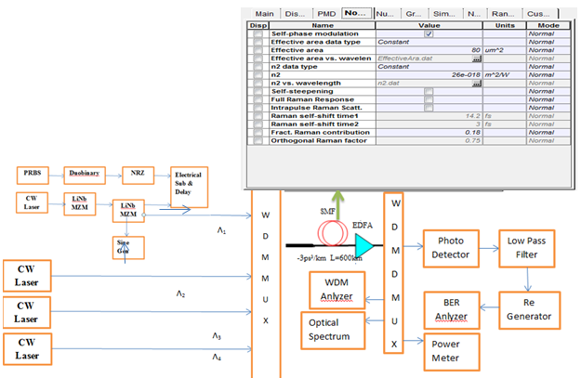
Fig 1: Network Architecture of the proposed system.
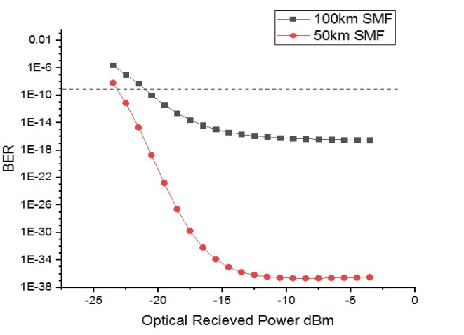
Fig: 2. BER vs Received Optical power
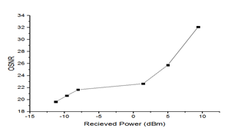Figure-3. ONSR vs Received Optical power
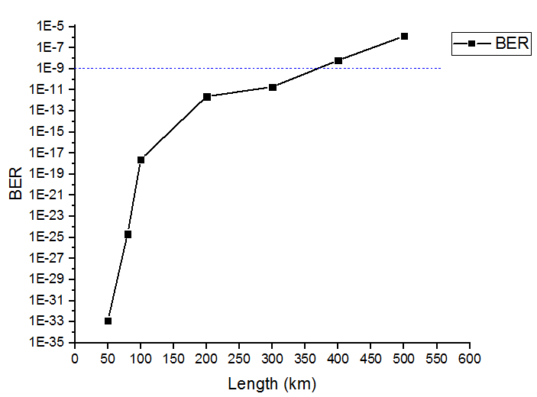
Figure-4. BER vs Length of Fiber
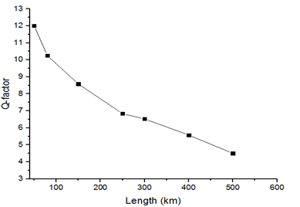
Figure-5 Q-Factor vs Length of Fiber

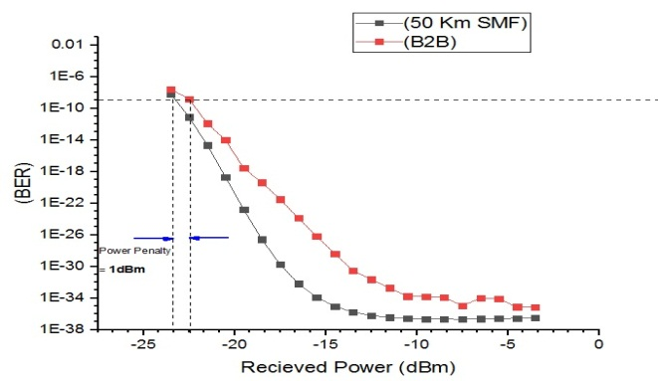
Figure.6 Power Penalties at 50Km SMF
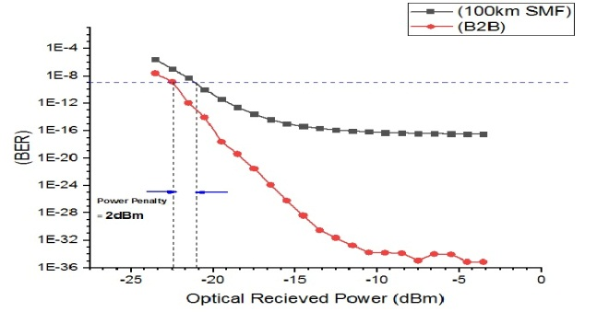
Figure.7. Power Penalties at 100Km SMF
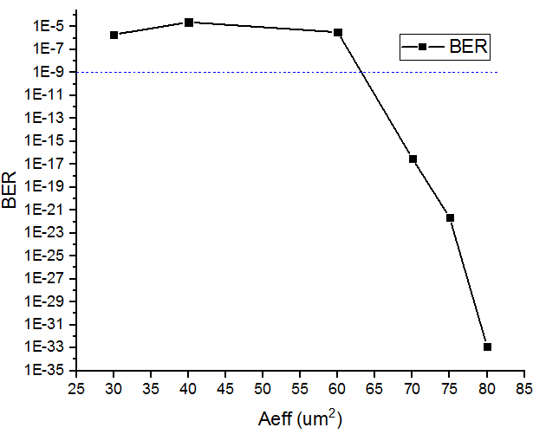
Figure-8. BER vs Effective Area of Fiber
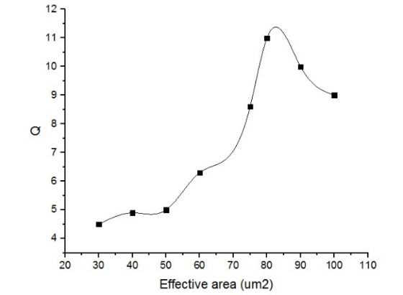
Figure-9 Q.-Factor vs Effective area of Fiber
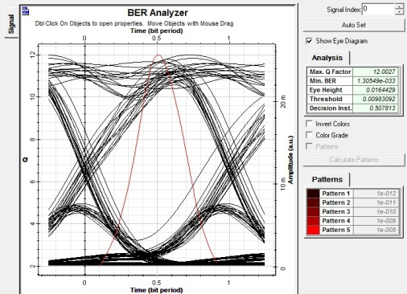
Figure.10(a).Eye diagram of the proposed system at 50Km SMF

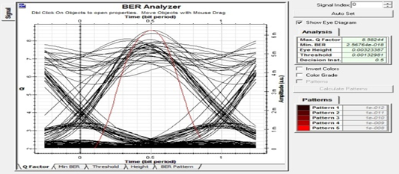
Figure-10(b).Eye diagram of the proposed system at 100Km SMF

Table: 1 Simulation parameters used in the proposed scheme
Name of the Parameters | Quantity of the parameters
Reference wavelength | 1553nm
Attenuation | 0.2dB/km
Dispersion | 17ps/nm/km
Dispersion slope | 0.062ps/nm²/K
Beta-2 | -18ps²/km
Beta-3 | -1ps³/km
Effective Area | 80um²
Nonlinear refractive index (n2) | 2.6*10⁻¹⁷
n2 datatype | Kept constant
A_{e} data type | Unchanged
Orthogonel Raman factor | 0.75
Phase transformation of Nonlinearity | 3mrad
Dark current of photo detector | 10nA

Table.2.Power Budget analysis of the proposed scheme at 50Km and 100Km SMF
References
[1]. Agrawal GP. Nonlinear fiber optics. 5th ed. New York: Academic Press, 2013.

[2]. Boyd RW. Nonlinear optics, Third ed. Academic Press Inc.,London, 2008.
[3]. Daniel Semrau The impact of Transceiver Noise on Digital nonlinearity Compensation Journal of Lightwave Technology Year: 2018 , Volume: 36 , Issue: 3 Page s: 695 - 702.
[4]. Dar R, Feder M. “Inter-channel nonlinear interference noise in WDM systems: modeling and mitigation”. Journal of Light wave Technology; 33(5),2015
[5]. Shtaif M, Dar R, Mecozzi A, Feder M. Nonlinear interference noise in WDM systems and approaches for its cancelation. Proceeding of European Conference on Optical Communications (ECOC).Cannes, 2014.
[6]. Dar R, Feder M, Mecozzi A, Shtaif M. “Accumulation of nonlinear interference
Parameters | 50Km SMF Network | 100Km SMF Network
Min Launch Power (dBm) | 6 | 6
SMF Attenuation (dB) | 10(0.2dB/Km over 50 km of SMF) | 10(0.2dB/Km over 50km of SMF)
Coupler/Mux/Demux(dBm) | 2 | 2
Optical Splitter(dBm) | 3 | 3
Min receiver Sensitivity (dBm) | -30 | -30
System Margin | 5 | 5
Available Power Budget(dB) | 16 | 6
noise in fiber-optic systems”. Optics Express. 22:14199–211.2014
[7]. Dar R, Geller O, Feder M, Mecozzi A, Shtaif M. ‘Mitigation of inter-channel nonlinear interference in WDM systems’ proceeding of European Conference on Optical Communications (ECOC).Cannes, 2014.
[8]. Dar R, Winzer PJ. “Nonlinear interference mitigation: methods and potential gain”. Journal of Lightwave Technology. 35 (4):903–30,2017
[9]. Marsella D, Secondini M, Agrell E, Forestieri F. “A simplestrategy for mitigating XPM in proceeding of nonlinear WDM optical systems.Optical Fiber Communication Conference (OFC). Optical Society of America, 2015.
[10]. Paikun Zhu, Juhao Li “Dispersion-tolerant Upstream PON Transmission Scheme with Improved Power Budget Based on Optical Carrier Suppression” in proceeding of 15th International Conference on Optical Communications and Networks (ICOCN), Hangzhou, China, 2016.
[11]. Yousaf Khan “Power Budget Analysis of Colorless Hybrid WDM/TDM-PON Scheme Using Downstream DPSK and Re-modulated Upstream OOK Data Signals” Journal of Optical Communications, 35(3), 231–237, 2014.
[12]. Qiu M, Zhuge Q, Chagnon M, Gao Y, Xu X, Morsy-Osman M,et Digital subcarrier multiplexing for fiber nonlinearity mitigation in coherent optical communication systems”. Optics Express. 22:,2014
[13]. Serena P. “Nonlinear signal noise interaction in optical links with nonlinear equalization.” Journal of Lightwave Technology.;34:1476–83.2016
[14]. Bangjiang Lin ; Juhao Li “Effect of fiber nonlinearity on the power budget for direct detection OFDM-PON”in proceeding of IEEE/CIC International Conference on Communications in China (ICCC) Year: 2014.
[15]. Yousefi MI, Kschischang FR. Information transmission using the nonlinear Fourier transform, Part I: mathematical tools.IEEE Trans Inf Theory.;60:4312–28,2014
[16]. Wahls S, Poor HV. Fast numerical nonlinear Fourier transforms. IEEE Transactions on Information Theory.;61:6957–74.2015
[17]. Eliasson H, Johannisson P, Karlsson M, Andrekson PA. Mitigation of nonlinearities using conjugate data repetition. Optics Express.;23:2392–402.2015
[18]. Le ST, Prilepsky JE, Turitsyn SK. Nonlinear inverse synthesis for high spectral efficiency transmission in optical fibers. Optics Express.;22:26720–41.2014
[19]. Yankov MP, Fehenberger T, Barletta. Low complexity tracking of laser and nonlinear phase noise in WDM optical fiber systems. Journal of Lightwave Technology.
;2015
[20]. Lin C, Chandrasekhar S, Winzer PJ. Experimental study of the limits of digital nonlinearity compensation in DWDM systems. In proceeding of Optical Fiber Communication Conference (OFC). Holmdel, NJ 07733, USA, 2015.
[21]. Golani O, Dar R, Feder M, Shtaif M. Modeling the bit-error-rate performance of nonlinear fiber-optic systems. Journal of Lightwave Technology. 2016
[22]. Dar R, Feder M, Mecozzi A, Shtaif M. Pulse collision picture of inter-channel nonlinear interference noise in fiber-optic communications. Journal of Lightwave Technology.34:593–607.2016
[23]. Ali, Farman, Yousaf Khan, Amjad Ali, et al. "Minimization of Nonlinear Impairments and Its Impact on Transmission Performances of High-Capacity Long-Haul Optical Networks" Journal of Optical Communications, 2018
[24] G. Keiser, Optical Fiber Communication, McGraw-Hill 4th Edition, 2008. [25].http://harrisbroadcast.com/applicationnotes/fiberoptics/ calculator/default.asp
[26]. Michael J. Fujita, S.K. Ramesh, and Russell L.“Fiber Optic Communication Link Design”, California, 2003

